

FACULTY OF SCIENCE, ENGINEERING, AND COMPUTING
School of Engineering and the Environment Department of Mechanical Engineering

MSc DEGREE

IN
RENEWABLE ENERGY ENGINEERING
By
OGHENEFEJIRO JESHURUN EDITOR ETEMIRE
K2354862
VIRTUAL DESIGN DEVELOPMENT AND PERFORMANCE CHARACTERISATION OF A MODEL PVT SYSTEM.
September 19, 2024
Dr Hossein Mirzaii

I warrant that this thesis is free from any form of plagiarism and that I have taken all necessary precautions to ensure the integrity and authenticity of the research presented herein. I fully understand the consequences of any violation of academic integrity policies and take full responsibility for the content of this report.

Word Count: The word count excluding Abstract, Nomenclature, Table of contents, List of Figures, Equations, Tables and References is 15672 words.

Table of Contents
Chapter 1 INTRODUCTION 1
1.1 BACKGROUND OF STUDY 5
1.2 PROBLEM STATEMENT 5
1.3 RESEARCH OBJECTIVES 6
1.4 SCOPE AND LIMITATIONS 7
1.5 JUSTIFICATION / SIGNIFICANCE OF THE RESEARCH 8
Chapter 2 LITERATURE REVIEW 9
2.1 Photovoltaic Thermal Setup Introduction 9
2.2 Challenges in Photovoltaic (PV) Performance: Heat Regulation and Cooling Approaches 13
2.2.1 Photovoltaic Thermal PVT Air Powered Arrangement 16
2.2.2 Photovoltaic Water-Driven Structure Energy Setup 17
2.2.3 BI-Fluid Photovoltaic-Powered Structural Energy System 19
2.2.4 Energy Configuration of a Heat Pipe-Based Photovoltaic System 20
2.2.5 Photovoltaic System with Phase Change Material for Solar Energy Configuration 21
2.2.6 PVT Cooling with Nanofluid Technologies 22
2.2.7 Summary of Photovoltaic-Thermal (PVT) Collector Systems Types 23
2.3 Revised Design of a Photovoltaic-Thermal (PVT) Collector for Solar Panels 24
2.4 Heat Absorbers and Combined Flow Channels in Heat Exchangers 26
2.5 Efficiency Evaluation and Calculations for Photovoltaic Collectors 27
2.6 Digital Modeling of the PVT System through CFD and Polysun Simulations 31
2.6.1 ANSYS Simulation Technique 31
2.6.2 Polysun Energy Simulation System. 33
2.7 Economics of Levelized Cost of Energy (LCOE) Analysis for PVT Systems 34
2.8 Unexplored Gaps Areas in Existing Research 36
Chapter 3 METHODOLOGY 39
3.1 Creation and Evolution of the Conceptual Design of the Photovoltaic Thermal System 39
3.1.1 Photovoltaic PV Panel Materials 41
3.2 Creation and Optimization of Photovoltaic Systems with SOLIDWORKS CAD Tool 42
3.2.1 Design of Photovoltaic Model 42
3.2.2 Configuration of a Solar Thermal Integrated Heat Exchanger Systems 48
3.2.3 Construction of Photovoltaic and Solar Thermal Combined Heat Exchanger 49
3.3 Virtual Simulation of PVT using CFD (ANSYS) 50
3.3.1 Description Overview of Photovoltaic System Model 50
3.3.2 Meshing Grid Generation for Geometrical Structures 51
3.3.3 Setting Boundary Condition Constraints and Presumptions 54
3.3.4 Modeling Solutions for Individual Layers of Photovoltaic Systems 57
3.3.5 Thermal CFD Simulation Using ANSYS 63
3.4 POLYSUN SIMULATION OF PVT MODEL. 65
3.4.1 Site Location and Climatic Information 65
3.4.2 Typical Temperature Levels in Wandsworth 66
3.4.3 SOLAR ENERGY 67
3.4.4 SOLAR ELEVATION & AZIMUTH 68
3.4.5 RAINFALL 71
3.4.6 CLOUD 71
3.4.7 POLYSUN Modeling Outcome of the Photovoltaic-Thermal System 72
3.4.8 Comparison of Metrics for Simulation Performance 82
3.5 Economic Evaluation and Levelized Cost of Electricity (LCOE) Assessment 86
3.5.1 Step-by-Step Explanation of the LCOE Calculation 86
3.5.2 Consequences of Comparative Evaluation 89
3.6 Evaluation of Net Present Value (NPV) Calculations 89
Chapter 4 RESULT 95
4.1 Comprehensive Discussion and Critical Evaluation of Results 95
4.1.1 Impact of Temperature on Photovoltaic Cell Efficiency 95
4.1.2 Design and Simulation of the PVT System 95
4.1.3 Performance Enhancement through Polysun Simulation 96
4.1.4 Levelized Cost of Electricity (LCOE) and Economic Feasibility 97
4.1.5 Factors Influencing PVT Efficiency and Optimization 97
4.1.6 Limitations and Areas for Future Research 98
Chapter 5 CONCLUSION 99
Chapter 6 REFERENCES 101

LIST OF FIGURES
Figure 1: Connection between Photovoltaic Systems, Solar Thermal Technologies, and Photovoltaic-Thermal Hybrid Systems (PV, ST, and PVT) (Hasan & Sumathy, 2010). 2
Figure 2: Development of a Photovoltaic-Thermal (PVT) System Framework (Noxpanco et al., 2020). 3
Figure 3: Diagrammatic Representation of a Photovoltaic Thermal Glass-Based System Model (Abakam et al., 2019). 3
Figure 4: Thermal exchanger mechanism in the photovoltaic panel (Rahman et al., 2017). 4
Figure 5: Components of a Standard PVT Collector (Bandaru et al., 2021). 9
Figure 6: Unglazed and Glazed PVT Configurations for Solar Systems (Sommerfeldt & Madani, 2018). 10
Figure 7: Voltage vs Current at Different Temperatures and Corresponding Maximum PowerPoints for a Solar PVT System (Krauter & Ochs, 2004). 12
Figure 8: Power to voltage at different cell temperatures during operation, along with their corresponding maximum power point (MPP), for a solar PVT system (Krauter & Ochs, 2004). 12
Figure 9: Thermal Behavior and Power Output Efficiency of the Solar Cells on a Summer Day (Tiwari & Gaur, 2014). 14
Figure 10: Increase in Temperature Relative to Power Output for Various Solar Panels (Hamzat et al., 2021). 15
Figure 11: Classification of Photovoltaic Thermal (PVT) System Models (Samykano, 2023). 16
Figure 12: Photovoltaic Thermal Air-Model Description (Dwivedi et al., 2020). 17
Figure 13: Photovoltaic Thermal Water Setup for Solar Model (Aste et al., 2016). 18
Figure 14: BI-Fluid Photovoltaic Thermal Experimental Structural Setup (Jarimi et al., 2016). 20
Figure 15: Solar-Enhanced Direct-Expansion Heat Pump System Utilizing an Innovative PV and Mini-Channel Evaporator (Zhou et al., 2020). 21
Figure 16: Configuration of a PCM-Enhanced Photovoltaic Thermal System (Naghdbishi et al., 2020). 22
Figure 17: Design of a Shell and Tube Photovoltaic Collector Model (Yao et al., 2021). 24
Figure 18: Thermal Exchange Mechanisms in Photovoltaic Panels (Radiation, Convection & Conduction) (Barbu et al., 2021). 25
Figure 19: Flow Configurations in Flat-plate Absorbers: a) Sequential, b) Concurrent, c) Network, d) Helical, e) Hybrid Parallel-Sequential, and f) Biomimetic (Poredoš et al., 2020). 27
Figure 20: Comprehensive Overview of Frequently Applied Models and Techniques in ANSYS-Fluent Configurations (Abdelrazik et al., 2023). 32
Figure 21: Geometry and Mesh Development in CFD Simulations (Rangababu & Kumar, 2015). 33
Figure 22: Simulation of a Photovoltaic Thermal (PVT) System on Polysun Platform (Sanz et al., 2020). 33
Figure 23: Fluctuation of Net Present Value (NPV) concerning the Payback Period (PBP) (Cui et al., 2020). 36
Figure 24: Composition of Traditional Crystalline Silicon Photovoltaic Panels (Schnatmann et al., 2022). 40
Figure 25: Front Surface Design of the Photovoltaic Model (SOLIDWORKS, 2023). 44
Figure 26: Engineering Diagram of the Front Face of the Photovoltaic Model Design (SOLIDWORKS, 2023). 44
Figure 27: Backside Configuration of the Photovoltaic Structure (SOLIDWORKS, 2023). 45
Figure 28: Technical Schematic of the Rear Side of the Photovoltaic System Layout (SOLIDWORKS, 2023). 46
Figure 29: Integrated Heat Exchanger (SOLIDWORKS, 2023). 48
Figure 30: Rear Design of the Photovoltaic Thermal (PVT) System (SOLIDWORKS, 2023). 49
Figure 31: Design of the Front Layer in Photovoltaic Thermal (PVT) Module (SOLIDWORKS, 2023). 50
Figure 32: Solar Panel ANSYS Geometry (ANSYS, 2023). 51
Figure 33: Mesh Geometry of the Solar PV Module (ANSYS, 2023). 53
Figure 34: Steady-State Thermal Solution for the Set Boundary Conditions (ANSYS, 2023). 57
Figure 35: Ethylene Tetrafluoroethylene Temperature Result from the 1st Layer of the PV (ANSYS, 2023). 58
Figure 36: Ethylene-Vinyl Acetate Top Temperature Layer in between the Monocrystalline Cell (ANSYS, 2023). 59
Figure 37: Ethylene-Vinyl Acetate Bottom Temperature Layer in between the Monocrystalline Cell (ANSYS, 2023). 60
Figure 38: Monocrystalline Silicon Cell Solar Radiation Temperature of the Photovoltaic Model (ANSYS, 2023). 60
Figure 39: PET Temperature of the PV Panel layer (ANSYS, 2023). 61
Figure 40: TAPE Adhesive Temperature layer of the PV (ANSYS, 2023). 62
Figure 41: Carbon Fiber Reinforced Polymer Back Temperature Result Layer for the PV System (ANSYS, 2023). 62
Figure 42: Thermal Simulation of the CFRP of the PV System Directional Heat Flux (ANSYS, 2023). 63
Figure 43: MESH for the Solar Thermal Integrated Heat Exchanger (ANSYS, 2023). 64
Figure 44: Medfield Street, London Borough of Wandsworth, England, United Kingdom (Global Solar Atlas, 2024). 66
Figure 45: Typical Maximum and Minimum Temperatures in Wandsworth (Weather Spark, 2024). 67
Figure 46: Average Daily Incident Shortwave Solar Energy in Wandsworth (Weather Spark, 2024). 68
Figure 47: Sun Angle and Direction in Wandsworth (Weather Spark, 2024). 68
Figure 48: Photovoltaic Power Generation and Solar Energy Exposure (Global Solar Atlas, 2024). 69
Figure 49: Average Hourly Profile and Solar Energy Exposure (Global Solar Atlas, 2024). 70
Figure 50: Typical Monthly Precipitation in Wandsworth (Weather Spark, 2024). 71
Figure 51: Types of Cloud Coverage in Wandsworth (Weather Spark, 2024). 72
Figure 52: Domestic Hot Water Preheating by PVT (Polysun Simulation Software, 2024). 73
Figure 53: Graphical Representation of Photovoltaic Yield (Qinv), Auxiliary Heat Energy (Qaux), and Solar Fraction (Sfn) (Polysun Simulation Software, 2024). 78
Figure 54: Graphical Representation of Total Energy Consumption of the System (etot), Overall Electricity Usage (Ecs), and Self-Consumption (Eocs) (Polysun Simulation Software, 2024). 80
Figure 55: Daily Peak Temperature Graph of a PVT Collector (Polysun Simulation Software, 2024). 81
Figure 56: Sankey Diagram for the PVT system (Polysun Simulation Software, 2024). 82
Figure 57: Space Heating (Seasonal Storage, PVT Collector) (Polysun Simulation Software, 2024). 83
Figure 58: Domestic hot water & Space heating, Preheating by PVT (Polysun Simulation Software, 2024). 83
Figure 59: Graphical Analysis of Ecs, Etot, Qaux, and Qinv for the Three Systems Under Comparison (Polysun Simulation Software, 2024). 84
Figure 60: Graphical Analysis of Sfn, Eocs, Qsol, and Quse for the Three Systems Under Comparison (Polysun Simulation Software, 2024). 85
Figure 61: Graphical Representation of Net Present Value for the Lifetime of a Solar PVT System (Microsoft Excel, 2022). 93

LIST OF TABLES
Table 1: Summary of Recently Achieved Laboratory Efficiencies Based on Standard Test Conditions (NREL) (Tiwari & Gaur, 2014). 11
Table 2: Efficiency of Photovoltaic Modules and Their Sensitivity to Temperature (Seng, 2010). 14
Table 3: Mechanical and Thermal Characteristics of Photovoltaic Components (Pavlovic et al., 2021). 43
Table 4: Key Parameters in Photovoltaic System Design (SOLIDWORKS, 2023). 47
Table 5: Average Value of Skewness (Saud T. Al Jadir, 2023). 52
Table 6: Configuration parameters for the geometry and meshing of photovoltaic modules in ANSYS (ANSYS, 2023). 52
Table 7: Boundary Condition Analysis for Solar PV Module Using ANSYS Software (ANSYS, 2023). 55
Table 8: Assumed Solar PV module system (Saud T. Al Jadir, 2023). 56
Table 9: Solar Characteristics of Layers Used in Photovoltaic Modules (Wodołażski et al., 2021). 56
Table 10: Summary of Photovoltaic-Thermal Systems, Solar Heat, and Power Generation (Polysun Simulation Software, 2024). 74
Table 11: Meteorological Data Overview of the PVT system (Polysun Simulation Software, 2024). 75
Table 12:Solar Thermal Energy in the System (Qsol) (Polysun Simulation Software, 2024). 77
Table 13: Tabulated POLYSUN Simulation Report (Polysun Simulation Software, 2024). 80
Table 14: Financial Considerations of Photovoltaic Systems (Babu & Ponnambalam, 2021). 87
Table 15: Detailed Process for Estimating Energy Output Over the Lifespan of a Solar PV System (Microsoft Excel, 2022). 87
Table 16: Financial Break Down Cost of Photovoltaic Thermal System (Babu & Ponnambalam, 2021). 90
Table 17: Net Present Value Explicit Calculation (Microsoft Excel, 2022). 91

LIST OF EQUATION
Equation 1: Relationship between the Instantaneous Electrical Efficiency and Reference Electrical Efficiency (Barbu et al., 2021). 25
Equation 2: Comprehensive Efficiency of Photovoltaic-Thermal (PVT) Systems (Abakam et al., 2019; Duffie & Beckman, 1980). 28
Equation 3: Thermal Performance of Solar Collectors (Abakam et al., 2019). 28
Equation 4: Harnessing Solar Radiation for Effective Energy Capture (Abakam et al., 2019; Duffie & Beckman, 1980). 28
Equation 5: Effective Energy Output of a Photovoltaic Thermal (PVT) System (Abakam et al., 2019). 28
Equation 6: Incoming Solar Energy (Abakam et al., 2019). 29
Equation 7: Solar Transmission and Absorption in Photovoltaic Systems (Duffie & Beckman, 1980). 29
Equation 8: Thermal Extraction Efficiency Factor (Duffie & Beckman, 1980). 29
Equation 9: Collector Performance Efficiency Parameter (Abakam et al., 2019; Duffie & Beckman, 1980). 29
Equation 10: Fin Efficiency Factor (Abakam et al., 2019; Duffie & Beckman, 1980). 30
Equation 11: Absorber Material (Duffie & Beckman, 1980; Hasan & Sumathy, 2010). 30
Equation 12: Heat Conversion Efficiency of the PVT System (Calise et al., 2012). 30
Equation 13: Power Conversion Efficiency of the PVT System (Calise et al., 2012; Duffie & Beckman, 1980). 30
Equation 14: Levelized Cost of Electricity (LCOE) General Equation (Jakob, 2012). 34
Equation 15: Annual Energy Generated (E_{t}) Through LCOE (Babu & Ponnambalam, 2021). 35
Equation 16: General Formula for Levelized Cost of Energy (LCOE) (Hernández-Moro & Martinez-Duart, 2013). 35
Equation 17: Net Present Value Formula (Babu & Ponnambalam, 2021). 89

ACKNOWLEDGEMENT
I am deeply grateful for the guidance and strength provided by God Almighty, whose grace has been a constant source of support throughout this journey. I also extend my heartfelt thanks to my parents, particularly my father, Engr. Etemire, for his unwavering financial support, encouragement, and belief in my capabilities, which have been crucial to the completion of this project. Additionally, I sincerely appreciate my supervisor's invaluable expertise, mentorship, and patience. Their guidance has greatly contributed to the success of this research and to my development as a scholar.

ABSTRACT
This project investigates the virtual design, development, and performance characterization of a model photovoltaic-thermal (PVT) system. PVT systems, which combine photovoltaic and thermal technologies, offer a promising approach to improving the efficiency of solar energy systems by generating both electricity and heat simultaneously. The primary objectives of this study were to assess how temperature affects the performance of photovoltaic (PV) cells, develop a PVT system that incorporates advanced cooling techniques, and evaluate its economic feasibility through a Levelized Cost of Energy (LCOE) analysis.
Using a combination of Computational Fluid Dynamics (CFD) and Polysun simulations, the thermal and electrical performance of the PVT system was analyzed under various environmental conditions. Results revealed that increased temperatures significantly reduce PV cell efficiency, consistent with existing literature, with efficiency losses of up to 14% observed as temperatures rose beyond 25°C. To mitigate these effects, a fluid-based cooling system was integrated, successfully reducing temperatures across the PV layers, and thereby improving overall efficiency. The cooling system was validated through simulations, showing stable temperature regulation with peak values around 50°C.
Economic viability was assessed through an LCOE analysis, which indicated that the PVT system had a competitive cost of £0.1217 per kWh, lower than the current UK grid price. This confirms the financial benefits of the PVT system, particularly over its 25-year operational lifespan. The environmental benefits were also significant, with the system contributing to CO₂ emissions reductions and annual energy savings.
The project identified key factors influencing system efficiency, such as material selection and cooling mechanisms, highlighting the potential for further optimization using advanced materials like nanofluids and phase-change materials (PCMs). While the system performed well under simulated conditions, future work should focus on real-world testing and expanding simulations to account for dynamic environmental factors. Overall, the study demonstrates that PVT systems can enhance solar energy efficiency, providing both economic and environmental advantages, with potential for future development and wider application.

NOMENCLATURE
AC Area Collector
CAD Computational Aided Design
CdTe Cadmium Telluride
CFD Computational Fluid Dynamics
CFRP Carbon Fiber Reinforced Polymer
CHP Combined Heat & Power
CIGS Copper-Indium-Gallium-Diseleride
COP Coefficient of Performance
ETFE Ethylene Tetrafluoroethylene
EVA Ethylene – Viniylacetate
FIT Feed–in–Tariff
FPC Flat Plate Collector
FR Heat extraction efficiency factor
GW Giga Watt
HP Heat Pipe
HTF Heat Transfer Fluid
LCOE Levelized Cost of Electricity
LHP Liquid Heat Pipe
MPP Maximum PowerPoint
NPV Net Present Value
NREL National Renewable Energy Laboratory
PBP Payback Period
PET Polyethene Terephthalate
PV Photovoltaic
PVF Poly Vinyl-Fluoride
PVT Photovoltaic Thermal
ST Solar Thermal
SEG Smart Export Guarantee
STC Standard Testing Condition
STPV Semi-Transparent Photovoltaic
TES Thermal Energy Storage
TWh Tera watt-hour

INTRODUCTION
The increasing awareness of environmental issues and the pressing need to reduce fossil fuel consumption to curb global warming, aiming to keep temperature rises below 2°C above pre-industrial levels, have driven a significant shift towards sustainable energy systems (Herrando and Ramos, 2022). This is particularly important in Europe, where heating and cooling demands account for 51% of total energy consumption, primarily in space heating, process heating, and water heating (Herrando and Ramos, 2022). Rising global temperatures, largely due to carbon (CO₂) emissions from coal-fired power plants, are central to climate change discussions. Renewable energy sources like solar photovoltaic (PV), wind, and biomass are becoming vital in addressing these concerns (Kabeel et al., 2021). As the global demand for energy rises, renewable sources are expected to meet 67% of total energy needs by mid-century, with significant contributions in electricity generation (58%), heating (29%), and transportation (13%) (Ahmadi et al., 2018; Chandrasekar, 2023). Solar energy stands out as a highly promising renewable energy source. Still, conventional PV systems convert only a fraction of the solar radiation into electricity, with much of it lost as heat, thus lowering efficiency. Hybrid photovoltaic thermal (PVT) systems offer a solution by capturing both electricity and thermal energy from solar radiation, addressing these efficiency losses see Fig. 1. Water is often chosen as the heat transfer fluid in these systems due to its superior heat transfer properties over the air, significantly improving PV panel cooling and electrical efficiency (Baranwal and Singhal, 2021). First proposed by Kern and Russel, the PVT system (see Fig. 2) dual function enhances electrical efficiency while using excess heat for thermal applications (Tiwari and Gaur, 2014).
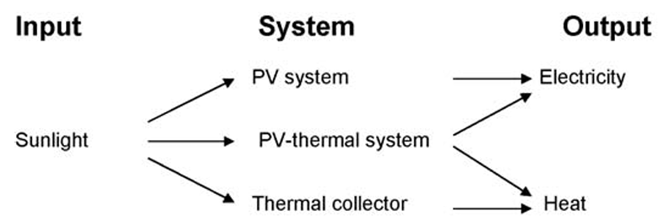
Figure 1: Connection between Photovoltaic Systems, Solar Thermal Technologies, and Photovoltaic-Thermal Hybrid Systems (PV, ST, and PVT) (Hasan and Sumathy, 2010).
One challenge facing PV systems is their reduced electrical efficiency as the temperature of the PV cells rises, with efficiency dropping by 0.4% to 0.5% for each 1°C increase in temperature. This temperature sensitivity limits PV energy yield, especially in regions with high solar irradiance. PVT systems, combining PV panels with thermal collectors, effectively address this by dissipating excess heat, keeping PV cells cooler and thereby increasing their electrical output (Abakam et al., 2019). The extracted thermal energy is also used for heating applications, enhancing the system’s overall performance. This dual-output capacity makes PVT systems more cost-effective and versatile compared to standalone PV or solar thermal systems, especially in scenarios where both electricity and heat are required see Fig. 3. This integration significantly improves energy efficiency and offers financial advantages through enhanced performance, making PVT systems particularly suitable for domestic and small-scale applications (Calise et al., 2012).
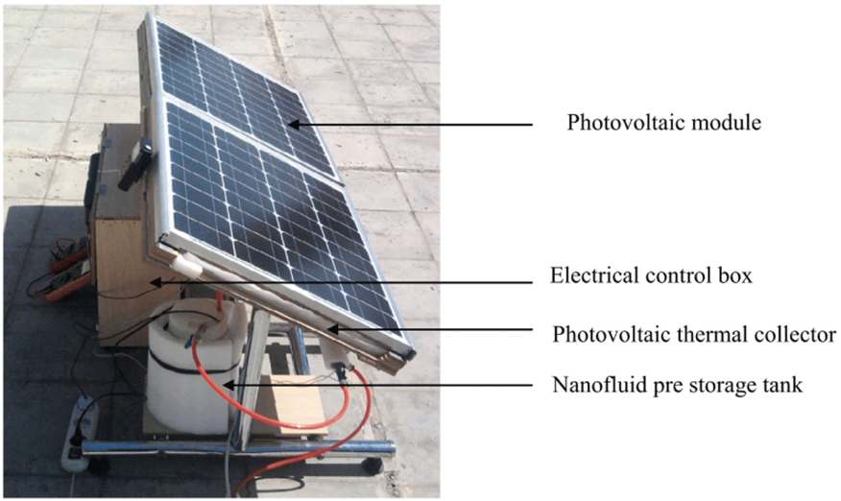
Figure 2: Development of a Photovoltaic-Thermal (PVT) System Framework (Noxpanco et al., 2020).
Both electricity and heat are essential in residential and commercial sectors, historically met by conventional fossil fuels like coal and natural gas. The transition to solar energy is critical for reducing reliance on these non-renewable resources. Solar energy, being the most abundant and widely available clean energy source, is now viewed as a viable alternative to fossil fuels (Abakam et al., 2019). Solar technologies such as solar thermal (ST) and photovoltaic (PV) panels are being increasingly deployed, with hybrid photovoltaic-thermal (PVT) systems combining the strengths of both technologies. PVT systems improve overall energy efficiency by generating both electrical and thermal energy, thus reducing heat losses during PV conversion and cooling the PV cells to enhance performance.
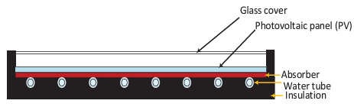
Figure 3: Diagrammatic Representation of a Photovoltaic Thermal Glass-Based System Model (Abakam et al., 2019).
Research indicates that cooling can increase electrical efficiency from 0.3–0.9% up to 4–12% compared to standalone PV systems. This higher efficiency makes PVT systems see Fig. 4 as ideal for small-scale installations, particularly in urban areas where space is limited (Ramos et al., 2017). Additionally, the financial benefits of PVT systems, including faster payback on initial investment, are influenced by factors such as energy prices and government incentives for renewable energy adoption. Conventional PVT systems often feature PV panels integrated with flat plate collectors for low-temperature applications such as domestic hot water production, floor heating, and desiccant cooling. The combination of electrical and thermal energy generation in PVT systems leads to higher power density, reduced capital and maintenance costs, and improved overall system efficiency, particularly when operating at lower fluid temperatures (Barbu et al., 2021; Dubey et al., 2013). Global installed PV capacity reached 300 GW by 2016, generating 365 TWh of electricity annually, with major contributors like China, the USA, Germany, and Japan leading the global PV market (Gagliano et al., 2019).
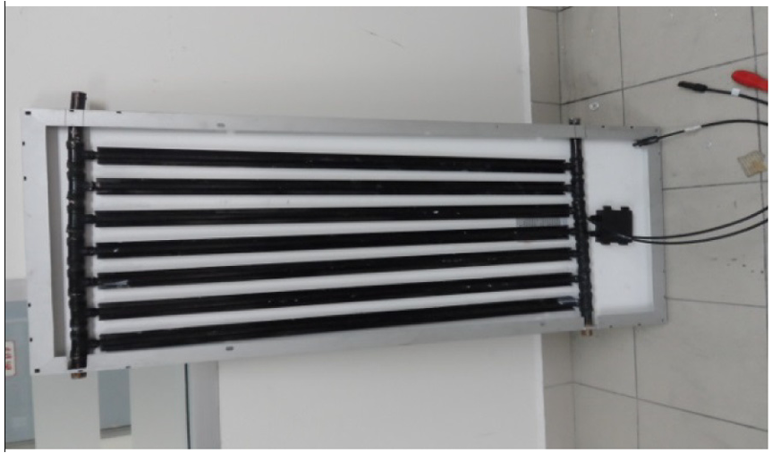
Figure 4: Thermal exchanger mechanism in the photovoltaic panel (Rahman et al., 2017).

BACKGROUND OF STUDY
The growing global need for renewable energy has driven significant progress in solar technologies, especially in photovoltaic (PV) systems, which transform sunlight into electricity. However, the performance of PV cells is negatively impacted by increasing temperatures, reducing energy output and complicating efforts to enhance their efficiency (Chow, 2018). To mitigate this issue, photovoltaic-thermal (PVT) systems have been created by combining PV cells with thermal collectors, enabling electricity and heat production. This combination helps to cool the PV modules, thereby improving electrical efficiency while simultaneously generating thermal energy, leading to a more efficient overall energy conversion process (Gagliano et al., 2019).
Recent innovations in computational tools, such as Computational Fluid Dynamics (CFD) and simulation programs like Polysun, now allow for the precise virtual modeling and assessment of PVT systems' performance. These advanced tools make it possible to fine-tune system designs and optimize their operation in various conditions before the creation and evaluation of physical prototypes (Charalambous et al., 2007).

PROBLEM STATEMENT
In the field of solar power, photovoltaic (PV) systems are fundamental to the worldwide shift toward renewable energy solutions. Nonetheless, the performance of PV cells is adversely affected by rising temperatures during operation, leading to a notable decrease in their peak power output and overall energy efficiency. This issue poses a major challenge to the effectiveness and cost-efficiency of PV systems, especially in hotter regions where solar energy potential is at its peak. Conventional PV systems do not incorporate strategies to counteract thermal impacts, which results in considerable efficiency losses and restricts their use in environments sensitive to temperature changes.
Photovoltaic-thermal (PVT) systems, which integrate solar PV technology with thermal management, represent a promising solution by employing cooling methods to boost the efficiency of PV modules. However, there remains a significant gap in exploring the design and performance of these systems, especially from a virtual modelling standpoint using sophisticated simulation software such as Computational Fluid Dynamics (CFD) and Polysun. The lack of extensive research comparing the performance and cost-effectiveness of PVT systems to conventional PV setups highlights the necessity for a thorough study of their design, development, and overall effectiveness.
This project aims to address existing limitations by designing, creating, and assessing a PVT system that integrates advanced cooling mechanisms to ensure photovoltaic cells operate at ideal temperatures. This will help boost energy generation and improve overall system performance. By utilizing virtual modeling and comprehensive performance simulations, the project intends to highlight the improvements provided by PVT systems and create a foundation for their broader use, especially in areas where high ambient temperatures have historically hindered the efficiency of traditional photovoltaic systems.

RESEARCH OBJECTIVES
1. To explore how temperature affects the performance of photovoltaic cells.
- Examine existing studies on the decline in PV cell efficiency caused by temperature increases.
- Determine the primary elements influencing thermal regulation in PV systems.

2. To design a PVT system conceptually, integrating cooling techniques.
- Create a conceptual model utilising principles from thermal engineering and photovoltaic technology.
- Define the design parameters and technical specifications for the proposed PVT system.

3. To develop the PVT system virtually through CFD and Polysun simulation tools.
- Apply CFD to simulate the thermal characteristics and cooling effectiveness of the PVT system.
- Use Polysun software to model the combined performance of the PVT system under diverse environmental conditions.
- Assess the simulation outcomes to determine the enhancements in performance.

4. Conduct a Levelized Cost of Energy (LCOE) evaluation.
- Calculate the economic feasibility of the PVT system and compare it with standard systems.

5. To pinpoint and evaluate key factors influencing the efficiency and output of the PVT system compared to conventional PV and thermal setups, recommending optimization techniques.

SCOPE AND LIMITATIONS
This research centers on designing, developing, and analyzing the performance of a photovoltaic-thermal (PVT) system through virtual simulations, intending to improve the efficiency of photovoltaic (PV) modules by incorporating cooling methods. It employs Computational Fluid Dynamics (CFD) and Polysun software to simulate and examine the PVT system's thermal behavior and overall performance. The investigation specifically looks at how temperature impacts PV cell efficiency, proposes a cooling-enhanced PVT system, and evaluates its virtual performance under different environmental scenarios.
Nevertheless, the project is constrained by its entirely virtual approach, lacking any physical testing or prototype creation at this stage. Although the simulations offer comprehensive insights, they do not account for real-world aspects such as manufacturing variations, material inconsistencies, or differences in installation. Additionally, the simulations are based on assumed environmental conditions that might not align with actual field scenarios. Should the virtual outcomes prove favorable, future research could focus on constructing a physical prototype to verify the results and conducting live performance assessments using tools like the GUNT ET202. The economic assessment, while offering a cost comparison, is also subject to fluctuations in market conditions and energy prices over time.

JUSTIFICATION / SIGNIFICANCE OF THE RESEARCH
This research is pivotal in pushing forward the advancements in solar thermal engineering, especially in enhancing the operational efficiency of photovoltaic (PV) systems. By tackling the challenge of temperature-related efficiency reductions in PV cells, the project aids in creating more effective and sustainable energy solutions. The conceptualization and simulated evaluation of a PVT system incorporating cooling strategies may lead to more dependable and affordable solar energy production. Utilizing simulation tools like CFD and Polysun delivers a critical understanding of the thermal dynamics within PVT systems, allowing for the refinement of their efficiency under different conditions.
In addition, the study explores possible economic advantages through the Levelized Cost of Energy (LCOE) assessment, which can guide decisions regarding the cost-efficiency of PVT systems compared to conventional PV and thermal options. Should the findings prove successful, they could stimulate further innovations and commercialization of PVT technology, potentially decreasing the dependence on fossil fuels and supporting the worldwide shift toward sustainable energy sources.

LITERATURE REVIEW

Photovoltaic Thermal Setup Introduction
Photovoltaic Thermal (PVT) systems integrate solar photovoltaic (PV) and thermal technologies to simultaneously generate electricity and heat (Lamnatou and Chemisana, 2017). Originally developed by Martin Wolf in 1970, interest in these systems has increased due to their potential to address inefficiencies in traditional PV modules (Cremers et al., 2015). One primary concern is the rise in temperature within PV cells, which diminishes their efficiency. Various cooling techniques have been explored, with water cooling proving to be particularly effective. By circulating water near the PV surface, the system dissipates excess heat, thereby improving the PV module's performance and simultaneously providing heated water for various applications as seen in Fig. 5 (OLAUSSON and WERNIUS, 2021).
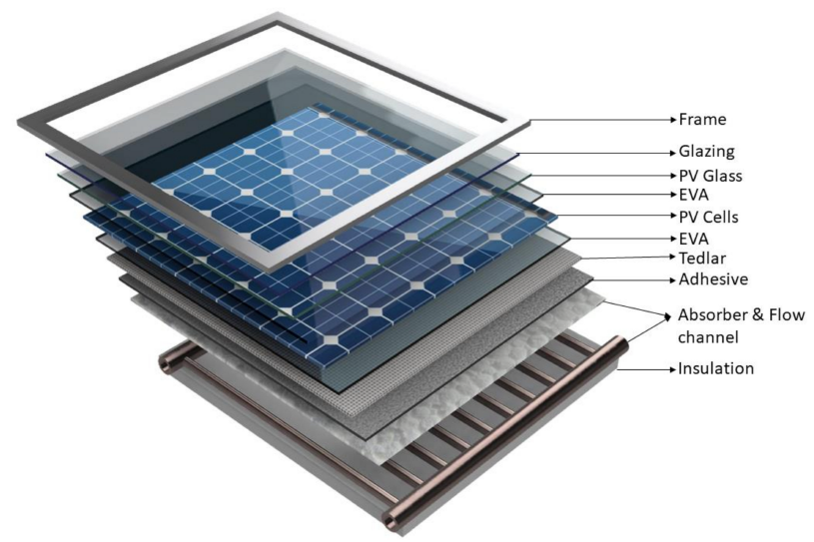
Figure 5: Components of a Standard PVT Collector (Bandaru et al., 2021).
PVT module designs vary depending on the intended use. For building applications, a common configuration pairs the PV module with a flat plate collector. These designs may be either unglazed, where PV cells are directly exposed to the surface, or glazed, where an air gap exists between the cells and the cover (Kim and Kim, 2012). Unglazed systems tend to yield higher electrical efficiency, but lower thermal performance compared to glazed designs (OLAUSSON and WERNIUS, 2021).
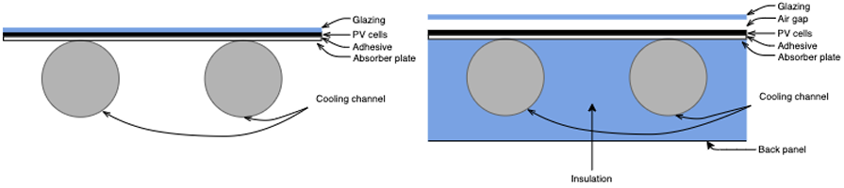
Figure 6: Unglazed and Glazed PVT Configurations for Solar Systems (Sommerfeldt and Madani, 2018).
The global decline of conventional energy sources and their harmful environmental impact, such as increased CO₂ emissions, has accelerated the development of alternative energy solutions. Solar energy presents a promising alternative, being abundant enough to meet human energy demands through PV devices. Photovoltaic technologies have evolved over four generations, each with distinct characteristics (Tiwari and Gaur, 2014). First-generation PV cells are predominantly single-crystal and polycrystalline silicon-based, maintaining a strong presence in the market. Second-generation cells, such as amorphous silicon (a-Si), Cadmium Telluride (CdTe), and Copper-Indium-Gallium-Di-Selenide (CIGS), focus on thin-film designs that reduce production costs. More recent advancements, including third-generation polymer solar cells and fourth-generation quantum dot solar cells, aim to improve efficiency further (Green, 2000). Table 1 presents a summary of various generations of solar cells, along with their most recent efficiency rates achieved in laboratory settings.

Table 1: Summary of Recently Achieved Laboratory Efficiencies Based on Standard Test Conditions (NREL) (Tiwari and Gaur, 2014).
Solar Cell Materials | Efficiency h₀ (%)  (Source: NREL, USA)
Mono c-Si | 25
Poly c-Si | 20.4
a-Si | 10.1
a-Si/nc-Si | 12.3
CdTe | 18.3
CIGS | 20.3
Organic Semiconductors | 10.7
Organic Dyes | 11

A detailed comparison of these technologies, including laboratory-tested efficiency rates, is crucial for understanding their performance across different climatic conditions. For example, the National Renewable Energy Laboratory (NREL) has documented peak efficiencies of 25% for monocrystalline and 20.4% for polycrystalline silicon modules under standard test conditions (1000 W/m², ambient temperature of 25°C) (Khanam et al., 2021).
Temperature is a critical factor in the performance of PV modules, as higher cell temperatures reduce efficiency. Photovoltaic cells rely on solar radiation to generate electricity, but most of the absorbed energy is converted into heat. This rise in temperature increases electron collisions within the cell, raising the circuit’s resistance and lowering its overall efficiency (Kabeel et al., 2021). Studies have shown that temperature increases negatively affect both the open-circuit voltage and power output of PV cells as depicted in Fig. 7 and Fig. 8 (Krauter and Ochs, 2004).
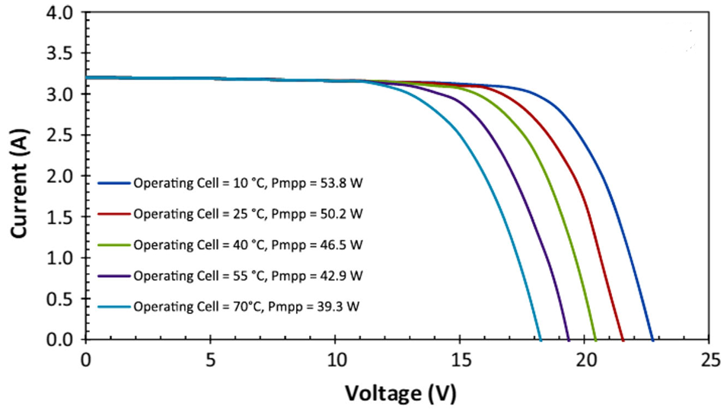
Figure 7: Voltage vs Current at Different Temperatures and Corresponding Maximum PowerPoints for a Solar PVT System (Krauter and Ochs, 2004).
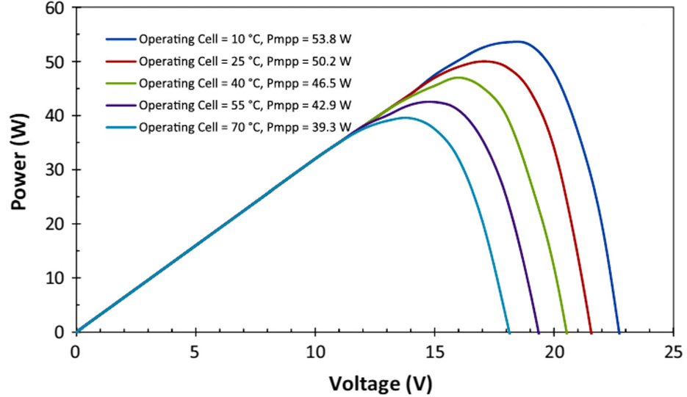
Figure 8: Power to voltage at different cell temperatures during operation, along with their corresponding maximum power point (MPP), for a solar PVT system (Krauter and Ochs, 2004).
Consequently, numerous researchers have investigated cooling strategies for PV modules to mitigate this effect. Water has been widely used as a cooling medium due to its high density and specific heat capacity, which are advantageous over air cooling (Baranwal and Singhal, 2021). Among the various designs studied, (Zondag et al., 2003) sheet-and-tube water collectors have demonstrated the most promising results for domestic hot water production. Comparative research by (Dubey and Tiwari, 2008) on fully- and partially covered PV modules found that partially covered flat plate water collectors achieved higher efficiency. (Ibrahim et al., 2009) explored various designs for water collectors and determined, through performance comparisons, that the spiral flow configuration was the most efficient. Additionally, studies by (Baranwal and Singhal, 2021) using computational fluid dynamics (CFD) simulations revealed that a spiral flow design with varying flow rates and heat fluxes (ranging from 30 L/h to 180 L/h and 600 W/m² to 1000 W/m², respectively) maximized the thermal and electrical efficiency of PVT systems.

Challenges in Photovoltaic (PV) Performance: Heat Regulation and Cooling Approaches
The performance of photovoltaic (PV) modules is significantly influenced by temperature, with higher cell temperatures reducing efficiency due to excess heat generation. This is primarily a result of the photovoltaic effect, where the energy absorbed by the cells is limited to a specific bandgap range (Hamzat et al., 2021). Photons with energy below this threshold cannot be utilized and instead contribute to heating the cells, particularly during periods of high solar radiation. As seen in Fig. 9, PV efficiency typically peaks in the morning when temperatures are lower, decreases towards midday, and recovers slightly by evening (Seng, 2010).
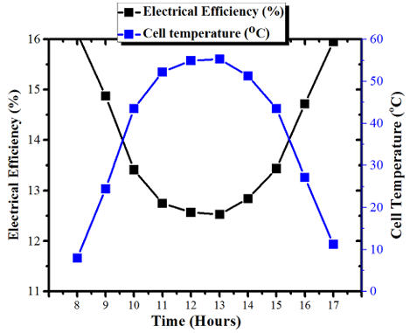
Figure 9: Thermal Behavior and Power Output Efficiency of the Solar Cells on a Summer Day (Tiwari and Gaur, 2014).
Various materials are used in the production of PV cells, including crystalline silicon-based cells like monocrystalline and polycrystalline, as well as thin-film technologies such as amorphous silicon (a-Si), tandem a-Si/microcrystalline, Copper Indium Gallium Selenide (CIGS), Cadmium Telluride (CdTe), and dye-sensitized (TiO2) cells. Table 2 shows the temperature coefficient, which measures the drop in power output per degree Celsius increase, varies across these materials (Adeeb et al., 2019).
Table 2: Efficiency of Photovoltaic Modules and Their Sensitivity to Temperature (Seng, 2010).
Cell Type | Temperature  Coefficient (%/⁰C) | Cell  Performance (%)
Mono-Crystalline | -0.4 to -0.5 | 12.5 – 15
Poly-Crystalline Silicon | -0.4 to -0.5 | 11 – 14
Amorphous-Si (a-Si) | -0.35 to -0.38 | 11 – 13
CdTe | -0.25 | 9 – 12
CIGS | -0.32 to -0.36 | 10 -13
Dye Sensitized (TiO₂) | -0.25 | 11 - 15

For instance, thin-film cells have thinner semiconductor layers (0.3–2 µm) and exhibit a lower temperature sensitivity, as demonstrated in a study by (Adeeb et al., 2019), where thin-film cells showed a temperature coefficient of 0.0984%, compared to 0.109% for monocrystalline and 0.124% for polycrystalline cells. Fig. 10 further illustrates the inverse relationship between surface temperature and power output in different PV panels.
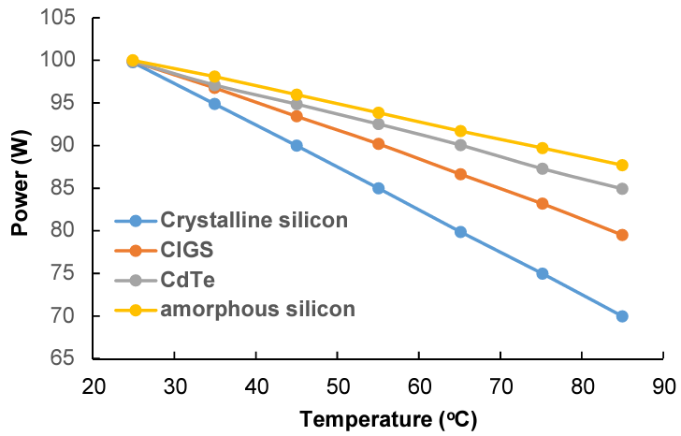
Figure 10: Increase in Temperature Relative to Power Output for Various Solar Panels (Hamzat et al., 2021).
A more advanced solution for optimizing the performance of PV modules is the Photovoltaic Thermal (PVT) system, which integrates PV cells with a thermal collector to simultaneously generate electrical and thermal energy. This combined system improves overall solar energy conversion per unit area compared to individual PV technologies. Cooling strategies for PVT systems are divided into passive and active approaches, based on heat dissipation mechanisms. The choice of heat transfer fluid (HTF) is critical for PVT performance, with air and water being the most common fluids. Over time, research has focused on optimizing these fluids to enhance system efficiency, with various designs, including air, water, dual-fluid systems, heat pipes, and phase change materials (PCMs), as shown in Fig. 11 (Samykano, 2023).
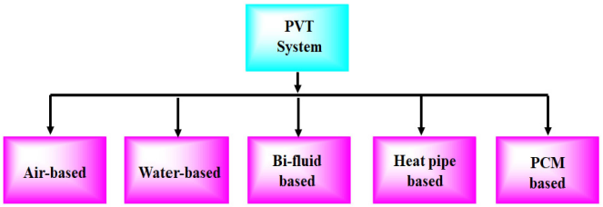
Figure 11: Classification of Photovoltaic Thermal (PVT) System Models (Samykano, 2023).

Photovoltaic Thermal PVT Air Powered Arrangement
Air-based PVT (Photovoltaic Thermal) systems, whether in single or double-pass configurations, enable air to flow across the photovoltaic surface either through natural convection or forced circulation, depending on the design. These systems are not only aimed at generating electricity but also at extracting heat from the PV panel to produce warm air (Ali, 2020). The designs include various components such as the PV panel, insulation, supportive frames, and sometimes transparent covers to facilitate airflow around the absorber plate. Air-based PVT systems are categorized into several types based on airflow design: the conventional or back-pass system, double-pass systems with air entering from above the PV panel, single-pass parallel systems, and single-pass systems with air flowing over the panel. Research has focused on improving these systems' design and operational efficiency, utilizing computational models to predict their performance as shown in Fig. 12 (Rukman et al., 2019).
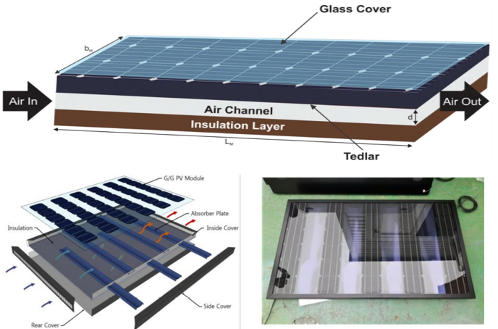
Figure 12: Photovoltaic Thermal Air-Model Description (Dwivedi et al., 2020).
For instance, a study by (Özakin and Kaya, 2019), which employed ANSYS Fluent software, and examined how panel temperature and airflow velocity impacted system performance. The study found that adding small, densely spaced fins could boost exergy output and thermal efficiency by up to 70% while also lowering PV module temperatures by 10% to 15%. Maintaining high air velocity, particularly during peak sunlight hours, is essential for optimal performance. While rotating air devices have been tested to enhance cooling, their effectiveness tends to vary with temperature changes (Li et al., 2022). Water-based PVT systems have been proposed as an alternative to enhance thermal control in such setups.

Photovoltaic Water-Driven Structure Energy Setup
Water serves as an efficient medium for cooling photovoltaic panels due to its widespread availability and superior heat transfer capabilities. However, for water-based cooling systems to operate effectively, the photovoltaic setup must be designed to resist corrosion and be well-sealed to prevent leakage (Hamzat et al., 2021). While water-cooled systems may incur higher costs compared to air-cooled alternatives, particularly in industrial applications, they offer the advantage of reducing the temperature of the photovoltaic panels and simultaneously facilitating heat extraction (Hasanuzzaman et al., 2016). Air-cooled photovoltaic thermal (PVT) systems generally show reduced thermal performance, especially in warmer climates. In contrast, water, with its superior thermal properties, significantly enhances the efficiency of PVT systems, whether through passive or active cooling approaches (Aste et al., 2016). By incorporating water-carrying pipes behind the photovoltaic panels, heat is efficiently transferred away from the panels, cooling them and generating warm water for various uses see Fig. 13. Typically, a standard water-based PVT system comprises an uncovered PVT collector, a storage tank, a water circulation system, and a pump, which together promote stratification, enhancing thermal efficiency and lowering the PV cell's operational temperatures (Brottier and Bennacer, 2020).
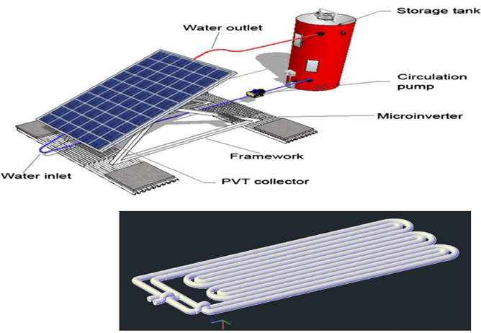
Figure 13: Photovoltaic Thermal Water Setup for Solar Model (Aste et al., 2016).
Studies have demonstrated that water-based PVT systems can safely reach temperatures up to 74.2°C, making them particularly suitable for preheating domestic water, with consistent long-term performance. For example, an 8 m² PVT system can heat a 300-litre tank, though the surface area required is approximately twice that of conventional thermal systems to achieve the same heating output. Additionally, tests using twin oscillating absorbers and copper piping showed a thermal efficiency of 59.6%, with higher flow rates further improving both electrical and thermal performance, underscoring the advantages of water-cooled PVT systems (Misha et al., 2020).

BI-Fluid Photovoltaic-Powered Structural Energy System
A limited number of studies have examined PV/T systems that utilize both air and water as working fluids, though these systems offer a multifaceted approach by generating heated air, warm water, and electricity simultaneously (Sathe and Dhoble, 2017). They feature integrated air and water heat exchangers, which reduce operational costs and material usage, though their efficiency in converting thermal energy into electricity is somewhat limited. Initial research indicated that PV/T systems using only air or water for thermal management underperformed. To address this, a dual-fluid PV/T system was developed to enhance overall efficiency by simultaneously producing electricity and heat for both air and water (Jarimi et al., 2016). This system, as depicted in Fig. 14, incorporates a photovoltaic layer, a coiled copper tube for water heating, and a separate channel for air heating. Upon testing, the system demonstrated notable performance, achieving thermal and electrical efficiencies as high as 76% under specific operational conditions (Noxpanco et al., 2020).
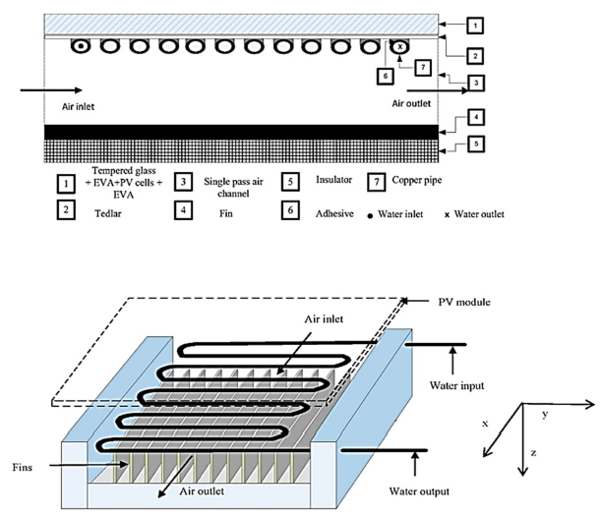
Figure 14: BI-Fluid Photovoltaic Thermal Experimental Structural Setup (Jarimi et al., 2016).

Energy Configuration of a Heat Pipe-Based Photovoltaic System
The heat generated in PV/T systems is efficiently transferred to a heat pump’s evaporator through a series of steps that enhance both thermal and electrical performance. Initially, the refrigerant in the system expands from a liquid to vapour directly within the PV panels' hydraulic system, where it undergoes compression, raising the temperature to enable heat transfer. Subsequently, the refrigerant condenses, transferring this heat to water, before passing through an expansion valve or capillary tube, reducing its pressure and converting it back to a liquid to re-enter the PV/T evaporator (Riaz et al., 2020). This mechanism, although more complex than conventional liquid cooling methods, significantly improves heat exchange (Noxpanco et al., 2020). In an advanced design as seen in Fig. 15, such as the PVT-HP system, a heat pipe transfers thermal energy between surfaces using a phase-changing working fluid. The working fluid evaporates due to pressure differences and external heat, while a condenser dissipates heat and a wick returns the fluid to the evaporator (Jouhara et al., 2017). An upgraded version, the PVT-LHP system, achieves enhanced performance with electrical, thermal, and overall efficiencies of 12.2%, 55.6%, and 67.8%, respectively. This system boasts a 28% higher efficiency and a coefficient of performance (COP) 2.2 times greater than standard technologies, demonstrating substantial improvements in energy utilization and system effectiveness (Samykano, 2023).
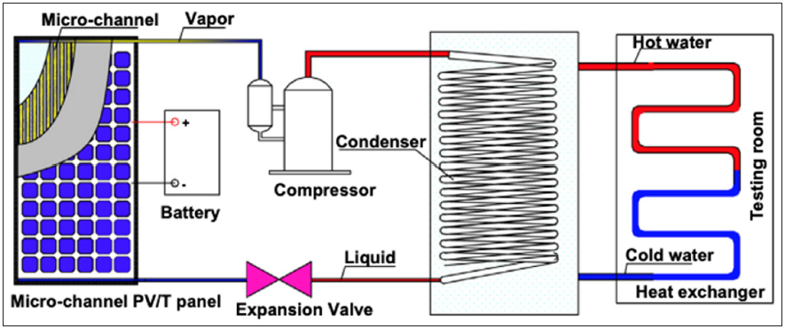
Figure 15: Solar-Enhanced Direct-Expansion Heat Pump System Utilizing an Innovative PV and Mini-Channel Evaporator (Zhou et al., 2020).

Photovoltaic System with Phase Change Material for Solar Energy Configuration
Phase Change Materials (PCMs) are substances that absorb or release thermal energy during a phase transition, typically from solid to liquid, within a defined temperature range, while maintaining a constant temperature throughout the process (Hall, 2010). In solar energy systems, particularly photovoltaic (PV) applications, PCMs have been used to regulate cell temperature, preventing overheating and thereby enhancing overall system efficiency. This regulation is especially crucial during the day when solar panels are exposed to direct sunlight, and PCMs help maintain the cells at near-ambient temperatures (Al-Waeli et al., 2020). Moreover, Thermal Energy Storage (TES) plays a significant role in managing energy demands, especially during the night. While batteries are a common method for storing excess daytime energy, PCMs have emerged as an alternative solution due to their ability to rapidly absorb and release energy (Nazir et al., 2019). PCMs offer numerous advantages, such as being cost-effective, safe, and available in a variety of phase transition temperature ranges. They are also instrumental in reducing the temperature of solar panels during the day and storing the absorbed heat to release it after sunset (Zhao et al., 2019). Techniques like adding nanoparticles or using encapsulation have been developed to enhance heat dissipation and extend the lifespan of PV systems. Studies have shown that PCM-integrated cooling setups, as seen in Fig. 16, significantly improve both cooling efficiency and electrical output. For instance, PCM-based cooling methods have been reported to boost system efficiency to 13.7%, compared to 7.1% for traditional PV systems (Naghdbishi et al., 2020). Thus, the incorporation of PCMs into photovoltaic-thermal (PVT) modules greatly enhances the performance by optimizing cooling processes and overall energy generation.
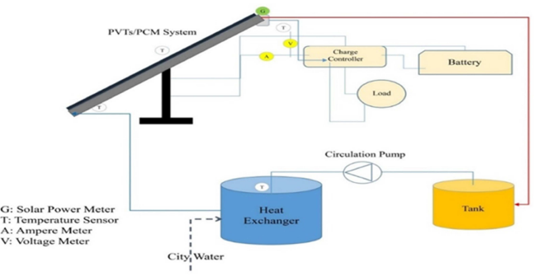
Figure 16: Configuration of a PCM-Enhanced Photovoltaic Thermal System (Naghdbishi et al., 2020).

PVT Cooling with Nanofluid Technologies
Nanofluids, which consist of nanoparticles such as metals, oxides, carbides, or carbon nanotubes dispersed within a liquid, are recognized for their superior thermal conductivity and enhanced heat transfer properties compared to traditional fluids. These unique thermophysical attributes make them particularly effective as cooling agents in photovoltaic thermal (PV/T) systems, where they contribute to improved thermal regulation and overall system efficiency (Saroha et al., 2015). A study conducted by (Karami and Rahimi, 2014) evaluated the cooling performance of Boehmite nanofluid in PV cells, using two-channel configurations: helical and straight. By measuring the electrical output and the average temperature reduction at different Boehmite nanofluid concentrations (0.01%, 0.1%, and 0.5 wt%), they demonstrated that nanofluids provide a more substantial reduction in PV cell temperatures compared to water. The helical channel configuration, achieving an electrical efficiency of around 37.67%, outperformed the straight channel, which reached approximately 20.57%. The study also highlighted that the cooling effectiveness varied with nanofluid concentration; for instance, the straight channel delivered the lowest cooling performance at 0.01%, while the helical channel showed reduced efficiency at a 0.5% concentration (Pinto and Fiorelli, 2016).

Summary of Photovoltaic-Thermal (PVT) Collector Systems Types
The study investigated various approaches to extracting heat from photovoltaic (PV) panels, focusing on different cooling fluids, channel designs for cooling, and techniques to enhance heat dissipation. Among these, water-cooled PVT systems are widely used to remove excess heat from the back of PV modules, offering benefits for both residential heating and industrial processes. However, their effectiveness is limited in colder regions due to the potential for water freezing. Several solutions, such as glazing, heat pipes, and phase change materials (PCMs), were carefully evaluated. Water-based PVT systems offer flexibility, catering to both water heating and industrial applications. On the other hand, air-based PVT systems exhibited lower thermal performance due to less efficient heat transfer. While water enhances the overall efficiency of these systems, it also introduces operational difficulties, particularly in freezing conditions and in systems dependent on passive cooling methods (Samykano, 2023).

Revised Design of a Photovoltaic-Thermal (PVT) Collector for Solar Panels
The study investigates a 'tube and sheet' Photovoltaic Thermal (PVT) system, evaluating various designs such as harp, direct flow, and fractal patterns, along with different fabrication techniques like sheet and tube, roll bonding, and the creation of rectangular channels (Barbu et al., 2021). The PVT system utilizes flat-plate collectors that integrate photovoltaic modules with solar thermal components. These collectors feature a photovoltaic layer above the absorber plate, along with a transparent glass cover, channels for the cooling fluid, and thermal insulation to enhance energy efficiency (Calise et al., 2012). Among the configurations, Fig. 17 of the sheet-and-tube design, frequently used, faces challenges in heat transfer due to the welding process, which adds thermal resistance.
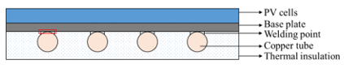
Figure 17: Design of a Shell and Tube Photovoltaic Collector Model (Yao et al., 2021).
A liquid-based heat exchanger was preferred over an air-based alternative because of its superior heat transfer capabilities, although it comes with higher complexity. This design allows for the preheating of household water, adding practical value (Yao et al., 2021). The direct flow channel configuration was chosen for its effectiveness and construction simplicity. The photovoltaic cells employed are mono-crystalline silicon, achieving 15% efficiency under Standard Test Conditions (STC), which include a reference temperature of 25°C, solar irradiance of 1000 W/m², and wind speed of 0 m/s. The cells have a temperature coefficient (βT) of -0.5%/K, as shown in Equ. 1, where Tc represents the cell temperature. The system employs a 30/70% glycol-water mixture as the collector fluid, which enhances heat transfer and provides freeze protection in colder climates (Aste et al., 2014).
Equation 1: Relationship between the Instantaneous Electrical Efficiency and Reference Electrical Efficiency (Barbu et al., 2021).
$$ηEL=ηSTC[1-βT\left(Tc-Tref\right)]$$
Heat transfer within the PVT system occurs through radiation, conduction, and convection. Radiation transfers heat without requiring direct contact and does not heat the medium through which it travels. Any object with a temperature above 0 K emits radiation. Conduction, driven by molecular activity, occurs when thermal energy moves through solids or between contact points, flowing from warmer to cooler areas. Convection, on the other hand, involves the transfer of heat in fluids or gases, with heat moving from hotter to cooler regions, either naturally or through external forces. These heat transfer mechanisms are illustrated in Fig. 18, where solar radiation impacts the glass cover, which reflects, absorbs, and transmits energy to the PV layer (Barbu et al., 2021).

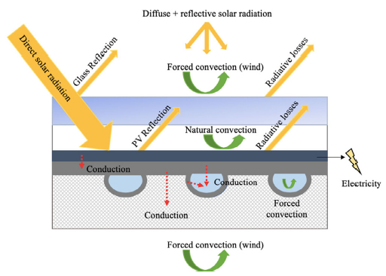
Figure 18: Thermal Exchange Mechanisms in Photovoltaic Panels (Radiation, Convection & Conduction) (Barbu et al., 2021).

Heat Absorbers and Combined Flow Channels in Heat Exchangers
Heat exchangers are crucial in managing the temperature of photovoltaic (PV) panel surfaces by dissipating excess heat, which enhances the efficiency and lifespan of the system. Various materials like stainless steel, aluminum, cast iron, copper, and bronze are used in heat exchanger construction, but copper is particularly suitable due to its high thermal conductivity, excellent heat resistance, and ability to prevent rust and corrosion (Hamzat et al., 2021). In a photovoltaic thermal (PVT) system, the thermal absorber plays a key role by channeling the heat from the PV module into a working fluid that circulates through embedded flow paths, functioning as a heat exchanger. These flow channels, located behind the absorber, significantly improve both the thermal and electrical performance by transferring heat away from the PV cells, which in turn boosts electrical efficiency (Nahar et al., 2017). Factors like material conductivity, thermal resistance, and design configuration greatly influence the heat transfer effectiveness between the PV cells, absorber, flow channels, and fluid. The method of coupling the absorber to the PV module—whether through mechanical bonding, chemical bonding, or EVA lamination—has a direct impact on the system’s thermal performance. Common absorber designs such as cylindrical tubes, flat-plate configurations, and rectangular tunnels can be further optimized with features like fins, grooves, or honeycomb patterns to improve heat transfer (Abdelrazik et al., 2018). Among these, roll-bond absorbers, known for their larger surface area and lower thermal resistance, offer better heat exchange efficiency compared to flat-plate tube absorbers.
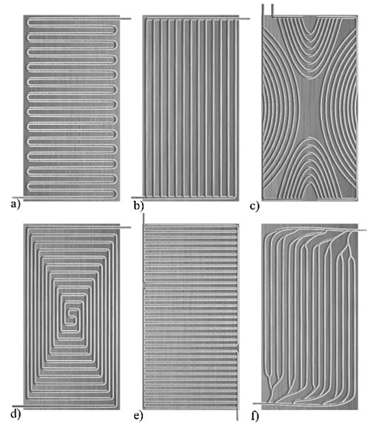
Figure 19: Flow Configurations in Flat-plate Absorbers: a) Sequential, b) Concurrent, c) Network, d) Helical, e) Hybrid Parallel-Sequential, and f) Biomimetic (Poredoš et al., 2020).
The design of the flow channels is critical for minimizing temperature and pressure losses across the absorber surface, with configurations like parallel, serial, spiral and hybrid systems being the most effective as seen in Fig. 19. However, increasing the number of flow channels can lead to challenges, such as pressure drops and water flow issues, as noted in experimental models aimed at maintaining uniform temperature control across PV panels through CFD analysis (Siddiqui et al., 2019).

Efficiency Evaluation and Calculations for Photovoltaic Collectors
The efficiency of a PVT system is evaluated by analyzing both its electrical and thermal performance, which are influenced by various factors, including the system's design features, the local climatic conditions, and the rate of water flow. The assessment is generally performed using the Hottel-Whillier model. Efficiency, in this context, pertains to the fraction of captured solar energy that is transformed into usable output. The combined efficiency of the PVT system accounts for both the electrical and thermal energy outputs, as illustrated in Equ. 2 (Abakam et al., 2019; Duffie and Beckman, 1980).

Equation 2: Comprehensive Efficiency of Photovoltaic-Thermal (PVT) Systems (Abakam et al., 2019; Duffie and Beckman, 1980).
$$η_{PVT}=η_{PV}+η_{TH}$$
Equ. 3 presents the solar collector's thermal efficiency (η_{th}) (Abakam et al., 2019).

Equation 3: Thermal Performance of Solar Collectors (Abakam et al., 2019).
$$η_{TH}=\frac{Q_{u}}{G}$$
In this scenario, G signifies the solar energy incident on the collector, expressed in watts per square meter (W/m²). Q_{u}, on the other hand, refers to the thermal energy successfully captured, also measured in watts per square meter (W/m²). Therefore, assessing the thermal efficiency of the system hinges on calculating the useful heat energy, Q_{u}, which is obtained using Equ. 4 (Abakam et al., 2019; Duffie and Beckman, 1980).

Equation 4: Harnessing Solar Radiation for Effective Energy Capture (Abakam et al., 2019; Duffie and Beckman, 1980).
$$Q_{u}=\dot{m}C_{p}(T_{o}-T_{i})$$
The parameters mˇ, C_{p}, T_{o}, and T stand for the mass flow rate (kg/s), the cooling fluid’s specific heat capacity (J/kg·K), the fluid’s outlet temperature (K), and its inlet temperature (K), respectively. The Hottel-Willier equations are utilized to calculate the useful energy yield, Q_{u}, for the PVT system, as demonstrated in Equ. 5 (Abakam et al., 2019).

Equation 5: Effective Energy Output of a Photovoltaic Thermal (PVT) System (Abakam et al., 2019).
$$Q_{u}=A_{C}F_{R}[S\left(τ_{α}\right)-U_{L}\left(T_{i}-T_{α}\right)]$$
The amount of useful energy, represented by Q_{u}, is influenced by multiple elements such as the area of the collector (A_{c}), the heat extraction efficiency factor (F_{R}), and the solar radiation incident on the surface (S). Other significant factors include transmissivity (τ), absorptivity (α), and thermal losses (U_{L}). Additionally, the fluid's inlet temperature (T_{i}) and the ambient environmental temperature (T_{a}) contribute to this outcome. The interaction of solar energy with these variables, shaped by processes like reflection, transmission, and absorption, is captured in Equ. 6 (Abakam et al., 2019).

Equation 6: Incoming Solar Energy (Abakam et al., 2019).
$$S=(τ_{α})G_{T}$$
In this scenario, G_{T} refers to the solar radiation, and (τα) represents the ability of the photovoltaic module to allow and capture light. This applies to a system with a single photovoltaic layer. On the other hand, for a two-layer transparent photovoltaic system with semi-transparent properties, the surface is considered opaque. Consequently, the transmission and absorption behaviour of the photovoltaic layer is governed by Equ. 7 (Duffie and Beckman, 1980).

Equation 7: Solar Transmission and Absorption in Photovoltaic Systems (Duffie and Beckman, 1980).
$${(τα)}_{Pv}=\left(τ_{α}\right)+(1-τ_{α})\frac{U_{t}}{U_{c-a}}$$
As indicated in Equ. 5 and reiterated in Equ. 8, the heat removal efficiency factor (F_{R}) plays a vital role in calculating both thermal efficiency and the amount of useful energy recovered (Duffie and Beckman, 1980).

Equation 8: Thermal Extraction Efficiency Factor (Duffie and Beckman, 1980).
$$F_{R}=\frac{\dot{m}C_{p}}{A_{C}U_{L}}\left[1-exp⁡\left(-\frac{A_{C}U_{L}F^{'}}{\dot{m}C_{p}}\right)\right]$$
The collector efficiency factor, denoted as F' and determined through Equ. 9, is used to represent the performance of the collector (Duffie and Beckman, 1980).

Equation 9: Collector Performance Efficiency Parameter (Abakam et al., 2019; Duffie and Beckman, 1980).
$$F^{'}=\frac{\frac{1}{U_{L}}}{W\left[\frac{1}{U_{L}[D+\left(W-D\right)F]}+\frac{1}{C_{b}}+\frac{1}{πD_{i}h_{fi}}\right]}$$
In this context, D represents the hydraulic diameter of the water tube (in meters), while W stands for the spacing between the water tubes (also measured in meters). The term F is used to signify the fin efficiency factor. The parameter C_{b} refers to the thermal conductance (in W/m²K) at the interface between the fin and the water tube. The heat transfer coefficient of the fluid, denoted by h_{fi}, is measured in W/m²K. The efficiency factor for the fin can be calculated using Equ. 10 (Abakam et al., 2019; Duffie and Beckman, 1980).
Equation 10: Fin Efficiency Factor (Abakam et al., 2019; Duffie and Beckman, 1980).

$$F=\frac{\tan{h}\left[\frac{m(W-D)}{2}\right]}{\frac{m(W-D)}{2}}$$
Where m is defined as follows from Equ. 10.
Equation 11: Absorber Material (Duffie and Beckman, 1980; Hasan and Sumathy, 2010).
$$m=\sqrt{\frac{U_{L}}{(K_{abs}L_{abs})×(K_{pv}L_{pv})}}$$
From Equ. 11 K represents the thermal conductivity of the absorber material (W/m²K), L_{abs} denotes the thickness of the absorber (m), K_{pv} signifies the thermal conductivity of the photovoltaic (W/m²K), and L_{pv} refers to the thickness of the PV collector. The thermal efficiency of the PVT system is determined by this relationship (Hasan and Sumathy, 2010).
Equation 12: Heat Conversion Efficiency of the PVT System (Calise et al., 2012).
$n_{th}=F_{R}{(τα)}_{pv}-F_{R}U_{L}\frac{T_{i}-T_{a}}{G_{T}}$
The electrical performance is determined using the following method in Equ. 12 (Calise et al., 2012).
Equation 13: Power Conversion Efficiency of the PVT System (Calise et al., 2012; Duffie and Beckman, 1980).
$$n_{e}=n_{ref}[1-β\left(T_{cell}-T_{ref}\right)]$$
Where η_{e} represents the electrical performance, η_{ref} is the benchmark efficiency of the semi-transparent photovoltaic (STPV) panel (with a reference value of η_{ref} = 0.12), β refers to the thermal sensitivity factor, T_{cell} is the operational temperature of the solar cell (measured in Kelvin), and T_{ref} denotes the standard reference temperature in Equ. 13 (Calise et al., 2012; Hasan and Sumathy, 2010).

Digital Modeling of the PVT System through CFD and Polysun Simulations

ANSYS Simulation Technique
Computational Fluid Dynamics (CFD) involves the use of advanced computational techniques and mathematical algorithms to simulate fluid behaviour, with an emphasis on heat, mass, and momentum transfer. Its application in solar energy systems has grown due to advancements in computational capabilities, which make CFD more advantageous compared to traditional experimental methods in Fig. 20. These developments enable more cost-effective design optimization by minimizing the need for physical testing. Moreover, CFD provides the flexibility to model complex, non-linear physical phenomena and simulate fluid dynamics over time. Although experimental research on photovoltaic (PV) systems is extensive, the application of CFD in this area is relatively underexplored. However, its role is expected to expand in addressing more complex PV challenges in the future (Abdelrazik et al., 2023).
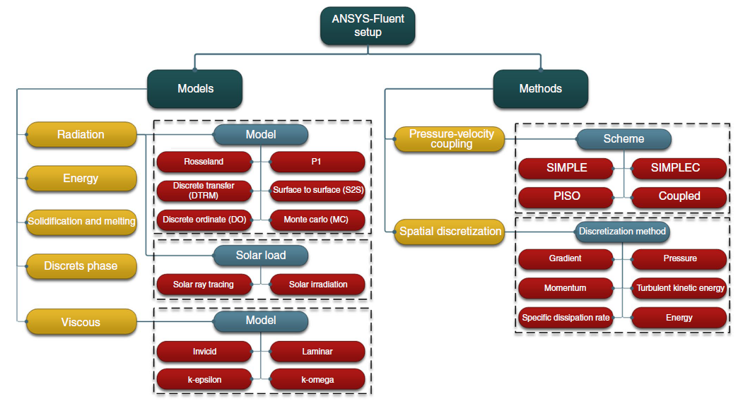
Figure 20: Comprehensive Overview of Frequently Applied Models and Techniques in ANSYS-Fluent Configurations (Abdelrazik et al., 2023).
ANSYS software serves as a comprehensive tool for simulating physical interactions such as heat exchange, fluid flow, and electromagnetic effects, allowing engineers to identify potential system weaknesses before physical prototypes are built. The process begins with geometric modelling, either through CAD or ANSYS Design Modeler, followed by the generation of a mesh, which is essential for ensuring a balance between accuracy and computational efficiency. ANSYS Meshing, equipped with advanced features from leading mesh generation tools, offers automated and reliable meshing capabilities (Khelifa et al., 2016). In Rangababu’s study, the impact of C_{u}O and Al₂O₃ nanofluids, as well as water, on heat transfer and entropy production in a solar flat plate collector (FPC) was analyzed as seen in Fig. 21. The study found that C_{u}O nanofluids increased the FPC's efficiency by 22% over water and by 8% over Al₂O₃ nanofluids. However, the study noted experimental and analytical errors of 20% and 30%, respectively, and concluded that entropy production rises with increased solar radiation (Rangababu and Kumar, 2015).
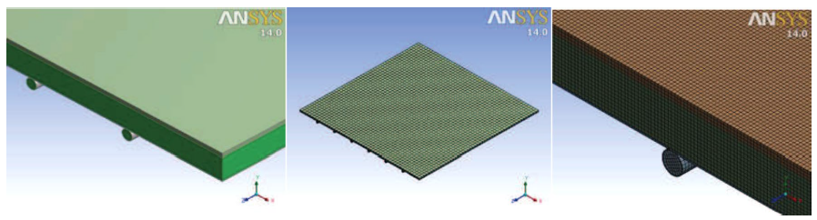
Figure 21: Geometry and Mesh Development in CFD Simulations (Rangababu and Kumar, 2015).

Polysun Energy Simulation System.
Polysun is an advanced simulation software designed to model a variety of energy systems, such as solar thermal, photovoltaic, hybrid configurations, heat pumps, and integrated energy solutions. Utilizing global meteorological data and accounting for shading effects, it provides highly accurate forecasts of energy yields. The software supports both Windows and Mac operating systems and is available in 13 languages. It allows users to modify existing system templates or create entirely customized configurations by incorporating various components, see Fig. 22 (Sanz et al., 2020).
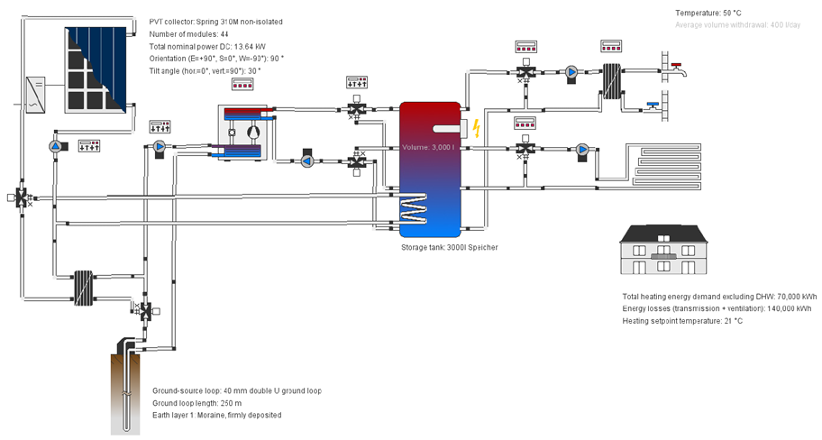
Figure 22: Simulation of a Photovoltaic Thermal (PVT) System on Polysun Platform (Sanz et al., 2020).
Polysun is especially valuable for process heat applications, offering the flexibility to fine-tune specific component parameters. Its extensive library of templates caters to residential, commercial, and industrial systems, including multi-unit buildings and co-generation or combined heat and power (CHP) models. While Polysun also facilitates economic assessments, it is primarily designed to optimize solar thermal heating systems and rooftop photovoltaic setups. In some cases, supplementary financial evaluations may be necessary for a more comprehensive analysis beyond what the software offers (Sanz et al., 2020).

Economics of Levelized Cost of Energy (LCOE) Analysis for PVT Systems
The Levelized Cost of Electricity (LCOE) is a fundamental metric for comparing and evaluating various power generation technologies. It considers multiple aspects such as project size, capital investment, operational duration, expected returns, associated risks, and energy capacity (Lai and McCulloch, 2017). Essentially, LCOE provides an economic assessment of the total costs needed to construct and operate a power generation facility throughout its entire lifecycle, divided by the cumulative energy output over that period. LCOE also represents the minimum price electricity must be sold at to cover all project costs and break even over its operational lifetime. This concept is captured in Equ. 14 through a general formula, which expresses the system's lifecycle costs relative to total energy output (Darling et al., 2011).
Equation 14: Levelized Cost of Electricity (LCOE) General Equation (Jakob, 2012).
$$LCOE=\frac{LifeCycle Cost (\$)}{Lifetime Energy Production \left(\frac{Kw}{h}\right)}$$
A discounted cash flow analysis, using the LCOE method, is typically performed to achieve a Net Present Value (NPV) of zero. Under this method, the present value of total costs is determined by multiplying LCOE by the annual energy production (Eₜ), and this is shown in Equ. 15. The variable "Costs_{t}" encompasses the total discounted costs, which includes initial capital expenditure (I₀), ongoing operational (Oₜ), and maintenance (Mₜ) expenses, all measured from the project's inception over its lifespan (Hernández-Moro and Martinez-Duart, 2013). The denominator in this calculation represents the discounted energy output for the same timeframe, excluding the initial investment from the summation of costs in "Costs_{t}" due to its occurrence at the start of the project.
Equation 15: Annual Energy Generated (E_{t}) Through LCOE (Babu and Ponnambalam, 2021).
$$\sum_{t=0}^{T}{\frac{({LCOE}_{t})×(E_{t})}{({1+r)}^{t}}=\sum_{t=0}^{T}{\frac{({Costs}_{t})}{({1+r)}^{t}}}}$$
Additionally, energy production in the first year is zero, and the gradual decrease in energy output over time is accounted for in the formula. The relevant formula for LCOE is given in Equ. 16, with parameters defined as follows: I₀ denotes the initial capital expenditure in dollars per kilowatt ($/kW); Oₜ refers to the annual operational costs in $/kW/year; Mₜ represents yearly maintenance costs in $/kW/year; Eₜ is the annual energy output in kilowatt-hours per year (kWh/year); T stands for the project lifespan, typically measured in years; r is the discount rate expressed as a percentage (%); and d indicates the depreciation rate, also in percentage (%) (Babu and Ponnambalam, 2021).
Equation 16: General Formula for Levelized Cost of Energy (LCOE) (Hernández-Moro and Martinez-Duart, 2013).
$$LCOE=\frac{I_{o}+\sum_{t=0}^{T}{(O_{t}+M_{t})/({1+r)}^{t}}}{\sum_{t=0}^{T}{E_{t}/({1+r)}^{t}}}$$
In addition, household energy consumption patterns and available technology play a critical role in determining the feasibility of installing photovoltaic-thermal (PVT) systems. Conducting a life-cycle analysis is crucial in understanding the potential economic advantages of these systems, making it an indispensable tool for evaluating competing technologies and guiding investment decisions. For instance, (Cui et al., 2020) examined the life-cycle costs of a PVT system integrated with a heat pump, using Monte Carlo simulations to manage uncertainties and risks in their economic analysis. Their financial assessment considered initial investment, energy expenses, loan repayments, maintenance, ongoing operational costs, tax incentives, and the present value of returns. These factors were examined under both the feed-in tariff (FiT) and renewable heat incentive programs. However, with the FiT scheme now replaced by the UK government’s Smart Export Guarantee (SEG), consumers can sell excess electricity back to the grid at either fixed or variable rates. According to Fig. 23, while the FiT scheme offered better payback periods and energy savings, the SEG is expected to play a significant role in the future of the solar energy market following the discontinuation of FiT in the UK (Bandaru et al., 2021).
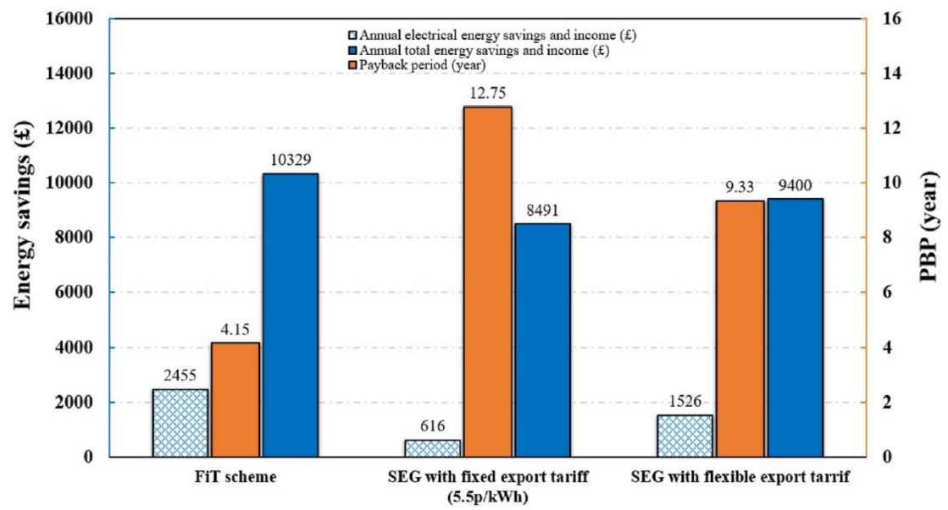
Figure 23: Fluctuation of Net Present Value (NPV) concerning the Payback Period (PBP) (Cui et al., 2020).

Unexplored Gaps Areas in Existing Research
Despite significant research advancements in photovoltaic thermal (PVT) systems, key areas require further exploration, which this project addresses:
- Limited Virtual Design Approaches: PVT studies have primarily focused on experimental setups, with virtual design and simulation underutilized. Computational methods, including CFD and Polysun, are not yet fully leveraged to understand PVT performance in various environmental conditions. For instance, Fig. 20 highlights that the application of CFD to model PVT thermal characteristics is still emerging. This project will use these tools for in-depth performance evaluations, offering scalable, cost-effective solutions for optimizing PVT systems.
- Inadequate Economic Analysis: The financial viability of PVT systems, particularly through metrics like Levelized Cost of Energy (LCOE), has not been sufficiently explored. Fig. 23 indicates some cost analysis, but a more comprehensive study is needed. This project will conduct a detailed LCOE analysis, employing Equ. 16, to assess the economic feasibility of PVT systems compared to conventional PV and thermal setups, addressing real-world application needs for cost efficiency.
- Suboptimal Cooling Techniques for Diverse Climates: While water and air-based cooling methods have been tested, their performance across different climatic conditions remains under-optimized. As shown in Table 2, temperature significantly affects PV technology efficiency, but further exploration of cooling methods under varied climates is necessary. This project will use CFD simulations, as demonstrated in Fig. 21, to optimize water, air, and nanofluid-based cooling designs across diverse climates.
- Underdeveloped Integration of Novel Materials: Nanofluids and phase-change materials (PCMs) hold promise for PVT systems, but their application is still in its early stages. While Fig. 16 shows the potential of PCMs for maintaining optimal PV temperatures, their integration into PVT systems remains underdeveloped. This project will investigate nanofluids for enhanced thermal and electrical performance, pushing forward research in this area.
- Hybrid Cooling Techniques Innovation: Hybrid cooling methods, such as combining water and air, have been underexplored. Most systems focus on single-fluid cooling strategies, yet Fig. 14 demonstrates the potential of dual-fluid systems for improved efficiency. This project will simulate and compare dual-fluid systems with single-fluid counterparts to enhance PVT performance and establish multi-functional cooling designs.
- Insufficient Comparative Simulation Techniques: Current studies often rely on a single simulation tool, limiting the comprehensiveness of performance evaluations. Fig. 22 exemplifies the use of Polysun, but this project will bridge the gap by cross-verifying results using both CFD and Polysun simulations. This approach will ensure robust and reliable performance characterization of the proposed PVT systems.
By addressing these gaps, the project aims to advance PVT system design and optimization, making them more economically viable and efficient across diverse conditions.

METHODOLOGY
The methodology of this research focuses on examining the effects of temperature on photovoltaic (PV) cell efficiency while developing and simulating a hybrid photovoltaic-thermal (PVT) system capable of generating both thermal and electrical energy. A combined experimental and simulation-based approach is employed, prioritizing the thermal management of PV cells, designing an effective PVT system, and conducting virtual development using advanced computational tools. To model and assess the system’s thermal and electrical performance, two key simulation platforms—CFD and Polysun—are utilized, enabling comprehensive evaluation and optimization of the PVT system design.

Creation and Evolution of the Conceptual Design of the Photovoltaic Thermal System
Crystalline-silicon (c-Si) photovoltaic (PV) modules are constructed in a traditional design, where c-Si wafers are arranged in series to form a string of cells. Electrical connections are established through a contact grid made of silver on both sides of the cells, which is soldered with a lead-tin alloy using copper busbars (Padoan et al., 2019). These cells are sandwiched between two clear polymer sheets, often made of ethylene-vinyl acetate (EVA), with low-iron glass covering the top for better optical transparency and a multi-layer polymer back sheet, usually polyethene terephthalate (PET) or polyvinyl fluoride (PVF), on the rear to provide insulation and UV protection. For improved durability and sealing, a second glass layer can be used instead of the back sheet. The encapsulation process offers both mechanical stability and optical clarity, while the edges of the module are sealed with an adhesive, and an aluminium frame adds structural support, although glass-glass modules may not require this frame (Heath et al., 2020). A junction box connects the internal cell strings to externally insulated cables as refer in Fig. 24.
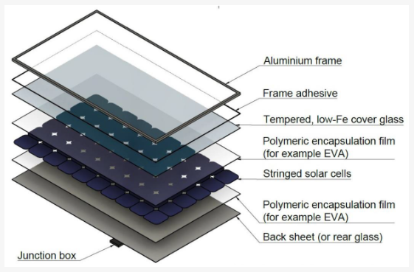
Figure 24: Composition of Traditional Crystalline Silicon Photovoltaic Panels (Schnatmann et al., 2022).
In a typical manufacturing process, the glass top layer is protected by EVA, which is applied in two layers—one beneath the cells and the other on the back. The low-iron glass ensures maximum clarity, and PET or an equivalent material acts as an insulating layer. The setup is heated in a vacuum chamber, such as a laminator or autoclave, at around 145°C for 10 minutes to polymerize the EVA. This vacuum ensures that the EVA spreads uniformly, compressing to a thickness of about 10-20 μm and fully encapsulating the cells to withstand harsh environments (Pavlovic et al., 2021; Schnatmann et al., 2022). In some cases, ethylene tetrafluoroethylene (ETFE) is used as the front layer instead of glass to reduce weight, improve transparency, and add flexibility. ETFE, enriched with fluorine atoms, is lightweight (just 2% of the weight of glass), self-cleaning, highly durable, and resistant to corrosion, high temperatures, and weathering. Its molecular structure also allows efficient light transmission with minimal reflection. Furthermore, ETFE provides excellent electrical insulation as seen in Fig. 24. Minor adjustments in the manufacturing process, such as using a laboratory autoclave instead of a laminator, can accommodate the use of ETFE(Pavlovic et al., 2021).

Photovoltaic PV Panel Materials
- Carbon Fiber Reinforced Polymer (CFRP): Carbon fiber reinforced polymer (CFRP) is gaining popularity in solar PV design due to its lightweight and strong mechanical properties, such as high tensile strength and stiffness. It reduces panel weight, making it ideal for rooftop installations with limited load capacity. Additionally, CFRP is resistant to corrosion and durable in various environments, ensuring long-term reliability. However, its high production cost limits its broader adoption in large-scale solar module manufacturing (Green, 2000).
- TAPE: Adhesive tapes are often used in solar PV module design as an alternative to liquid adhesives, providing uniform thickness, strong adhesion, and simplifying the manufacturing process. These tapes offer excellent UV resistance, water sealing, and electrical insulation, ensuring long-term durability. Specifically designed for PV applications, they can withstand high temperatures and environmental stresses, reducing the risk of delamination, a common failure mechanism in PV modules (Ali, 2020).
- Polyethene Terephthalate (PET): This is commonly used as a back sheet material in crystalline silicon photovoltaic (PV) modules, offering electrical insulation, mechanical protection, and environmental resistance. It is affordable, thermally stable, and flexible, but susceptible to hydrolysis in humid conditions, weakening its mechanical strength over time. Improved PET formulations and coatings have enhanced durability, and in some cases, PET is combined with additional layers like polyvinyl fluoride (PVF) for greater UV and moisture resistance (Schnatmann et al., 2022).
- Monocrystalline Silicon Solar Cells: This is the leading material in solar cell technology, known for its exceptional crystalline arrangement, which enhances electron movement and optimizes light capture. These cells boast efficiency rates between 22% and 24%, positioning them as a top choice for high-efficiency photovoltaic systems. Moreover, innovations in production techniques have lowered the cost of manufacturing monocrystalline wafers, facilitating their broader use in large-scale applications. Despite this, the energy required to produce mono-Si cells is significantly higher than that for polycrystalline alternatives, prompting ongoing efforts to enhance the sustainability of their manufacturing processes (Pavlovic et al., 2021).
- Ethylene-vinyl acetate (EVA): EVA is the primary encapsulant in photovoltaic modules due to its transparency, adhesive properties, and ability to protect solar cells from mechanical and environmental stress. It cushions the cells during lamination, ensuring a secure seal. However, UV exposure degrades EVA, reducing transparency. Recent innovations in UV-stabilized EVA formulations aim to improve durability and maintain solar module efficiency (Pavlovic et al., 2021).
- Ethylene Tetrafluoroethylene (EFTE): ETFE, a lightweight fluoropolymer, is increasingly favored for solar PV modules where flexibility and durability are crucial. It offers superior light transmission and self-cleaning properties, maintaining efficiency in dusty environments. Weighing just 2% glass, ETFE is ideal for flexible solar panels and can endure extreme weather. Its strong chemical resistance and electrical insulation further improve the durability and performance of PV modules in challenging conditions (Heath et al., 2020).
- FRAME: The frame of a photovoltaic (PV) module, typically made of aluminum, provides mechanical support and protects against damage. Aluminum is favored for its lightweight, corrosion resistance, and ease of manufacturing. However, some glass-glass modules are frameless, offering better durability at a higher cost. Research into materials like carbon fiber-reinforced polymer (CFRP) aims to reduce PV system weight while maintaining strength (Schnatmann et al., 2022).

Creation and Optimization of Photovoltaic Systems with SOLIDWORKS CAD Tool

Design of Photovoltaic Model
A conceptual model of the PVT system was created using SOLIDWORKS CAD software to visualize the system's configuration. The design incorporates a cooling mechanism beneath the photovoltaic cells, which helps dissipate excess heat, thereby lowering the operating temperature and improving overall efficiency. Specific design characteristics of the PV module are listed in Table 3.
Table 3: Mechanical and Thermal Characteristics of Photovoltaic Components (Pavlovic et al., 2021).
Material | Function | Layer | Thickness (mm) | Thermal  Conductivity (W/m.K) | Specific Heat Capacity  (J/Kg.K) | Density (Kg/m³)
ETFE | Front sheet | 1st | 0.28 | 0.24 | 1172 | 1730
EVA | Encapsulant | 2nd | 0.2 | 0.35 | 2090 | 945
Silicon | Solar Cell | 3rd | 0.15 | 148 | 700 | 2330
EVA | Encapsulant | 4th | 0.2 | 0.35 | 2090 | 945
PET | Back Sheet | 5th | 0.2 | 0.275 | 1275 | 1350
Tape | Adhesive | 6th | 0.13 | 0.19 | 2000 | 1012
CFRP | Support | 7th | 2 | 6.83 | 1130 | 1490

The technical details of the monocrystalline silicon PV cell used in this model are outlined in Table 4, while Fig. 25 showcases a 3D CAD model of the front side of the PV module, also developed in SOLIDWORKS.
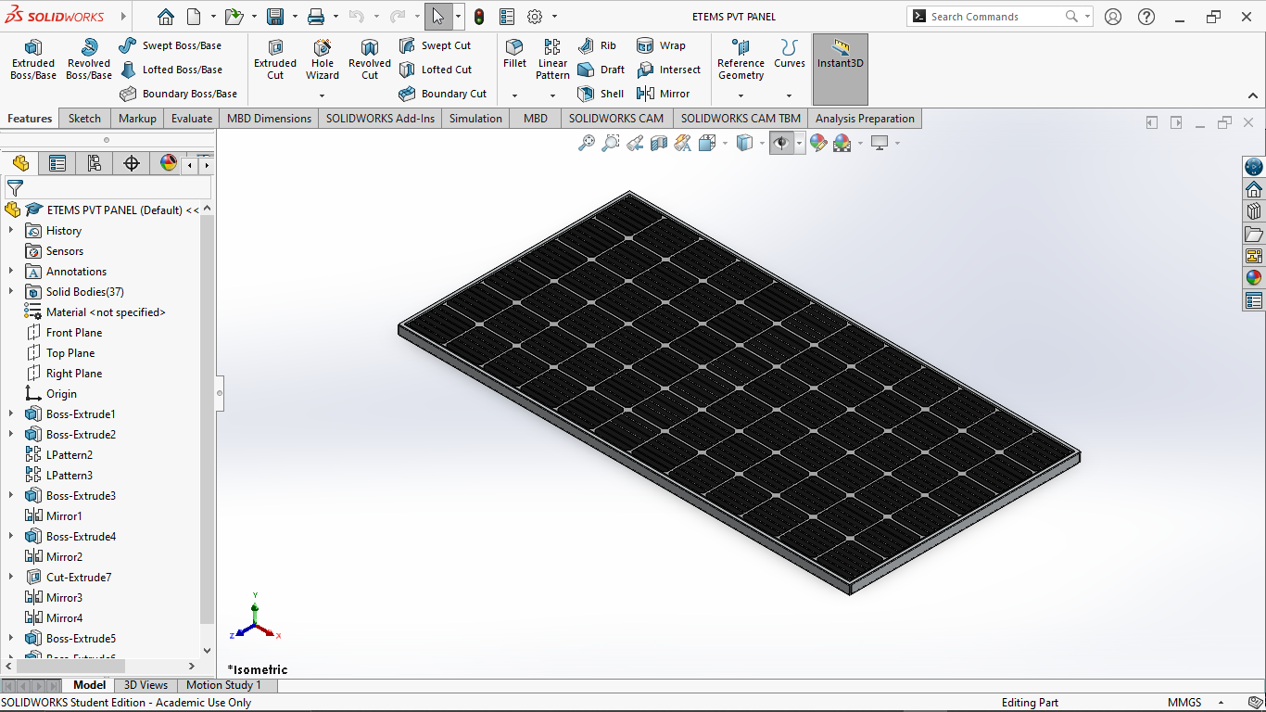
Figure 25: Front Surface Design of the Photovoltaic Model (SOLIDWORKS, 2023).
A detailed technical drawing of the front face, providing exact dimensions, is presented in the same Fig. 26.
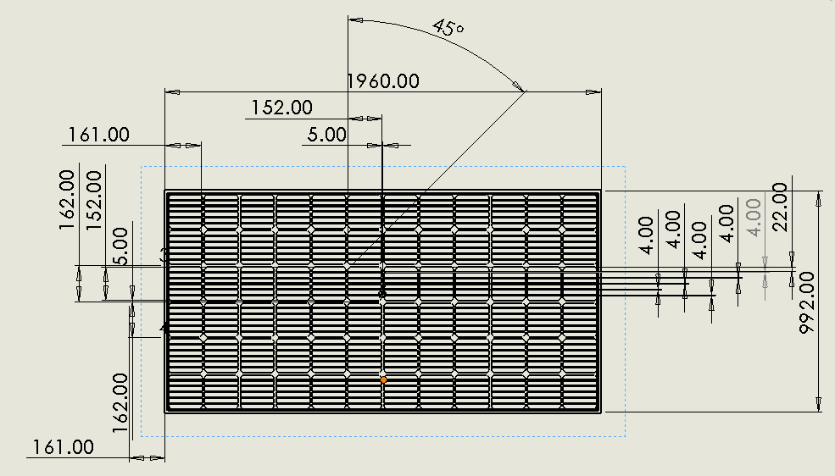
Figure 26: Engineering Diagram of the Front Face of the Photovoltaic Model Design (SOLIDWORKS, 2023).
The reverse side of the PV module is illustrated through the 3D model in Fig. 27, with Fig. 28 providing the technical drawing for the back face. Utilizing SOLIDWORKS for CAD modeling ensures both accurate visual representation and dimensional precision, which are crucial for performance evaluation and system integration.

Figure 27: Backside Configuration of the Photovoltaic Structure (SOLIDWORKS, 2023).
These technical drawings are also vital for ensuring geometric alignment and precision during assembly, factors essential for optimizing the module’s structural integrity and operational performance.
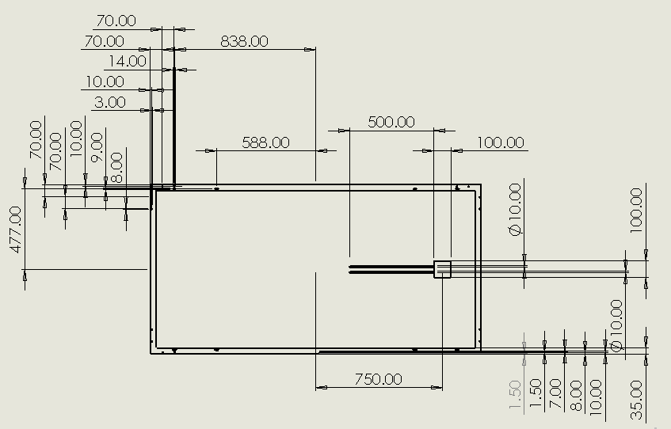
Figure 28: Technical Schematic of the Rear Side of the Photovoltaic System Layout (SOLIDWORKS, 2023).
This method aligns with standard practices in photovoltaic design, where CAD models and technical drawings are extensively used to validate physical dimensions and assess manufacturability. The inclusion of monocrystalline silicon cells, recognized for their high efficiency and durability, highlights the design's focus on both technical resilience and the energy output of the PV system.

Table 4: Key Parameters in Photovoltaic System Design (SOLIDWORKS, 2023).
PHOTOVOLTAIC DESIGN MODEL PARAMETERS
Feature/Position | Dimension (mm) |  | Feature/Position | Dimension (mm)
Overall Panel |  |  | Diagonal Angle Features
Total Width | 1960 |  | Diagonal Angle | 45 degrees
Total Height | 992 |  | Diagonal Angle | 45 degrees
Left Side Features |  |  | Bottom & Top Side Feature
Left side edge clearance | 161 |  | Total horizontal length | 750
Left Vertical Spacing | 162 |  | Horizontal feature | 588
Right Side Features |  |  | Frame Dimension
Right side extension | 4 |  | Total Height | 477
Final Small extension | 22 |  | Total width | 838

Configuration of a Solar Thermal Integrated Heat Exchanger Systems
Incorporating a solar thermal heat exchanger into photovoltaic (PV) modules in Fig. 27 represents a forward-thinking method aimed at boosting the system’s overall energy output. By removing surplus heat from the PV cells and transforming it into usable thermal energy, hybrid photovoltaic-thermal (PVT) systems can generate both electricity and heat concurrently. The heat exchangers are often constructed from materials such as copper or aluminum, selected for their superior thermal conductivity properties. Additionally, polymers and other modern materials are being investigated as cost-effective alternatives with the potential to enhance heat transfer efficiency (Zondag et al., 2003). This integration is especially beneficial in residential and industrial settings where both power and heat are in demand, resulting in greater energy productivity. The integrated solar thermal heat exchanger was designed and assembled using SOLIDWORKS CAD software, as depicted in Fig. 29.
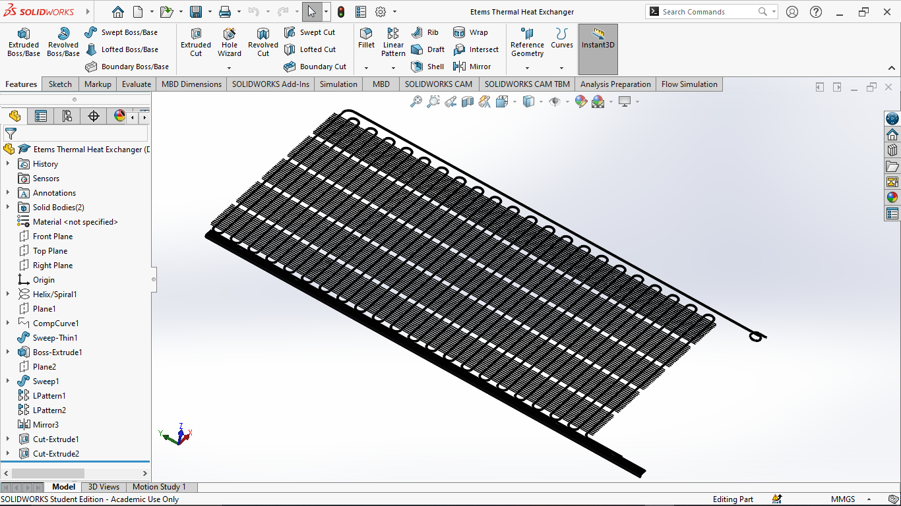
Figure 29: Integrated Heat Exchanger (SOLIDWORKS, 2023).

Construction of Photovoltaic and Solar Thermal Combined Heat Exchanger
The combination of photovoltaic (PV) technology with solar thermal systems involves creating a setup that can simultaneously produce electricity and capture thermal energy from sunlight.
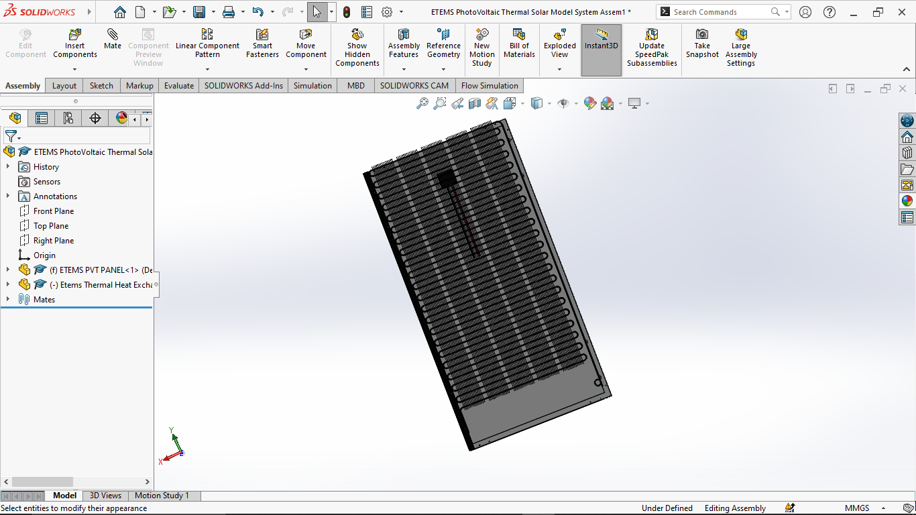
Figure 30: Rear Design of the Photovoltaic Thermal (PVT) System (SOLIDWORKS, 2023).
This dual-function heat exchanger is engineered to maximize solar energy collection, enabling both power generation and heat utilization. By integrating these systems, as illustrated in Fig. 30, overall efficiency is enhanced, allowing thermal energy to be used for tasks such as heating water, while the PV cells convert solar radiation into electrical energy. This configuration was modelled using SOLIDWORKS CAD software, particularly utilizing the assembly session's mate features, as depicted in Fig. 31.
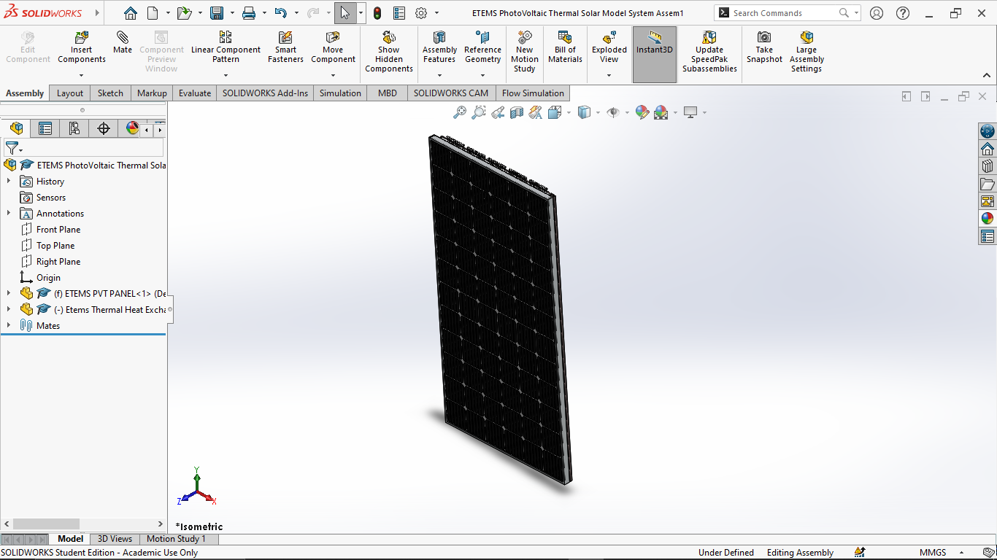
Figure 31: Design of the Front Layer in Photovoltaic Thermal (PVT) Module (SOLIDWORKS, 2023).

Virtual Simulation of PVT using CFD (ANSYS)
This part presents the simulations conducted using the ANSYS-Fluent computational fluid dynamics (CFD) modeling approach. Two separate simulation cases were explored: one focused on the heat exchanger incorporated within the solar thermal system, and the other targeted the photovoltaic (PV) setup. Additionally, a brief overview of the geometric design, physical modeling, and solution strategies employed in the CFD examination of the PV system is included.

Description Overview of Photovoltaic System Model
For the modeling and simulation process, ANSYS software (version 23.0) was utilized, with Design Modeler used to generate the geometry, as depicted in Fig. 32.
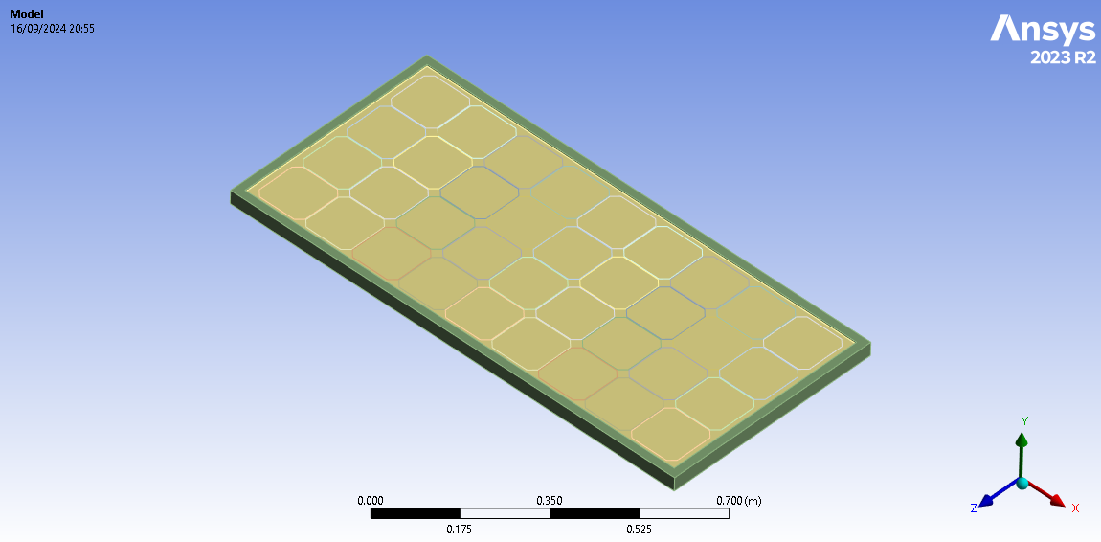
Figure 32: Solar Panel ANSYS Geometry (ANSYS, 2023).

The simulations concentrated exclusively on the layers of the PV cells, which include materials like ETFE, EVA, monocrystalline silicon, PET, adhesive tape, and CFRP. Each of these layers was assumed to have uniform thermal characteristics throughout. Table 3 outlines the specific thermal and physical attributes of these layers, including their thickness, thermal conductivity, density, and heat capacity.

Meshing Grid Generation for Geometrical Structures
Meshing involves breaking down a geometric model into smaller components and nodes to distribute loads more evenly across the structure. Increasing the number of components and nodes reduces the size of individual elements, which enhances precision in analysis, though it also increases computation time. Conversely, using too few elements can lead to inaccurate results. Structured mesh components are particularly advantageous near walls, where they improve the resolution of boundary layers and temperature gradients, with sizing functions concentrating nodes densely in those areas. This is especially important for natural convection within the boundary layers (Khelifa et al., 2016). However, unstructured mesh elements in these regions may cause high skewness in corners or where the geometry shifts, necessitating more cells to maintain similar mesh quality. In ANSYS, various meshing techniques are employed, such as tetrahedrons, which use triangular elements; hex dominant, focusing on hexahedral elements; sweep, using high-quality quadrilateral elements; and multizone, applied for complex bodies where conventional methods fall short (Saud T. Al Jadir, 2023).
Table 5: Average Value of Skewness (Saud T. Al Jadir, 2023).
Skewness value | Cell quality
1 | Degenerate
0.9 - 1 | Bad (silver)
0.75 - 0.9 | Poor
0.5 - 0.75 | Fair
0.25 - 0.5 | Good
0 - 0.25 | Excellent
0 | Equilateral

Two key criteria used to evaluate mesh quality are skewness and orthogonal quality. Skewness measures how closely a mesh element aligns with an ideal shape as illustrated in Table 5, while orthogonality, rated on a scale from 0 to 1, indicates mesh integrity, with 1 being optimal.
Table 6: Configuration parameters for the geometry and meshing of photovoltaic modules in ANSYS (ANSYS, 2023).
GEOMETRY & MESHING
Bounding Box |  | Skewness
Length X | 1.193m | Min | 1.31E-10
Length Y | 3.5e-002m | Max | 0.61722
Length Z | 0.558m | Average | 1.25E-02
Properties
Volume | 4.2724e-003m
Mass | 9.1606Kg

The mesh generated for the model using ANSYS contained 578,782 nodes and 90,728 elements, with the highest skewness value of 0.61722, ideal for tetrahedral meshes. The smallest mesh size was 1.3057e-010 mm, and the average mesh size around the PV cells was 1.2502e-002 mm, with automatic mesh defeaturing applied. All other parameters remained at default, as shown in Table 6, and Fig. 33 illustrates the final mesh structure.
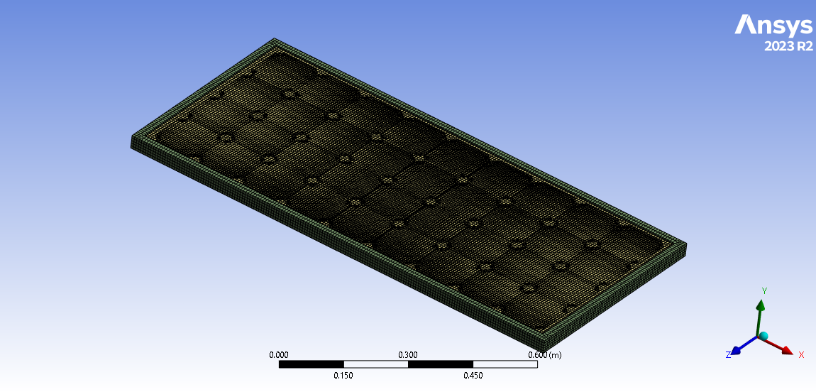
Figure 33: Mesh Geometry of the Solar PV Module (ANSYS, 2023).

Setting Boundary Condition Constraints and Presumptions
ANSYS FLUENT was utilized to simulate the thermal behaviour of the model, emphasizing temperature distribution and thermal radiation across the photovoltaic (PV) layers under steady-state conditions as shown in Table 7.

Table 7: Boundary Condition Analysis for Solar PV Module Using ANSYS Software (ANSYS, 2023).
STEADY-STATE THERMAL SOLUTION
Radiosity Control |  | Convection  Temperature 25°C |  |  | Radiation ETFE & CFRP |  | Heat Flux Load
Flux Convergence | 1.00E-04 | ETFE | 7.9475W/m²°C |  | Emissivity | 0.89 | ETFE | 100W/m²
Maximum Iteration | 1000 | CFRP | 7.9543W/m²°C |  | Ambient Temperature | 25°C | EVA | 25W/m²
Solver Tolerance | 0.1W/m² |  |  |  |  |  | Silicon Cell | 673W/m²
RESULTS TEMPERATURES °C
Minimum | 34.527 | 34.376 | 46.743 | 44.156 | 44.227 | 44.243 | 44.217 | -398.21
Maximum | 53.126 | 53.252 | 53.255 | 53.252 | 53.036 | 52.748 | 52.469 | -90.836
Average | 50.7 | 50.906 | 51.85 | 51.333 | 51.111 | 50.864 | 50.688 | -355.33
Layers | ETFE | EVA | Silicon  Cell | EVA | PET | TAPE | CFRP | Directional  Heat Flux  CFRP W/m²

Table 8: Assumed Solar PV module system (Saud T. Al Jadir, 2023).
Photovoltaic Model
Rated Maximum Power | 70W | Standard Testing Condition (STC)
Maximum System Voltage | 715W | Ambient Temperature | 25°C
Rated Voltage | 17.64V | Q_{solar} | 1000W/m²
Rated Current | 3.97A | Q_{generated} | 70W
Opened Circuit Voltage | 21.42V
Short Circuit Current | 4.48A

The simulation parameters were based on standard test conditions (STC), with a temperature of 25°C and solar irradiance (q_{solar}) of 1000 W/m², as outlined in Table 8 and Table 9.
Table 9: Solar Characteristics of Layers Used in Photovoltaic Modules (Wodołażski et al., 2021).
Material | Absorptivity | Transmissivity | Reflectivity
ETFE | 0.1 | 0.83 | 0.07
EVA | 0 | 1 | 0
Silicon Cell | 0.97 | 0 | 0.03

During the simulation, convection played a critical role in influencing heat transfer. The heat flux on the PV panel was derived from absorptivity (0.1 × 1000 W/m² = 100 W/m²), reflectivity (0.07 × 1000 W/m² = 70 W/m²), and transmissivity (0.83 × 1000 W/m² = 830 W/m²). The surface area of the monocrystalline silicon cell was calculated as 0.014679 m², with a total of 36 cells contributing to a combined surface area of 0.52848 W/m². From this, the heat flux reflected from the silicon cells back to the ethylene vinyl acetate (EVA) layer was found to be 25 W/m², based on 0.03 × 830 W/m². The power generated (70 W) was divided by the surface area (0.52848 W/m²), resulting in a heat flux of 132.45 W/m². This led to a net transmitted heat flux of 805 W/m² from the EVA layer to the monocrystalline cell. Accounting for heat reflection, the final net heat flux on the monocrystalline panel was determined to be 672.5 W/m², which was used as a boundary condition in the photovoltaic model illustrated in Fig. 34.
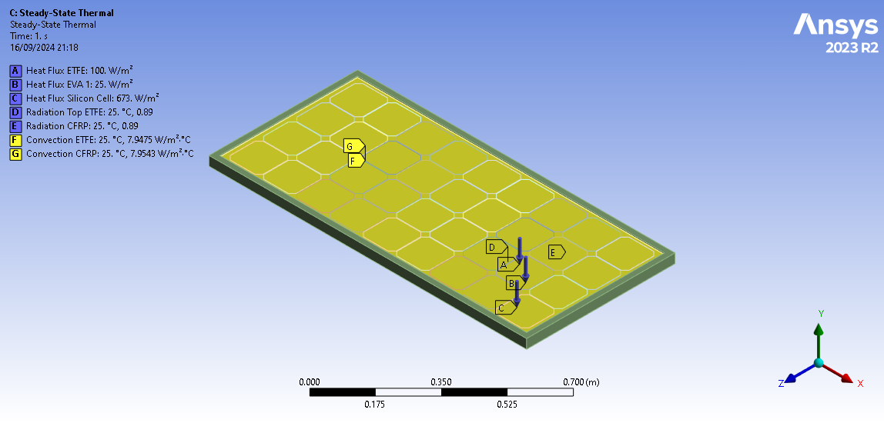
Figure 34: Steady-State Thermal Solution for the Set Boundary Conditions (ANSYS, 2023).

Modeling Solutions for Individual Layers of Photovoltaic Systems
Using ANSYS, this session produced CFD simulation results for the thermal radiation of the PV model layers from top to bottom. The steady-state thermal boundary condition was used to represent the greatest and lowest temperatures for each layer.
- Ethylene Tetrafluoroethylene: Fig. 35 depicts the simulation result.
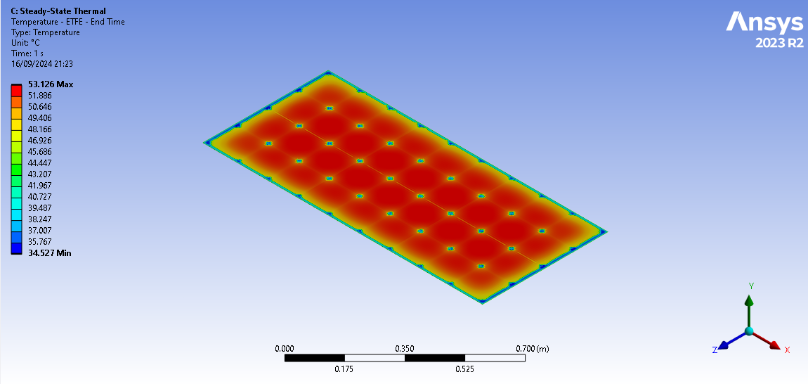
Figure 35: Ethylene Tetrafluoroethylene Temperature Result from the 1st Layer of the PV (ANSYS, 2023).

The temperature distribution of the photovoltaic (PV) panel shows that areas with temperatures up to 53.126°C reduce the efficiency of crystalline silicon cells by 11-14%, with each degree above 25°C causing a 0.4-0.5% loss. Cooler areas, between 34.527°C and 40°C, benefit from cooling mechanisms, improving reliability and preventing hotspots. While the ethylene tetrafluoroethylene (ETFE) layer aids heat management, it may not handle excessive heat, leading to degradation over time. Integrating a photovoltaic-thermal (PVT) system or active cooling solutions, like fluid-based systems or phase-change materials (PCMs), could help manage heat and efficiency in high-temperature conditions.
- Ethylene-Vinyl Acetate: Between each monocrystalline cell, two EVA were integrated from the PV, as seen in Fig. 36 and Fig. 37.
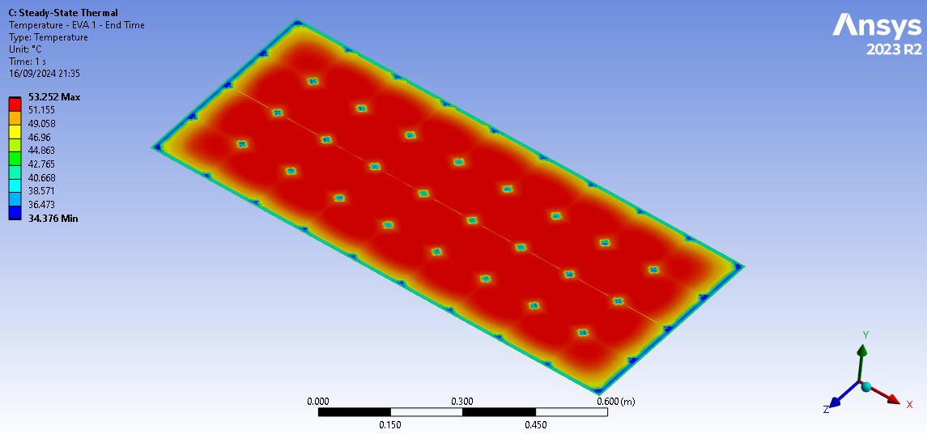
Figure 36: Ethylene-Vinyl Acetate Top Temperature Layer in between the Monocrystalline Cell (ANSYS, 2023).

The thermal simulation results from ANSYS 2023 demonstrate the temperature distribution on a photovoltaic (PV) panel coated with an Ethylene Vinyl Acetate (EVA) layer. This steady-state simulation provides the temperature profile at exactly 1 second. The temperature range, displayed by the colour bar, varies from 34.376°C (blue) to 53.252°C (red). The panel shows large areas shaded in red, indicating high temperatures, while cooler zones in blue and green appear intermittently. The higher temperatures suggest significant heat absorption, potentially reducing solar cell efficiency, highlighting the importance of effective thermal management for maintaining performance.
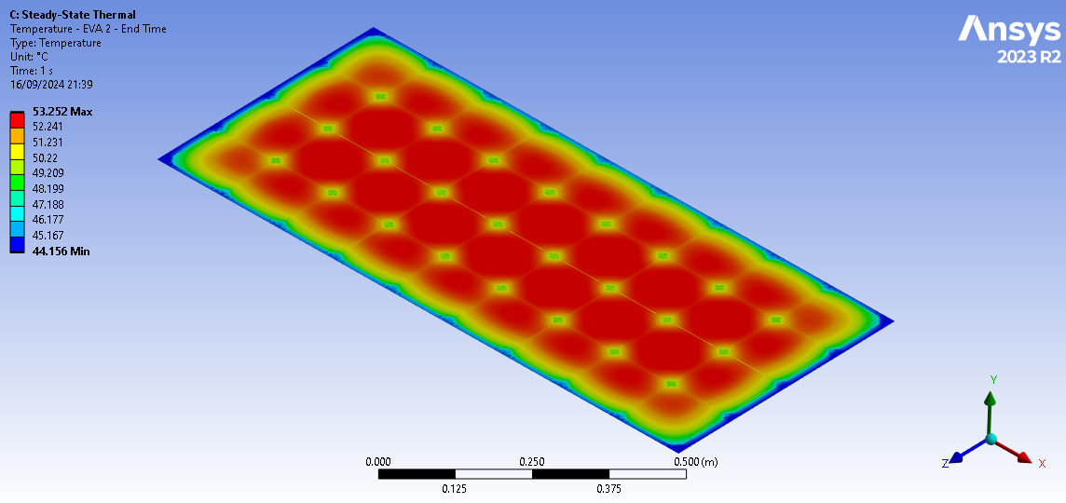
Figure 37: Ethylene-Vinyl Acetate Bottom Temperature Layer in between the Monocrystalline Cell (ANSYS, 2023).

- Monocrystalline Silicon Cell: The Cell result is displayed in Fig. 38.
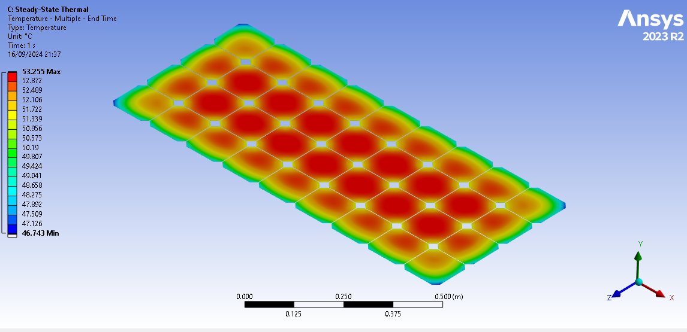
Figure 38: Monocrystalline Silicon Cell Solar Radiation Temperature of the Photovoltaic Model (ANSYS, 2023).

The thermal simulation using ANSYS 2023 highlights the temperature distribution on a silicon photovoltaic (PV) panel during a steady-state thermal analysis at 1 second. The temperature scale ranges from 46.743°C to 53.255°C, with the central area, where the solar cells are concentrated, showing higher temperatures (red), while the cooler areas near the edges (green and blue) indicate better heat dissipation. The observed heat build-up in the core cells may negatively impact the overall efficiency of the PV system, as higher temperatures can reduce performance, while the edges experience enhanced cooling.
- Polyethylene Terephthalate: The solution is as seen in Fig. 39.
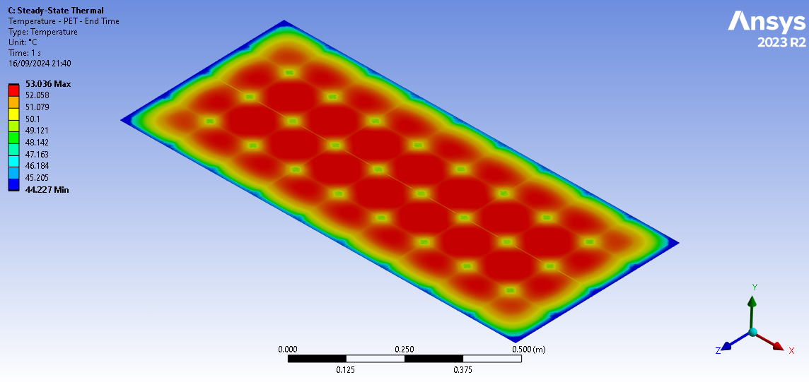
Figure 39: PET Temperature of the PV Panel layer (ANSYS, 2023).

- TAPE: Fig. 40 shows the tape solution.
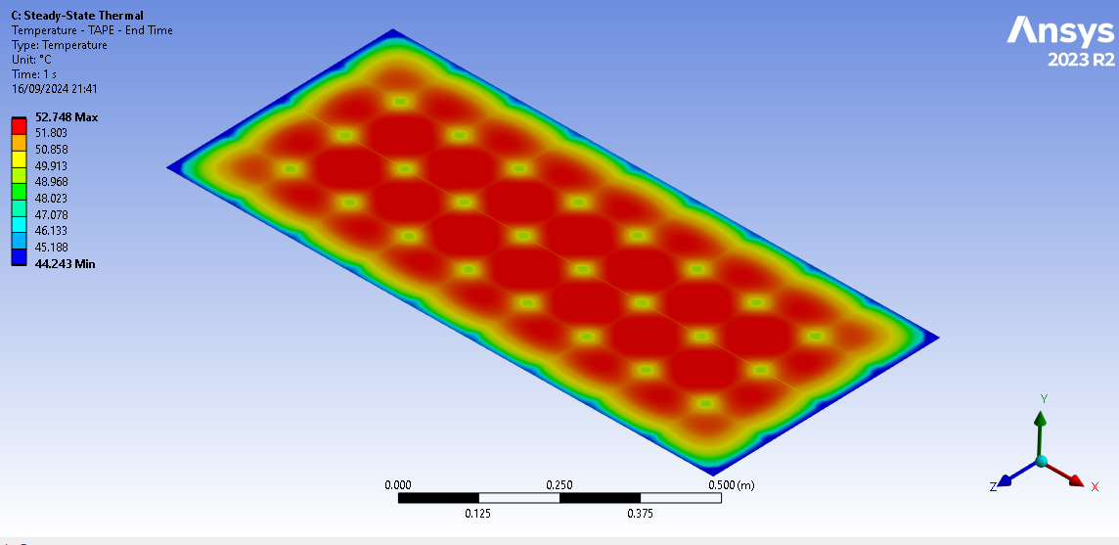
Figure 40: TAPE Adhesive Temperature layer of the PV (ANSYS, 2023).

- Carbon Fiber Reinforced Polymer: This final layer of PV is held in place by the frame and is located behind the PV cover as seen in Fig. 41.
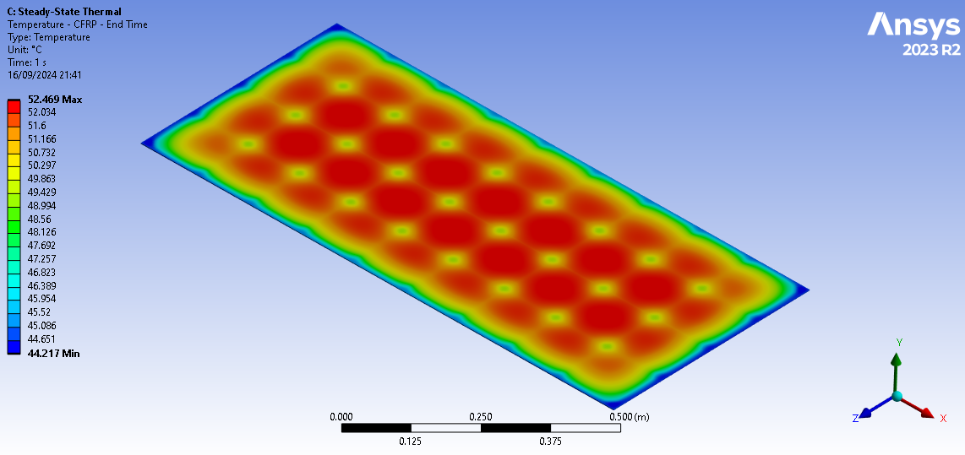
Figure 41: Carbon Fiber Reinforced Polymer Back Temperature Result Layer for the PV System (ANSYS, 2023).

Fig. 42 shows the thermal simulation performed with ANSYS 2023 focuses on the Directional Heat Flux along the Y-axis through a Carbon Fiber Reinforced Polymer (CFRP) backing of a photovoltaic (PV) panel in steady state at 1 second. The simulation results, shown in a scale ranging from -90.836 W/m² (red) to -398.21 W/m² (blue), predominantly indicate heat flux directed outward in the negative Y-direction, with blue coloration representing substantial dissipation. Heat is more pronounced at the panel's edges and corners, where higher flux occurs, while the center experiences lower but still notable flux. This pattern suggests that the CFRP backing enhances heat dissipation, reducing hotspots and promoting uniform cooling across the PV panel.
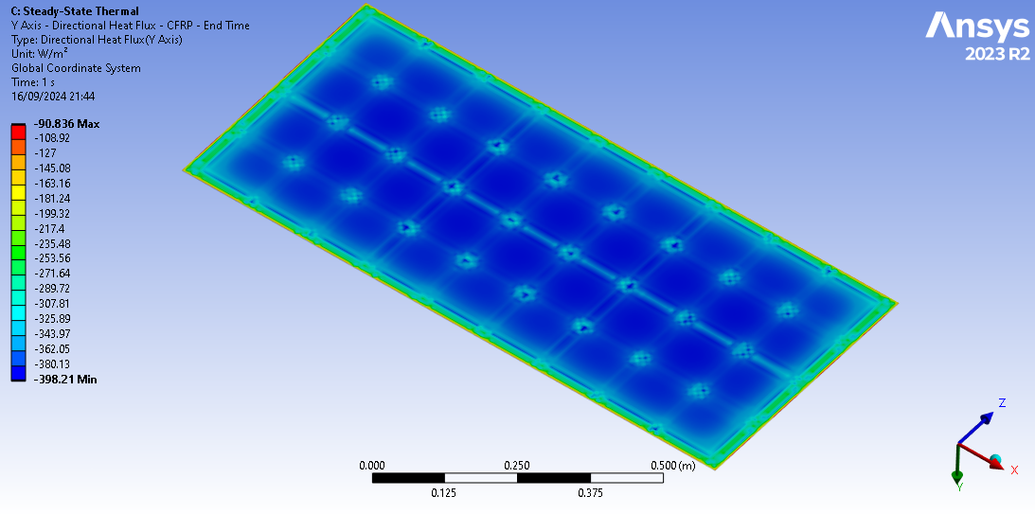
Figure 42: Thermal Simulation of the CFRP of the PV System Directional Heat Flux (ANSYS, 2023).

Thermal CFD Simulation Using ANSYS
The meshing setup displayed (Fig. 43) in the ANSYS 2023 simulation illustrates the structured design of a PV panel tailored for thermal analysis, concentrating on heat transfer and distribution within the photovoltaic framework. The mesh consists of a uniformly arranged, grid-like structure (fins) that enhances the heat transfer efficiency of the solar cells integrated with the panel's heat exchanger. This arrangement ensures consistent calculation nodes across the surface, providing high-resolution data for detailed thermal analysis, especially in detecting localized temperature variations. A coiled element, likely representing a fluid tube for the embedded heat exchanger, is positioned at the top right corner, indicating that a cooling system is incorporated into the PV system. This cooling mechanism is crucial for managing the heat generated by the PV panel during operation. The scale bar, located at the bottom, reveals the panel's length to be approximately 0.900 meters, offering a spatial reference for the dimensions and physical properties under analysis. Overall, the meshing setup is essential for enabling precise thermal simulations, allowing the software to calculate heat flow, temperature gradients, and the overall thermal performance of the panel, with specific attention to the impact of cooling mechanisms on heat management.
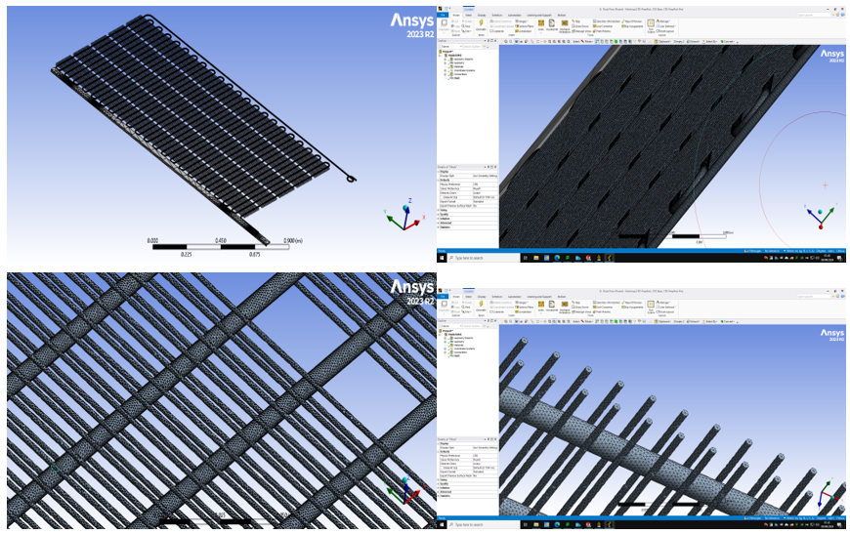
Figure 43: MESH for the Solar Thermal Integrated Heat Exchanger (ANSYS, 2023).

POLYSUN SIMULATION OF PVT MODEL.
This stage will encompass the simulation conducted using Polysun, along with the presentation of the corresponding results. To provide context, it will begin with an assessment of the project site, offering detailed insights into the geographical area where the system is intended for implementation.

Site Location and Climatic Information
This study will be modeled in the London Borough of Wandsworth, UK, as depicted in Fig. 44. Based on the information from the Global Solar Atlas, the southern region of the United Kingdom experiences greater solar radiation annually. As a result, this area has been selected for the configuration of the PV system, designed for a small residential setting. To optimize energy capture, the solar panels will be positioned at an angle of 37°.
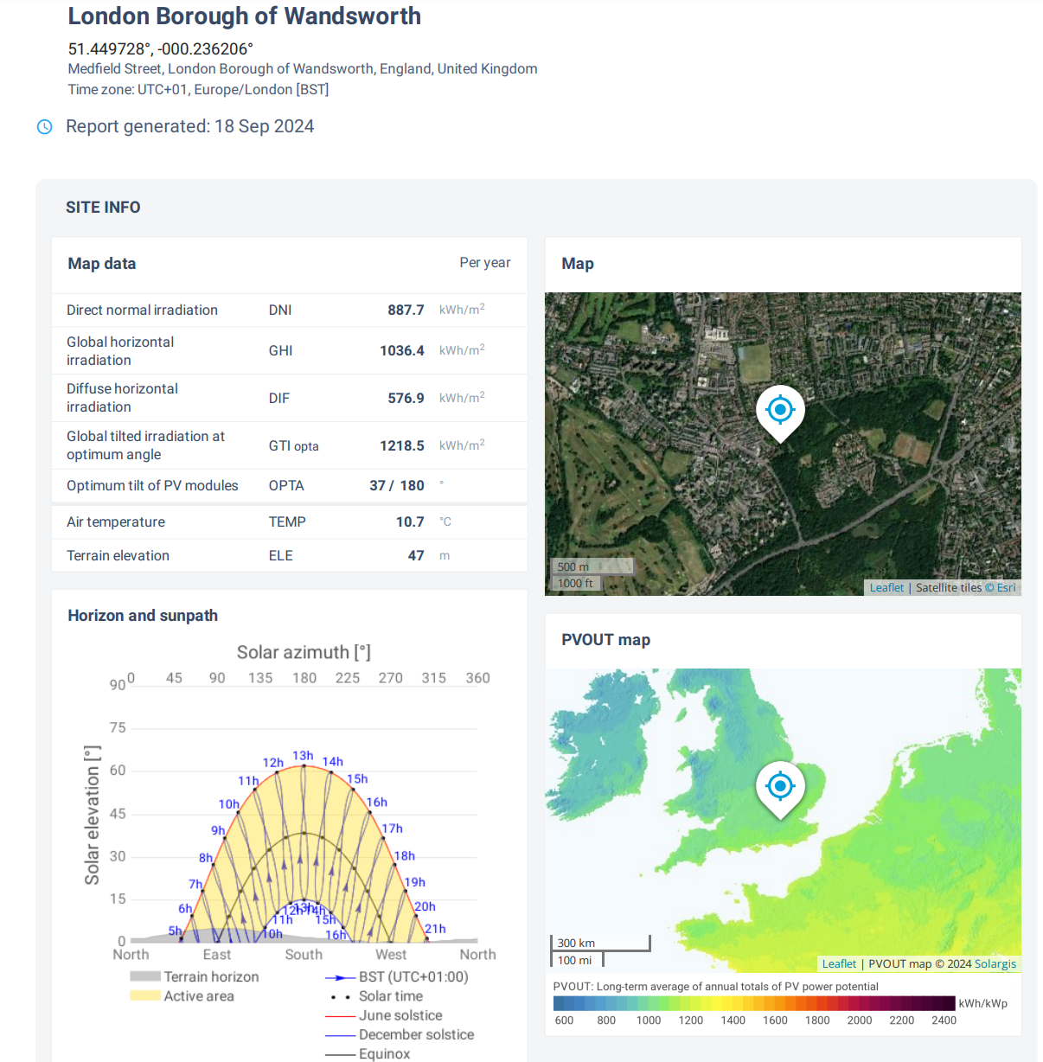
Figure 44: Medfield Street, London Borough of Wandsworth, England, United Kingdom (Global Solar Atlas, 2024).

Typical Temperature Levels in Wandsworth
The warmer period in Wandsworth spans approximately 2.8 months, from June 13 to September 7, during which daily high temperatures exceed 20°C. July is the peak of this season, experiencing the highest temperatures, with averages of 23°C during the day and 15°C at night. In contrast, the cooler season extends for about 4 months, from November 15 to March 16, where daytime highs typically fall below 11°C. February, being the coldest month, sees average temperatures range between 4°C at night and 9°C during the day, as depicted in Fig. 45.
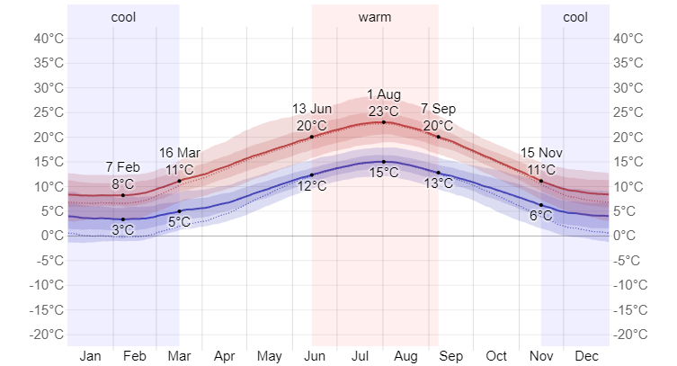
Figure 45: Typical Maximum and Minimum Temperatures in Wandsworth (Weather Spark, 2024).

SOLAR ENERGY
This section outlines the total daily amount of shortwave solar energy that reaches the earth's surface over a large area, factoring in seasonal changes in day length, the Sun’s position relative to the horizon, and the effects of cloud cover and atmospheric particles, as depicted in Fig. 46. Shortwave radiation encompasses visible and ultraviolet light. The daily incident shortwave solar energy demonstrates significant seasonal fluctuation. The brighter phase, lasting approximately 3.5 months from May 1 to August 17, features daily solar energy levels exceeding 5.3 kWh per square meter. June stands out as the brightest month in Wandsworth, averaging 6.3 kWh. Conversely, the darker phase lasts around 3.8 months, from October 25 to February 19, during which the daily incident energy drops below 1.8 kWh per square meter. December is the darkest month, with an average of 0.7 kWh.
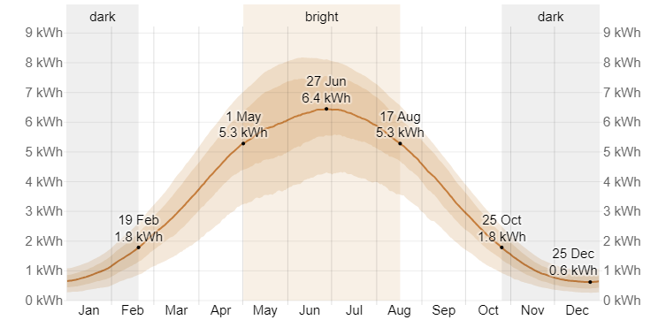
Figure 46: Average Daily Incident Shortwave Solar Energy in Wandsworth (Weather Spark, 2024).

SOLAR ELEVATION & AZIMUTH
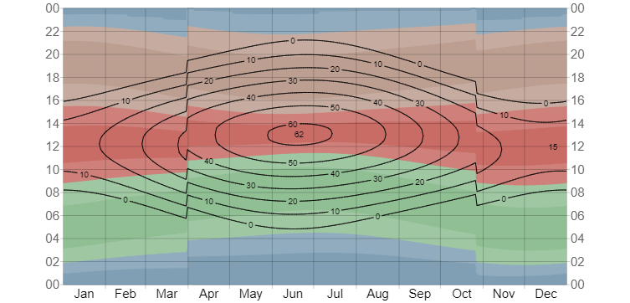
Figure 47: Sun Angle and Direction in Wandsworth (Weather Spark, 2024).

Fig. 47 offers a concise illustration of the sun's position, depicting both its elevation (the height of the sun above the horizon) and azimuth (its direction along the compass) for each hour across the reporting period.

Figure 48: Photovoltaic Power Generation and Solar Energy Exposure (Global Solar Atlas, 2024).
The horizontal axis corresponds to the days of the year, while the vertical axis reflects the time of day. For any given moment, the background color represents the sun's azimuth. Meanwhile, the black contour lines highlight areas of constant solar elevation. Fig. 48 and Fig. 49 present further details on PV performance and solar radiation.
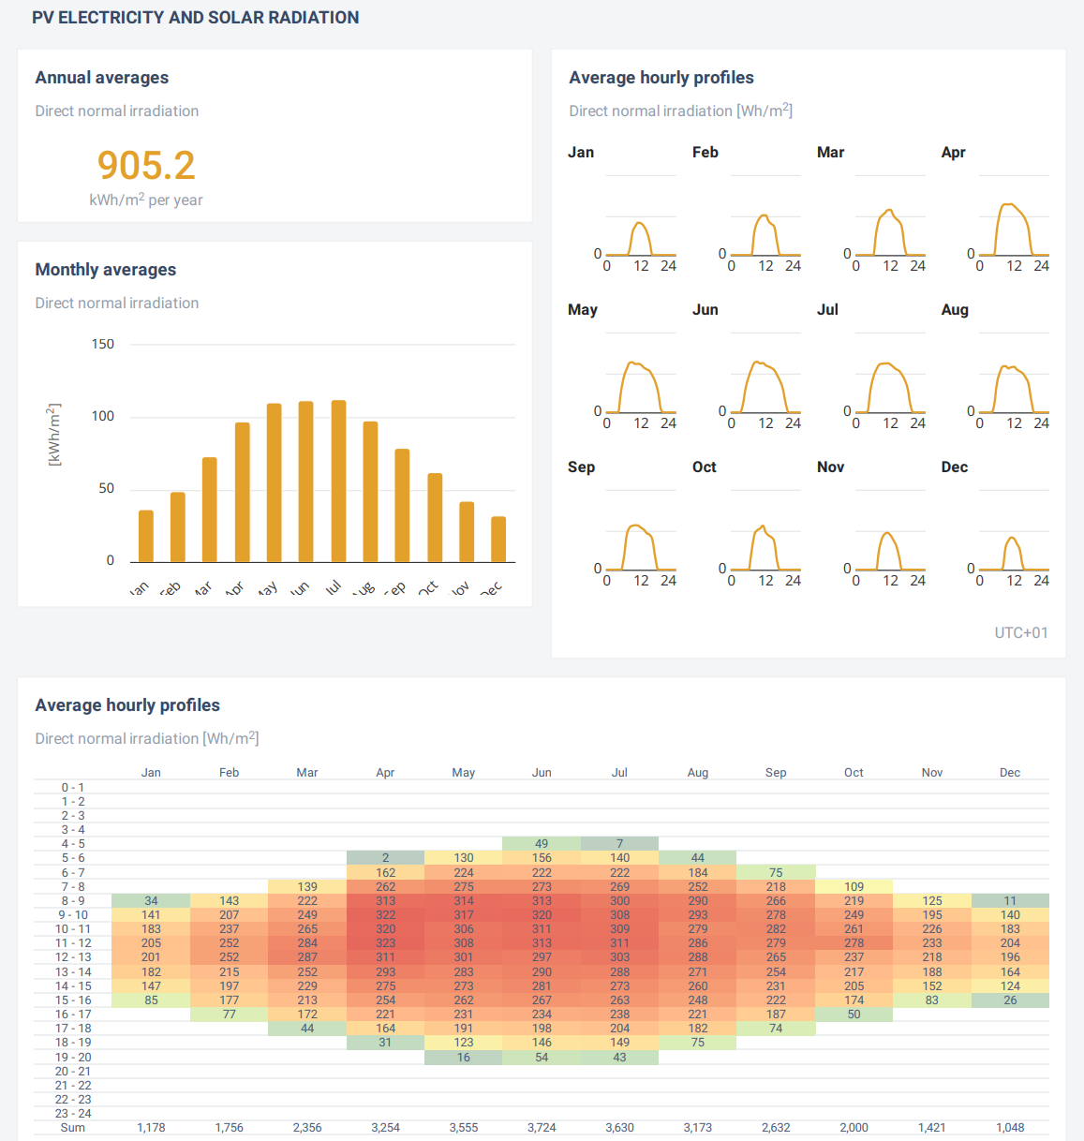
Figure 49: Average Hourly Profile and Solar Energy Exposure (Global Solar Atlas, 2024).

RAINFALL
The data presented in Fig. 50 illustrates not only the monthly totals but also the changes in rainfall over time, represented by a moving 31-day average centered on each day of the year. Rainfall in Wandsworth demonstrates some seasonal fluctuations, though it occurs year-round. October receives the highest average precipitation, measuring 56 millimeters, while March has the lowest, with an average of 32 millimeters of rainfall.
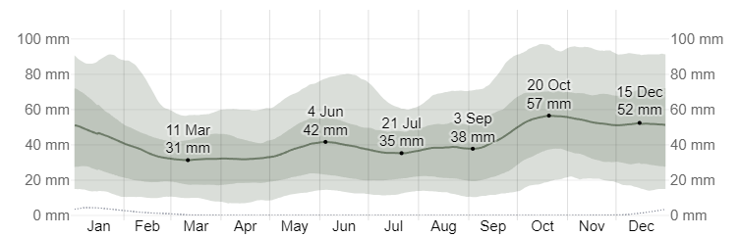
Figure 50: Typical Monthly Precipitation in Wandsworth (Weather Spark, 2024).

CLOUD
The cloud cover in Wandsworth varies considerably throughout the year, as illustrated in Fig. 51. The period with the least cloud cover starts approximately on April 1 and continues for about 6.5 months, concluding around October 18. July is typically the month with the clearest skies, where conditions are clear, mostly clear, or partly cloudy about 57% of the time. Conversely, the more overcast season begins around October 18 and lasts roughly 5.4 months, finishing near April 1. December is generally the cloudiest month, with overcast or mostly cloudy skies occurring around 72% of the time on average.
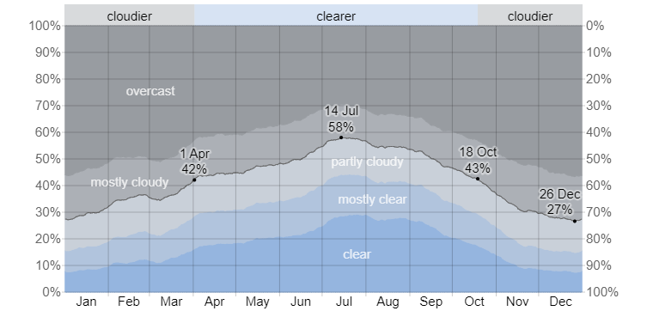
Figure 51: Types of Cloud Coverage in Wandsworth (Weather Spark, 2024).

POLYSUN Modeling Outcome of the Photovoltaic-Thermal System
The schematic in Fig. 52 presents a Photovoltaic Thermal (PVT) system designed for domestic hot water preheating, highlighting components that enhance solar energy utilization. The solar array consists of four modules, producing a nominal output of 0.8 kW, with a 90° east azimuth and a 45° tilt. Two storage tanks, with capacities of 300L and 200L, hold potable water, with the latter heating water to 50°C for household use. A 10-kW gas boiler serves as a supplementary heat source, ensuring a consistent hot water supply. The system is configured to support a typical residential electricity demand of 3,500 kWh annually and integrates with the local grid at 400 V. The installation is located in Wandsworth Town at coordinates -0.194° longitude, 51.449° latitude, and an elevation of 12 m.
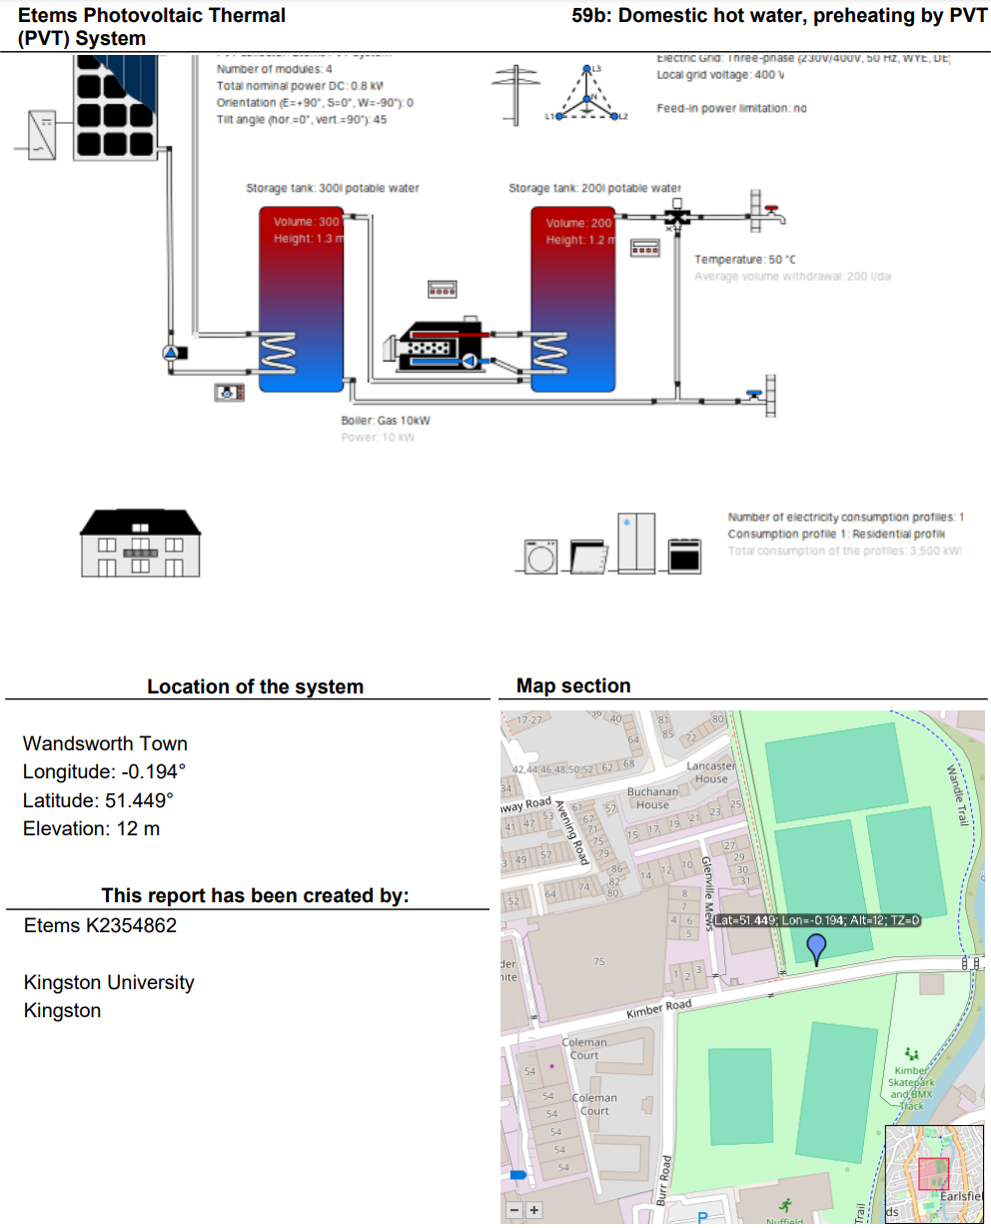
Figure 52: Domestic Hot Water Preheating by PVT (Polysun Simulation Software, 2024).

The annual performance of the PVT system in Table 10 highlights important energy consumption and output metrics. The system consumes 6,797 kWh per year, including 3,506 kWh for household electricity and 4,050 kWh of natural gas for heating backup. It utilizes 3,218 kWh of energy, achieving a performance ratio of 0.79 and a primary energy factor of 1.39. The solar thermal component, with a 5.3 m² collector area, provides 21.4% of the heating demand, yielding 835.4 kWh annually. It also saves 88.4 m³ of gas, reducing CO2 emissions by 215 kg. Additionally, 713 kWh of electricity is self-consumed, representing 93.9% of the generated electricity and contributing 20.3% to household energy self-sufficiency.
Table 10: Summary of Photovoltaic-Thermal Systems, Solar Heat, and Power Generation (Polysun Simulation Software, 2024).
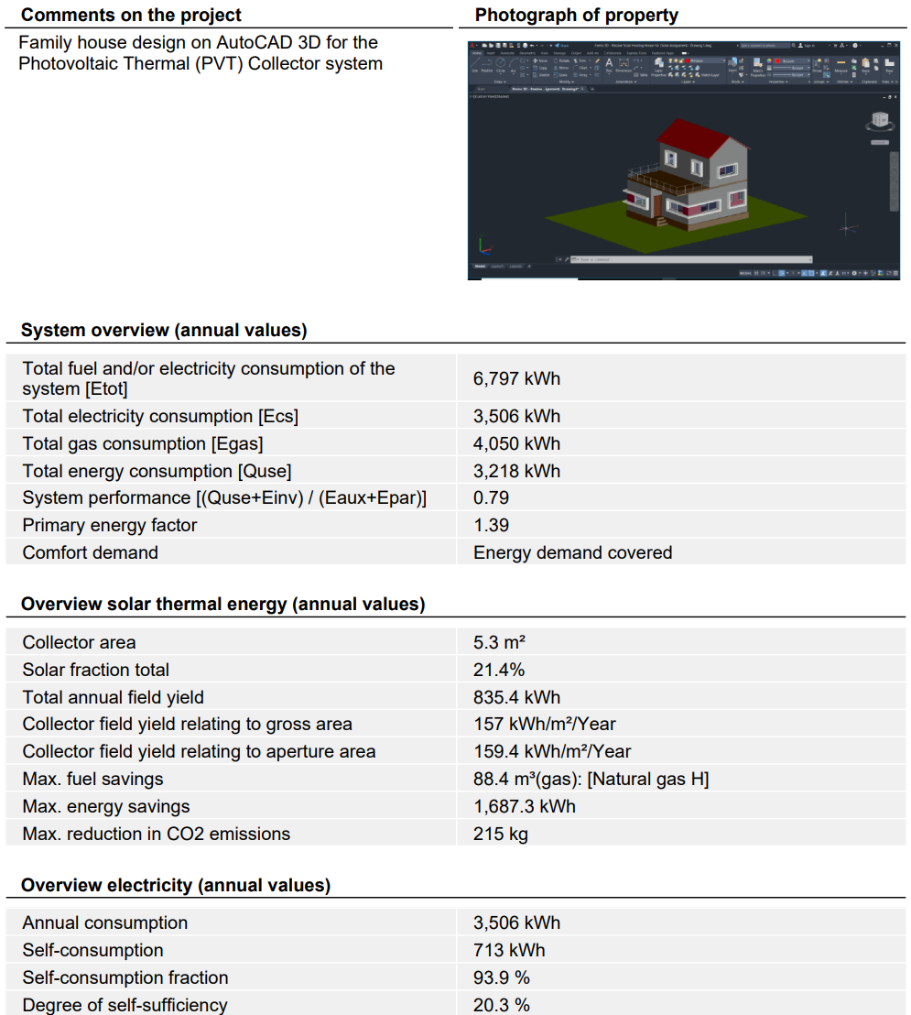
The graphical data in Table 11 provides an analysis of the solar system's performance, focusing on solar fraction, horizon line, and meteorological conditions. The solar fraction, which represents the energy supplied by the solar system, peaks at 36% in July and drops to 4% in December. The horizon line shows the sun's altitude, with its highest point around solar noon. Meteorological data indicates an average outdoor temperature of 11.9°C and total global irradiation of 998 kWh/m² annually, with diffuse irradiation at 548 kWh/m² under overcast conditions. The gas boiler operates with a 10-kW power rating, and 75.9% efficiency, delivering 3,073 kWh while consuming 4,050 kWh of gas annually.
Table 11: Meteorological Data Overview of the PVT system (Polysun Simulation Software, 2024).
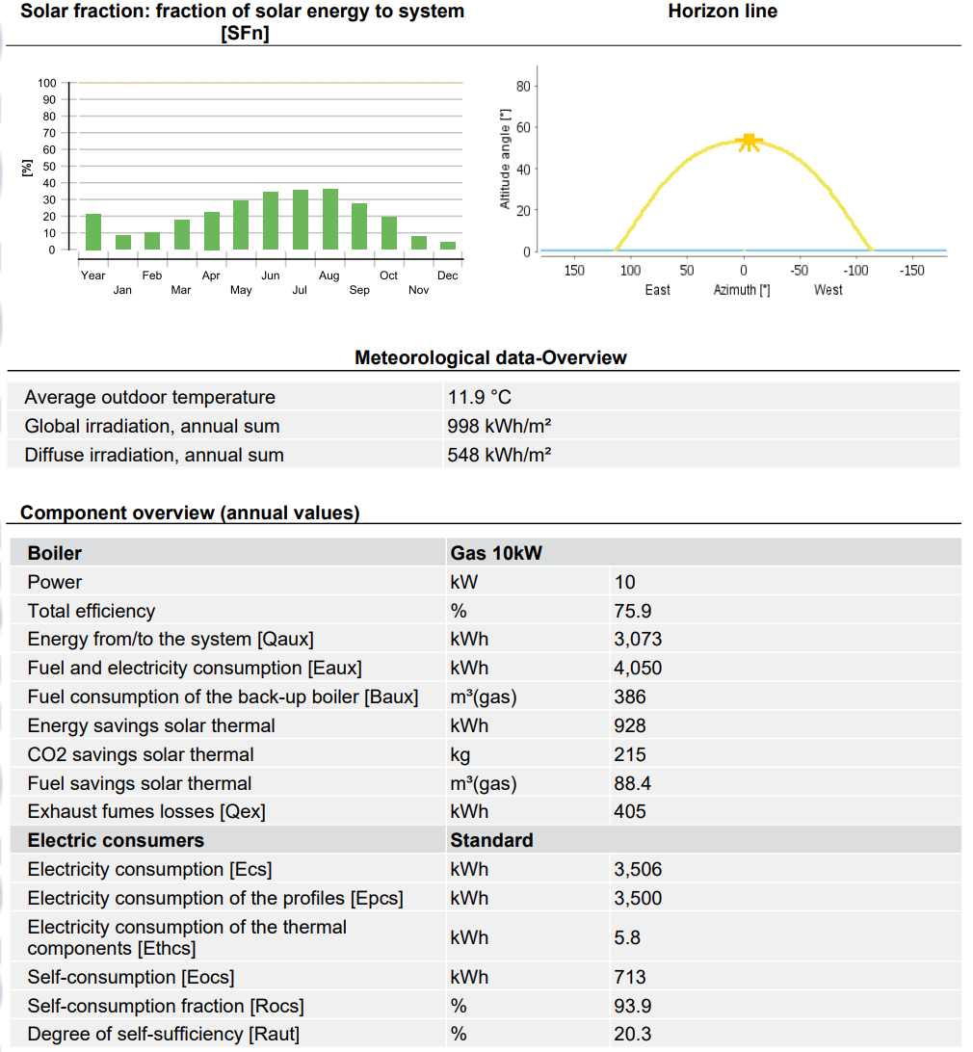

The specifications of the storage tank and solar loop, as detailed in Table 12, are essential to understanding the system's design and performance, alongside a graph showing solar thermal energy delivery. The storage tank, with a 200L capacity, is made of stainless steel, insulated with 80mm of rigid polyurethane foam, and stands 1.2 meters tall. It loses 238 kWh through standby heat and 182 kWh from connection losses. The solar loop uses a 33.3% propylene mixture as a heat transfer fluid, with a total volume of 32.3L, maintained at 4 bars for optimal circulation. The solar energy delivery graph shows a peak of 120 kWh in June and July, reflecting the system’s highest performance during summer.
Table 12:Solar Thermal Energy in the System (Qsol) (Polysun Simulation Software, 2024).
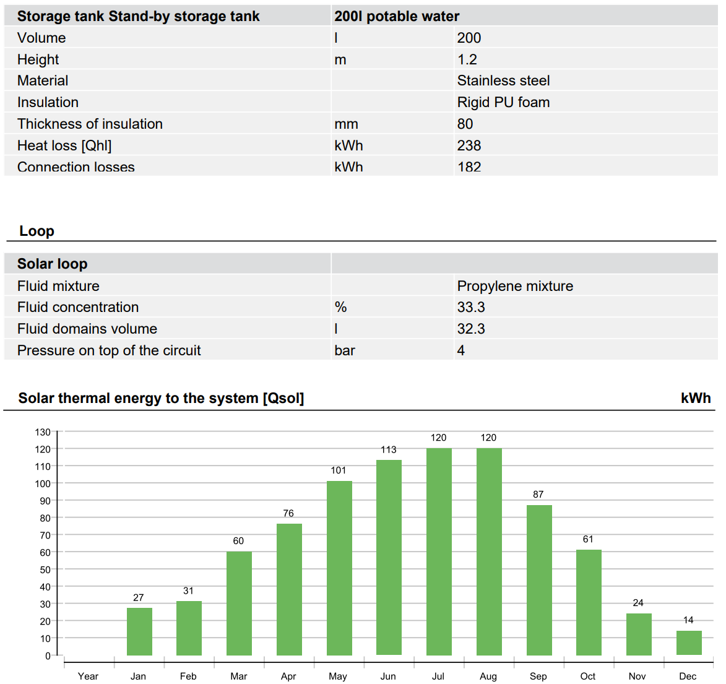
The analysis of energy yield and solar fraction in Fig. 53 demonstrates the seasonal fluctuations in the performance of a photovoltaic thermal system. The AC output (Qinv) from the photovoltaic system is highest in May at 91 kWh, while the lowest occurs in December at 23 kWh, highlighting the effect of shorter winter daylight hours. Conversely, energy from the heat generator (Qaux), primarily supported by a boiler, peaks in the colder months with 298 kWh in January and 299 kWh in December and drops during summer due to greater solar thermal energy. The solar fraction (SFn), which shows the percentage of energy met by solar power, peaks at 36% in July and decreases to 4% in December, reflecting lower solar availability during winter. This analysis reveals the seasonal dependence on solar energy and the increased need for auxiliary heating during low-radiation months.
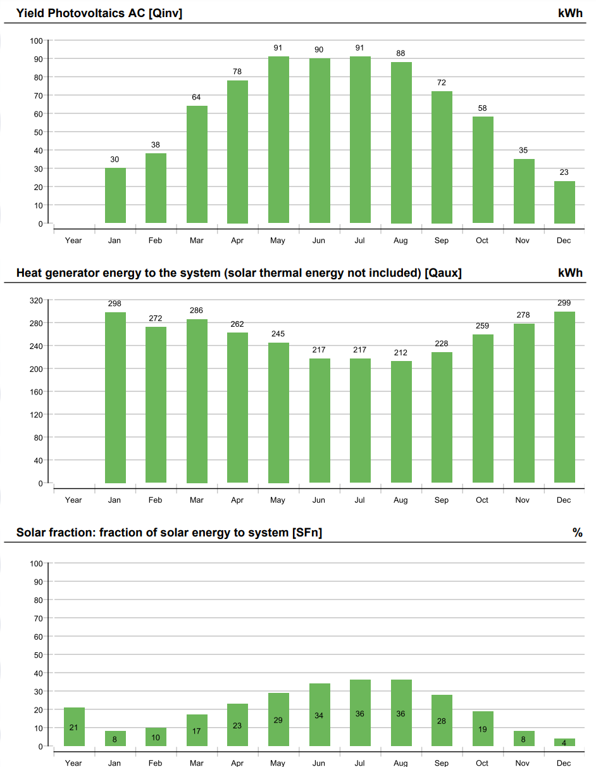
Figure 53: Graphical Representation of Photovoltaic Yield (Qinv), Auxiliary Heat Energy (Qaux), and Solar Fraction (Sfn) (Polysun Simulation Software, 2024).
The annual performance of the system, in terms of fuel and electricity consumption, Fig. 54 shows clear seasonal trends. Total fuel and electricity consumption (Etot) is highest in January at 711 kWh, reflecting the increased heating needs during winter, and lowest in July at 450 kWh. Electricity consumption (Ecs) remains relatively steady throughout the year, with slight peaks in January (359 kWh) and December (345 kWh), coinciding with higher energy use in colder months. Self-consumption (Eocs) of electricity generated by the PVT system increases between April and August, ranging from 74 to 84 kWh, due to longer daylight hours and greater photovoltaic output, while it decreases sharply to 23 kWh in December when solar energy is scarce. Finally, a general professional report is presented in Table 13.
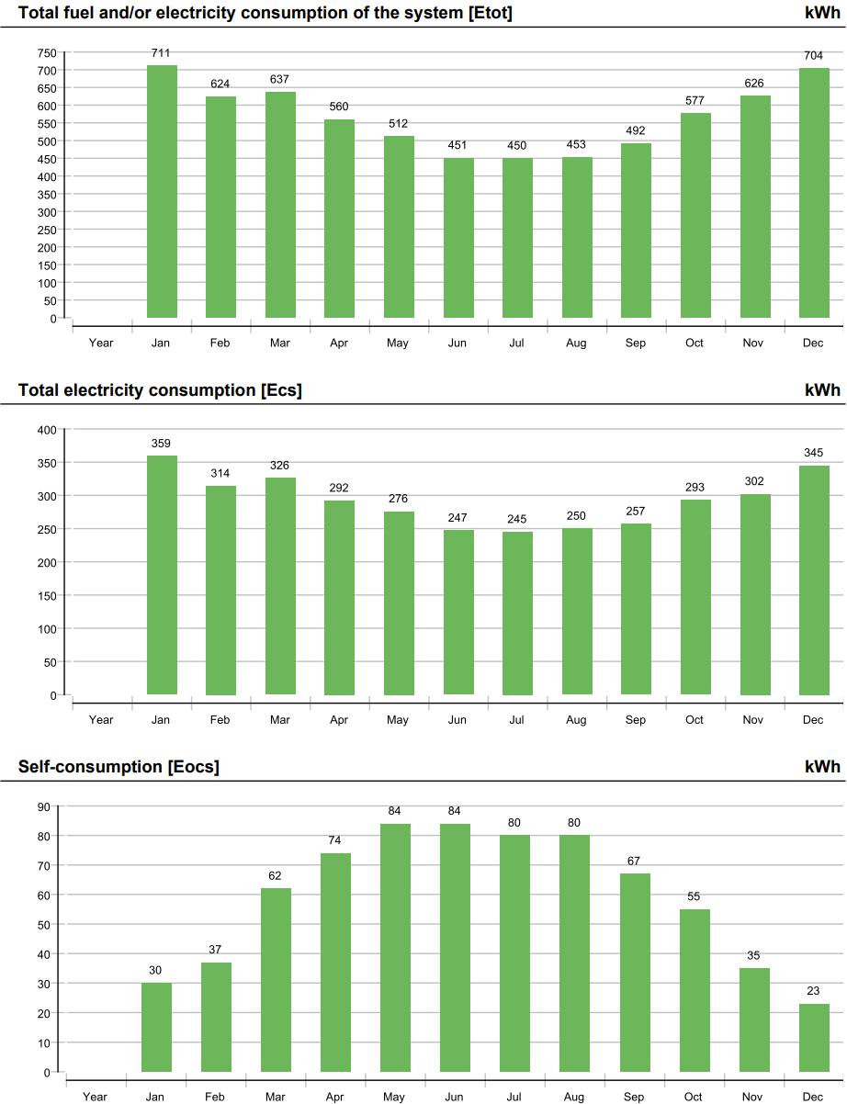
Figure 54: Graphical Representation of Total Energy Consumption of the System (etot), Overall Electricity Usage (Ecs), and Self-Consumption (Eocs) (Polysun Simulation Software, 2024).
Table 13: Tabulated POLYSUN Simulation Report (Polysun Simulation Software, 2024).
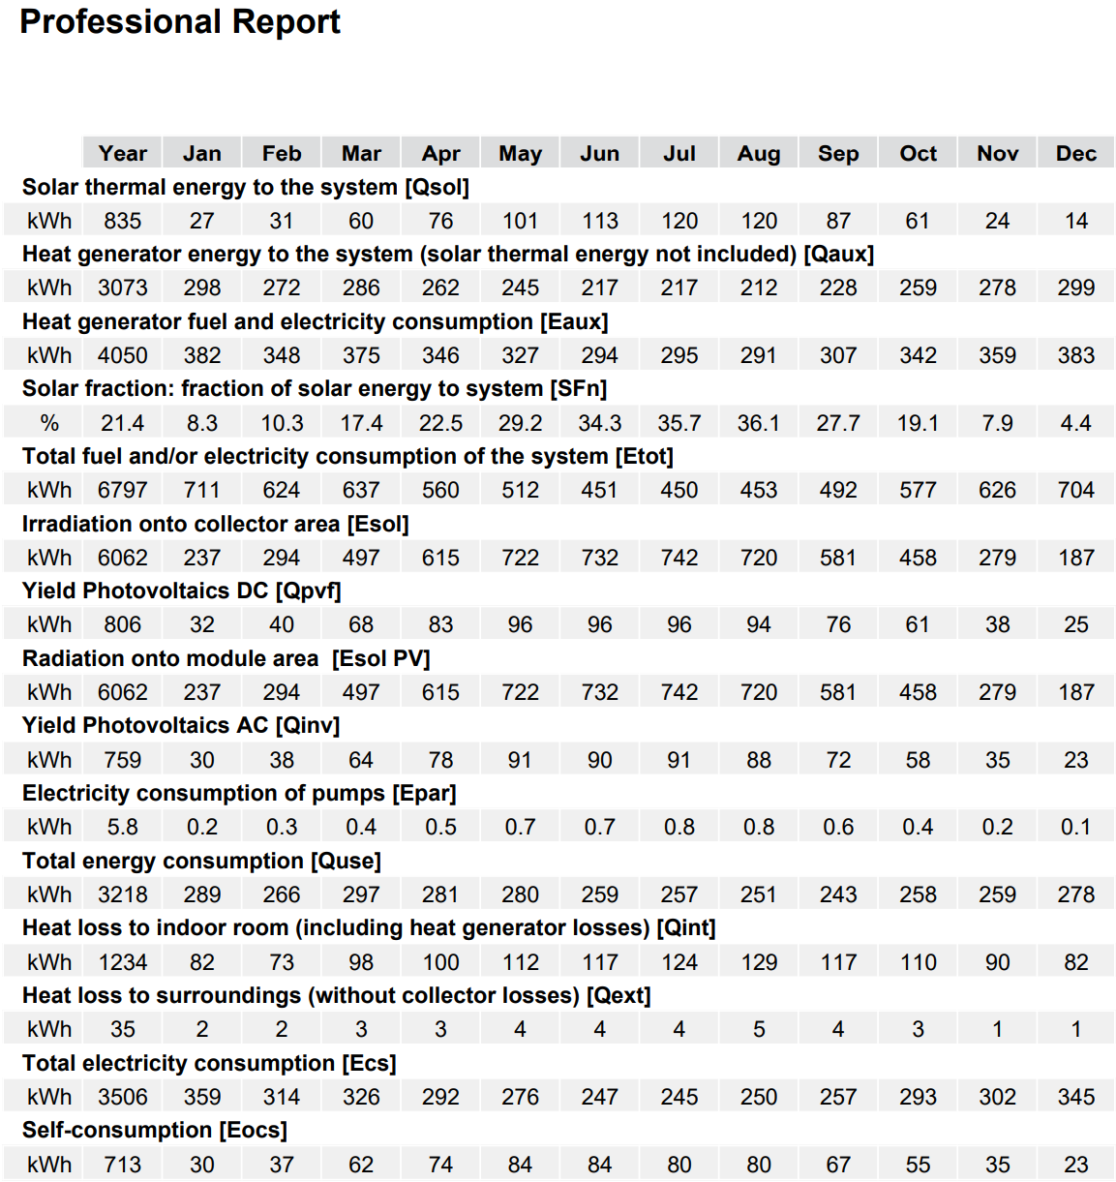

The daily maximum temperature of the PVT (Photovoltaic Thermal) collector, as illustrated in Fig. 55, demonstrates significant fluctuations throughout the year, influenced by seasonal changes in solar radiation. During the warmer months, particularly in the middle of the year, the temperature reaches its peak, nearing 45°C, while in the colder periods, it drops below 10°C. This pattern reflects the impact of increased solar radiation during summer and reduced radiation during winter. Additionally, the graph shows occasional sharp spikes and dips, likely caused by variations in daily weather conditions, such as particularly sunny or cloudy days.
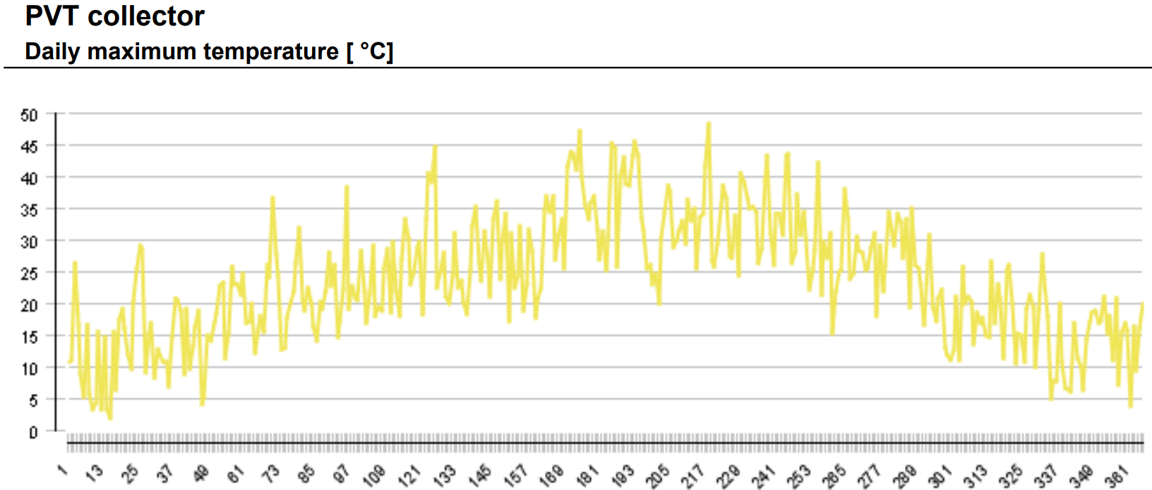
Figure 55: Daily Peak Temperature Graph of a PVT Collector (Polysun Simulation Software, 2024).

The energy flow diagram in Sankey format (Fig. 56) illustrates the annual energy balance of the system. Solar thermal energy contributes 835 kWh, playing a vital role in the overall distribution. The gas-fueled heat generator consumes 4,050 kWh of fuel and electricity annually, while the pump's energy usage is minimal at 6 kWh. The photovoltaic (PV) system generates 806 kWh of direct current (DC) power, with an additional 2,793 kWh sourced from the grid. Domestic hot water has the highest energy demand at 3,218 kWh, followed by losses to surroundings (440 kWh) and indoor room losses (1,234 kWh). The system self-consumes 713 kWh efficiently, though there are minor losses, including 47 kWh through the inverter and 46 kWh returned to the grid.
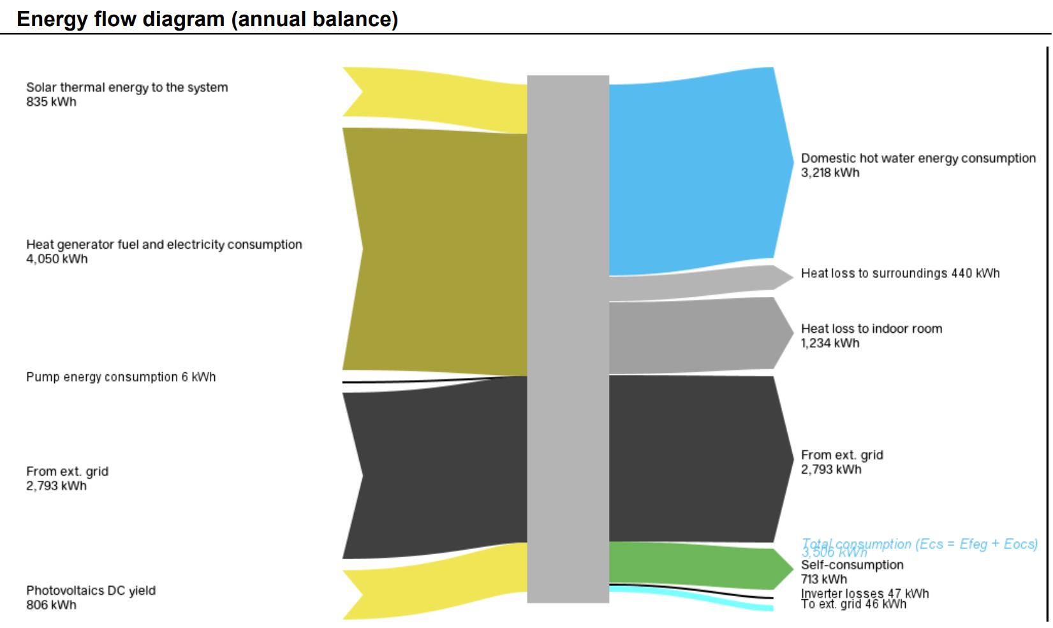
Figure 56: Sankey Diagram for the PVT system (Polysun Simulation Software, 2024).

Comparison of Metrics for Simulation Performance
The comparison involved evaluating the "Domestic Hot Water preheating PVT system," as illustrated in Fig. 52, against the Space Heating Seasonal Storage PVT Collector shown in Fig. 57, and the combined Domestic Hot Water and Space Heating preheating system, as depicted in Fig. 58. Below is the graph of the simulation comparison results.
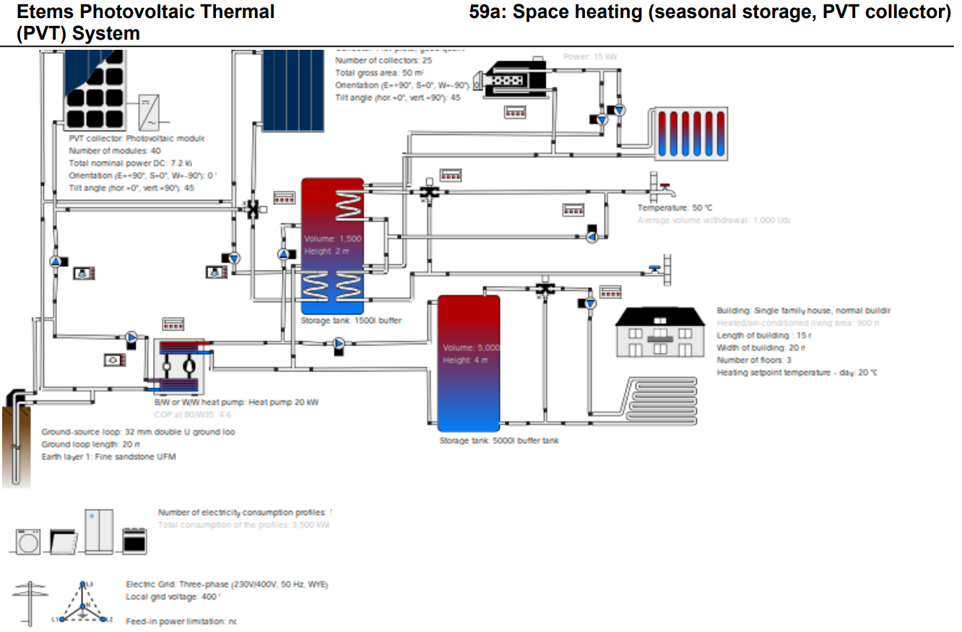
Figure 57: Space Heating (Seasonal Storage, PVT Collector) (Polysun Simulation Software, 2024).
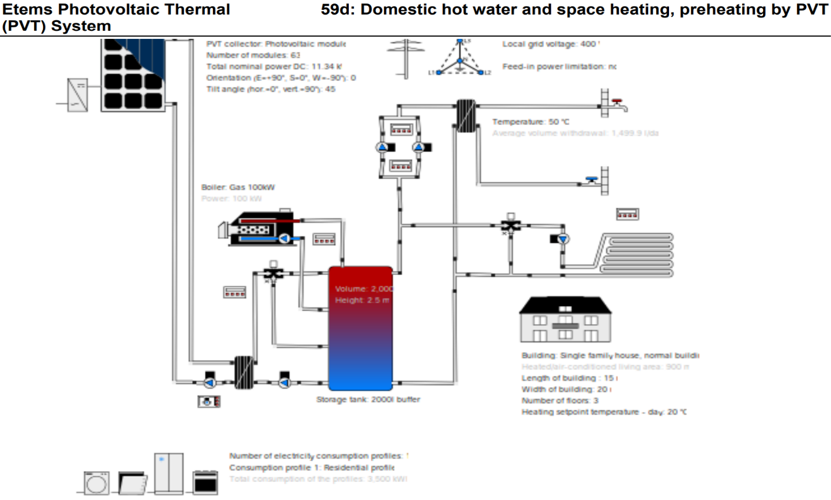
Figure 58: Domestic hot water & Space heating, Preheating by PVT (Polysun Simulation Software, 2024).
The system performance analysis, as depicted in Fig. 59, highlights annual variations across different heating modes, including preheating by PVT, seasonal storage, domestic hot water, and space heating. The highest electricity consumption occurs in winter, especially between January and March, with space heating being the largest contributor, represented by yellow bars. Domestic hot water and space heating consistently add to overall energy usage, as shown by black bars. Energy consumption follows a seasonal pattern, peaking in January and declining through summer as heating needs decrease. Similarly, heat generator demand, excluding solar thermal, rises in winter and drops during warmer months. Photovoltaic yield, represented by AC output, is greatest between April and August, corresponding to higher solar radiation during spring and summer.
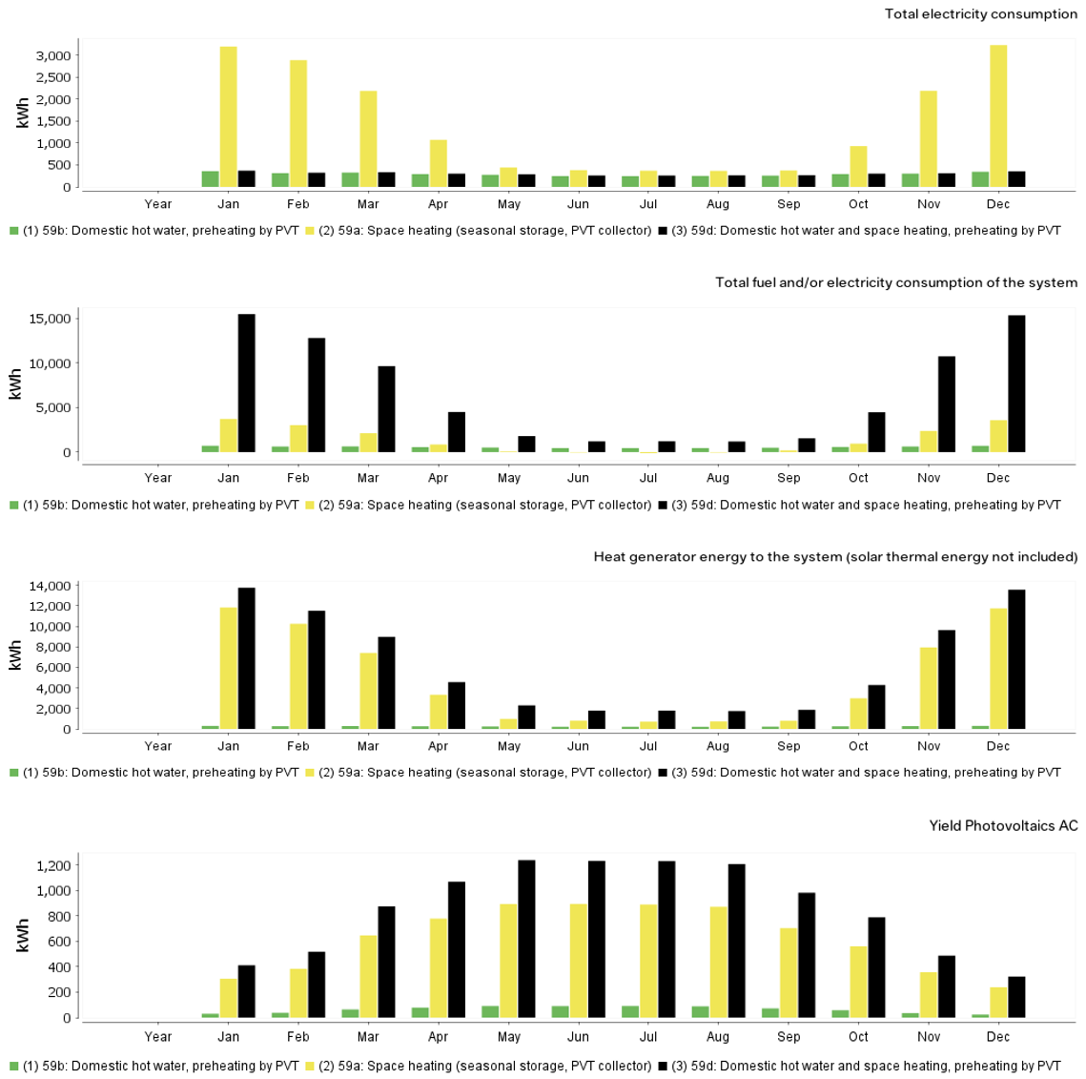
Figure 59: Graphical Analysis of Ecs, Etot, Qaux, and Qinv for the Three Systems Under Comparison (Polysun Simulation Software, 2024).
The data in Fig. 60 presents key monthly energy metrics, focusing on solar thermal energy performance. The most prominent trend is that space heating, shown by the yellow bars, dominates energy production, especially in winter, while preheating from the PVT system, indicated by the green bars, remains steady but lower year-round. Energy consumption follows a similar seasonal pattern, peaking in winter due to space heating demands and decreasing in summer. Self-consumption is highest in winter, driven by space heating, with a notable contribution from PVT preheating. The solar fraction, representing the percentage of energy from solar sources, peaks in summer but declines significantly during winter, particularly for space heating, reflecting the seasonal nature of solar energy's contribution.
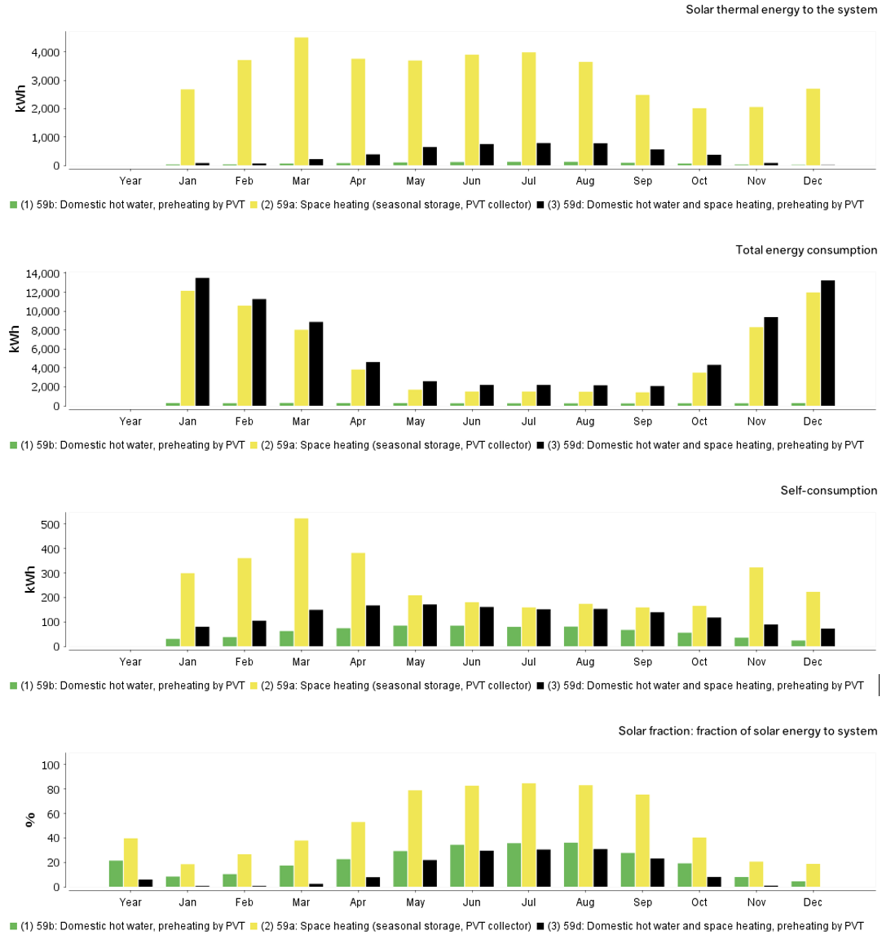
Figure 60: Graphical Analysis of Sfn, Eocs, Qsol, and Quse for the Three Systems Under Comparison (Polysun Simulation Software, 2024).

Economic Evaluation and Levelized Cost of Electricity (LCOE) Assessment
The economic viability of the PVT system was assessed using a levelized cost of energy (LCOE) analysis, which calculates the cost per unit of electricity generated over the system's lifetime. The LCOE for the designed PVT system was compared with that of the UK grid to evaluate the financial feasibility of the design. The formula applied for the LCOE is given from Equ. 14.

Step-by-Step Explanation of the LCOE Calculation
- Step 1 Calculate the Numerator (Total Costs): The financial analysis of a solar PVT system involves evaluating both the total lifetime costs and the expected energy production over the system’s lifespan. Lifetime costs include the initial capital investment, operational and maintenance expenses, and depreciation. In this case, the primary cost is the upfront investment of £12,000, incurred entirely in Year 0, with no further expenses anticipated in future years. This approach emphasizes the significant impact of upfront costs in the early stages of the system’s financial evaluation.
- Step 2: Calculate the Denominator (Total Energy Generated): The annual energy generation must be calculated while considering the degradation rate, followed by applying a discount rate to determine the discounted energy for each year. In this scenario, the initial energy output in Year 1 (E₁) is 7,200 kWh, with a degradation rate of 0.003.

E_{n}=E₁ x (1-0.003) ^{n-1}
E_{n} = 7200 x (1 – 0.003) ²⁵⁻¹, Therefore E_{n} = 6699.097458KWh.
$$E_{1}=\frac{E_{n}}{{(1+d)}^{n}}⇒\frac{7178.4}{{(1+0.05)}^{2}}=6511.02KWh$$

This causes the energy output to decline annually based on the degradation factor. After calculating the energy for each year, it is discounted using a rate of 0.05 to account for its present value in Table 14.

Table 14: Financial Considerations of Photovoltaic Systems (Babu and Ponnambalam, 2021).
ECONOMIC PARAMETERS | VALUE
Investment Cost | £12000 per Kw
Lifetime | 25 years
Discount rate | 5%
Annual electricity saving | 7200Kwh
Cost of Electricity | £0.18 per kWh
Depreciation Rate | 0.30%
Electricity Price Inflation Rate | 3%

The formula for discounted energy is applied to find the cumulative total over 25 years, with detailed calculations shown in Table 15.
Table 15: Detailed Process for Estimating Energy Output Over the Lifespan of a Solar PV System (Microsoft Excel, 2022).
Year | Energy Generated (kWh) | Discounted Energy (kWh)
1 | 7200.00 | 6857.14
2 | 7178.40 | 6511.02
3 | 7156.86 | 6182.37
4 | 7135.39 | 5870.31
5 | 7113.99 | 5574.00
6 | 7092.65 | 5292.64
7 | 7071.37 | 5025.49
8 | 7050.15 | 4771.82
9 | 7029.00 | 4530.96
10 | 7007.92 | 4302.25
11 | 6986.89 | 4085.09
12 | 6965.93 | 3878.89
13 | 6945.03 | 3683.10
14 | 6924.20 | 3497.19
15 | 6903.43 | 3320.67
16 | 6882.72 | 3153.05
17 | 6862.07 | 2993.90
18 | 6841.48 | 2842.78
19 | 6820.96 | 2699.28
20 | 6800.49 | 2563.03
21 | 6780.09 | 2433.66
22 | 6759.75 | 2310.82
23 | 6739.47 | 2194.18
24 | 6719.26 | 2083.43
25 | 6699.10 | 1978.26
- Final Step for LCOE (25 Years): The Levelized Cost of Electricity (LCOE) is calculated over 25 years, during which the total energy produced, adjusted for discounting, amounts to approximately 98,628.81 kWh. This value forms the basis for determining the LCOE, providing insight into the long-term financial performance of the solar PVT system.
$$LCOE=\frac{£12000}{\sum{\left(\frac{E_{n}}{({1+0.05)}^{n}}\right)}}$$

$$LCOE=\frac{12000}{98628.81}=0.1217£/KWh$$

Consequences of Comparative Evaluation
The solar PVT system is more cost-effective than typical UK grid electricity, with a Levelized Cost of Electricity (LCOE) of 12.17 pence/kWh, compared to the grid 15 pence/kWh. Over its 25-year lifespan, the system generates cheaper energy than grid electricity, leading to significant cost savings. As electricity prices are projected to increase due to inflation and other economic factors, these savings are expected to grow, further improving the system's financial appeal. Overall, the solar PVT system provides a lower cost per unit of electricity, making it a more financially viable long-term option.

Evaluation of Net Present Value (NPV) Calculations
The primary financial metric being analyzed is the Net Present Value (NPV), which considers the time value of money and the discounted future cash flows, particularly related to the energy savings produced by the PVT system.
Equation 17: Net Present Value Formula (Babu and Ponnambalam, 2021).
$$NPV=\sum{\left[\frac{S_{n}}{({1+d)}^{n}}\right]-C_{o}}$$

The NPV was calculated in Excel using Equ. 17, where the following variables were applied: S_{n} represents the annual electricity savings, d refers to the discount rate, C_{o} indicates the initial cost, and n denotes the analysis period in years.
Table 16: Financial Break Down Cost of Photovoltaic Thermal System (Babu and Ponnambalam, 2021).
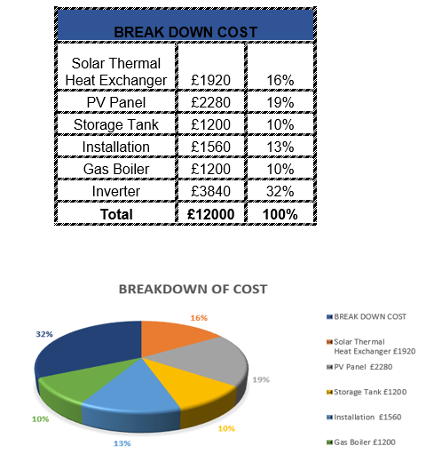
The economic factors are detailed in Table 14, with a cost breakdown provided in Table 16. The preliminary NPV data, calculated in Excel, is displayed in Table 17.

Table 17: Net Present Value Explicit Calculation (Microsoft Excel, 2022).
Year | Power Generation (kWh) | Electricity Price (£/kWh) | Electricity Savings (£) | Other Expenses (£) | Cash Flow (£) | Discount Factor | Present Value (£) | Cumulative NPV (£)
- | - | - | - | -£12,000.00 | -£12,000.00 | 1.000000 | -£12,000.00 | -£12,000.00
1 | 7,200 | £0.18 | £1,296.00 | £720.00 | £576.00 | 0.952381 | £548.57 | -£11,451.43
2 | 7,178 | £0.19 | £1,330.88 | £717.84 | £613.04 | 0.907029 | £556.04 | -£10,895.39
3 | 7,157 | £0.19 | £1,366.68 | £715.68 | £651.00 | 0.863838 | £562.36 | -£10,333.03
4 | 7,135 | £0.20 | £1,403.43 | £713.52 | £689.91 | 0.822702 | £567.59 | -£9,765.44
5 | 7,114 | £0.20 | £1,441.16 | £711.36 | £729.80 | 0.783526 | £571.81 | -£9,193.63
6 | 7,092 | £0.21 | £1,479.88 | £709.20 | £770.68 | 0.746215 | £575.10 | -£8,618.53
7 | 7,070 | £0.21 | £1,519.64 | £707.04 | £812.60 | 0.710681 | £577.50 | -£8,041.04
8 | 7,049 | £0.22 | £1,560.44 | £704.88 | £855.56 | 0.676839 | £579.08 | -£7,461.96
9 | 7,027 | £0.23 | £1,602.33 | £702.72 | £899.61 | 0.644609 | £579.90 | -£6,882.06
10 | 7,006 | £0.23 | £1,645.33 | £700.56 | £944.77 | 0.613913 | £580.01 | -£6,302.05
11 | 6,984 | £0.24 | £1,689.46 | £698.40 | £991.06 | 0.584679 | £579.45 | -£5,722.60
12 | 6,962 | £0.25 | £1,734.77 | £696.24 | £1,038.53 | 0.556837 | £578.29 | -£5,144.31
13 | 6,941 | £0.26 | £1,781.27 | £694.08 | £1,087.19 | 0.530321 | £576.56 | -£4,567.75
14 | 6,919 | £0.26 | £1,828.99 | £691.92 | £1,137.07 | 0.505068 | £574.30 | -£3,993.45
15 | 6,898 | £0.27 | £1,877.98 | £689.76 | £1,188.22 | 0.481017 | £571.56 | -£3,421.89
16 | 6,876 | £0.28 | £1,928.27 | £687.60 | £1,240.67 | 0.458112 | £568.36 | -£2,853.53
17 | 6,854 | £0.29 | £1,979.87 | £685.44 | £1,294.43 | 0.436297 | £564.76 | -£2,288.77
18 | 6,833 | £0.30 | £2,032.84 | £683.28 | £1,349.56 | 0.415521 | £560.77 | -£1,728.00
19 | 6,811 | £0.31 | £2,087.21 | £681.12 | £1,406.09 | 0.395734 | £556.44 | -£1,171.56
20 | 6,790 | £0.32 | £2,143.01 | £678.96 | £1,464.05 | 0.376889 | £551.78 | -£619.78
21 | 6,768 | £0.33 | £2,200.28 | £676.80 | £1,523.48 | 0.358942 | £546.84 | -£72.94
22 | 6,746 | £0.33 | £2,259.05 | £674.64 | £1,584.41 | 0.341850 | £541.63 | £468.69
23 | 6,725 | £0.34 | £2,319.37 | £672.48 | £1,646.89 | 0.325571 | £536.18 | £1,004.87
24 | 6,703 | £0.36 | £2,381.28 | £670.32 | £1,710.96 | 0.310068 | £530.51 | £1,535.39
25 | 6,682 | £0.37 | £2,444.82 | £668.16 | £1,776.66 | 0.295303 | £524.65 | £2,060.04

- NPV GRAPH DESCRIPTION: The graph in Fig. 61 shows the Net Present Value (NPV) development of the project over 25 years. The X-axis represents the timeline from Year 1 to Year 25, while the Y-axis indicates the cumulative NPV in pounds (£), ranging from -£14,000 to £4,000. The orange line depicts the NPV's progression, starting with an initial negative value of approximately -£12,000, representing the project's upfront cost. Over time, as the project yields returns, the NPV gradually increases, eventually moving from negative to positive values.

Figure 61: Graphical Representation of Net Present Value for the Lifetime of a Solar PVT System (Microsoft Excel, 2022).
- Break-even Analysis & Payback Period Financial Interpretation: The break-even point for the project is reached when the cumulative Net Present Value (NPV) equals zero, signifying that the returns have fully covered the initial investment. In this case, the break-even occurs around Year 20, where the cumulative NPV has balanced out, and the project has recovered its initial costs as depicted in Table 17. The payback period is similarly identified at 20 years, which is when the cumulative NPV becomes positive, indicating that from this point onward, the project begins to generate a net profit. Financially, during the first 20 years, the project is focused on recovering the investment, and by Year 21, the cumulative NPV surpasses zero, signalling the onset of profitability. Beyond this point, the project yields increasing returns, as illustrated in Fig. 61 by the continued upward trend of the cumulative NPV. Therefore, the break-even occurs at Year 20, with the payback period coinciding, after which the project begins to deliver profits.

RESULT

Comprehensive Discussion and Critical Evaluation of Results

Impact of Temperature on Photovoltaic Cell Efficiency
The first objective aimed to examine how temperature influences the efficiency of photovoltaic (PV) cells. Results from the CFD simulations confirmed a significant decline in efficiency due to increased temperatures across the various layers of the PV model. Fig. 35 revealed that the ETFE layer experienced temperatures as high as 53.126°C. According to literature, specifically studies by Krauter and Ochs (2004), this temperature range leads to an 11-14% drop in efficiency for crystalline silicon cells. This is consistent with prior research, which notes a 0.4-0.5% efficiency loss for each degree rise above 25°C, the standard test temperature for PV systems (Table 7). This observation correlates with Tiwari and Gaur’s (2014) findings in Table 2, where PV modules exhibit reduced performance at elevated temperatures.
To mitigate these thermal effects, the designed PVT system employed a fluid-based cooling system, which successfully reduced temperatures in critical areas, as highlighted by the cooler zones (34.527°C to 40°C) in Fig. 37. This outcome aligns with Hamzat et al. (2021), who emphasize the critical role of water cooling due to its high specific heat capacity. Notably, Baranwal and Singhal (2021) found that water cooling was more effective than air cooling, a conclusion that holds in the present study as seen in Fig. 36, where water cooling consistently maintained lower PV temperatures. Furthermore, the calculated heat flux through the layers, as shown in Table 8, resulted in a net heat flux of 672.5 W/m². This significant reduction in heat buildup confirms the efficacy of fluid-based cooling techniques, validating the thermal regulation approach employed.

Design and Simulation of the PVT System
The second objective focused on conceptualizing a PVT system that integrates cooling mechanisms. Using CFD and Polysun simulations, the designed system was thoroughly tested. The CFD simulation, as depicted in Fig. 25, used SOLIDWORKS CAD models to visualize the system and define critical parameters. The cooling mechanism integrated beneath the PV cells significantly enhanced thermal regulation. Meshing results, as shown in Fig. 33, demonstrated that the structured mesh provided high precision for heat transfer simulations, which is in line with Saud Al Jadir (2023), who emphasized the importance of structured meshing near wall regions for accurate boundary layer resolution.
The thermal simulations for EVA layers in Fig. 36 and Fig. 37 confirmed the effective dissipation of heat through the cooling channels. Temperatures across the layers remained stable at around 50°C, with peaks not exceeding 53.252°C. These findings align with Rukman et al. (2019), who also used CFD simulations to confirm that fluid-based cooling could maintain PV temperatures below critical thresholds. The mesh quality, particularly its skewness value of 0.61722 (Table 5), further reinforced the accuracy of the CFD results by ensuring minimal computational errors.
However, certain limitations exist in this design. Ali (2020) noted that, while water cooling is effective, the potential for leakage and corrosion must be managed, especially in large-scale systems. These risks could compromise long-term performance and raise operational costs, an area not deeply explored in this study. Future improvements could include anti-corrosive materials or more robust sealing methods, as suggested by Brottier and Bennacer (2020).

Performance Enhancement through Polysun Simulation
The Polysun simulation provided insights into the system's performance under real-world climatic conditions in Wandsworth, UK. The domestic hot water preheating configuration (Fig. 52) was particularly effective, generating 835.4 kWh of thermal energy annually and meeting 21.4% of the total heating demand. These findings align with Zondag et al. (2003), who highlighted the potential for PVT systems to meet residential heating needs when properly integrated with solar thermal collectors. The system’s ability to reduce CO₂ emissions by 215 kg annually, as noted in Table 10, supports Hamzat et al. (2021), who emphasized the environmental benefits of PVT systems.
However, the seasonal variation in system performance, depicted in Fig. 53, presented a notable challenge. The solar fraction peaked at 36% in July but fell drastically to 4% in December. This confirms the findings of Seng (2010), who reported that PV systems struggle to maintain efficiency during winter months due to reduced solar irradiance. Although this study's water-based cooling system performed well during summer, improvements are needed for colder periods. Misha et al. (2020) recommended using phase-change materials (PCMs) to store heat for later use, a strategy that could enhance year-round efficiency in future iterations of this PVT system.

Levelized Cost of Electricity (LCOE) and Economic Feasibility
A key objective of this project was to assess the economic feasibility of the PVT system through a Levelized Cost of Electricity (LCOE) analysis. The LCOE calculation, as outlined in Equ. 14, resulted in a value of £0.1217 per kWh over 25 years. This cost is significantly lower than the current UK grid price of £0.15 per kWh, confirming the financial advantage of the system. The financial breakdown in Table 14 and Table 15 shows that the system's initial investment of £12,000 has recovered well within its operational lifespan, demonstrating cost efficiency similar to findings by Babu & Ponnambalam (2021).
However, as Hernández-Moro & Martinez-Duart (2013) noted, inflation rates and maintenance costs could impact future profitability. While this study accounted for a degradation rate of 0.003 and electricity price inflation of 3%, additional variables, such as unexpected maintenance costs, could alter the LCOE and Net Present Value (NPV). Table 17 provides a thorough NPV breakdown, which shows a positive cumulative NPV by Year 20, indicating the project’s profitability after two decades. While this result is promising, a more detailed risk analysis, such as Monte Carlo simulations as suggested by Cui et al. (2020), could improve the reliability of the financial projections.

Factors Influencing PVT Efficiency and Optimization
The final objective sought to pinpoint and evaluate key factors influencing the efficiency of the PVT system. Temperature regulation emerged as a critical factor, as confirmed by both the CFD and Polysun simulations. The choice of materials, particularly the use of CFRP as a backing material in Fig. 41, significantly improved heat dissipation, reducing hotspots. The directional heat flux through the CFRP layer, shown in Fig. 42, demonstrated that the material’s high thermal conductivity contributed to uniform cooling, a conclusion supported by Abdelrazik et al. (2018).
Nevertheless, this study could be further optimized by integrating advanced materials such as nanofluids or phase-change materials (PCMs), which have shown potential in previous research. Samykano (2023) discussed the potential of PCMs to regulate cell temperatures during periods of high solar irradiance, a solution that could be implemented in future designs to improve thermal stability. Additionally, hybrid cooling techniques combining air and water, as proposed by Jarimi et al. (2016), could further enhance the system's overall efficiency. This dual-fluid approach was not explored in this study but could offer superior performance, particularly in variable climatic conditions.

Limitations and Areas for Future Research
While the project successfully met its objectives, several limitations were identified. First, the CFD and Polysun simulations were based on idealized conditions, which may not fully capture the complexities of real-world installations. As noted by Sanz et al. (2020), future studies should incorporate more dynamic weather models and include shading effects to provide a more comprehensive analysis. Additionally, the economic analysis could be expanded to include a broader range of financial variables, such as operational risks and varying energy price scenarios.
Future research could also focus on exploring hybrid PVT designs using dual-fluid systems or integrating advanced materials like nanofluids, as recommended by Karami & Rahimi (2014). These innovations could significantly enhance both the thermal and electrical performance of PVT systems, making them more viable for widespread adoption across different climates and applications.

CONCLUSION
This project set out to design, simulate, and evaluate a photovoltaic-thermal (PVT) system, aiming to enhance both electrical and thermal efficiency through the integration of cooling mechanisms. The research objectives were thoroughly addressed, and the findings validate the success of the project. The critical evaluation of the results, in comparison with existing literature, further demonstrates the robustness of the methodologies employed and highlights potential areas for future development.
The first objective, which focused on exploring how temperature affects PV cell efficiency, was successfully achieved. Through CFD simulations, the project showed that high temperatures negatively impacted PV efficiency, as evidenced by the temperature range of 53.126°C in the ETFE layer ( Fig. 35), causing an efficiency drop consistent with the literature. This correlates with Krauter and Ochs (2004), who also reported efficiency declines in crystalline silicon cells. The project mitigated these effects through fluid-based cooling, as seen in Fig. 37, and validated findings by Hamzat et al. (2021) and Baranwal and Singhal (2021), which demonstrate the critical role of water in managing PV temperatures.
In designing the PVT system, the second and third objectives were also met. Using CFD and Polysun simulations, the project demonstrated the efficacy of the cooling mechanism, achieving temperature stabilization across the PV layers. The results were supported by Rukman et al. (2019), who found that fluid-based cooling systems maintain lower operational temperatures. The system’s integration, modeled using SOLIDWORKS CAD ( Fig. 25), was confirmed to be effective, and the meshing analysis (Table 5) showed optimal conditions for accurate thermal modeling, aligning with the findings of Saud Al Jadir (2023).
Furthermore, the LCOE analysis, the focus of the fourth objective, showed that the designed system is economically viable. With an LCOE of £0.1217 per kWh over 25 years, the system was more cost-effective than grid electricity at £0.15 per kWh. This conclusion aligns with the work of Babu & Ponnambalam (2021), confirming the financial feasibility of PVT systems. However, as noted by Hernández-Moro & Martinez-Duart (2013), variables such as maintenance costs and inflation may affect future profitability. This reinforces the need for more comprehensive financial modeling, as suggested by Cui et al. (2020), in future iterations of this project.
The final objective, which sought to pinpoint the factors influencing PVT system efficiency, was also achieved. The results confirmed that material choices, particularly the use of CFRP (Fig. 41), greatly enhanced heat dissipation. These results are consistent with Abdelrazik et al. (2018), who emphasized the importance of advanced materials in thermal management. However, there remains potential for improvement by incorporating nanofluids and phase-change materials (PCMs), as recommended by Samykano (2023). Hybrid cooling systems, such as the dual-fluid approach proposed by Jarimi et al. (2016), also represent a promising area for future development, offering greater flexibility and enhanced performance across different climatic conditions.
Despite the successes of this project, several limitations were identified. The simulations were conducted under idealized conditions, limiting their real-world applicability. Future studies should incorporate more dynamic environmental models, as recommended by Sanz et al. (2020), to better account for variables such as shading, temperature fluctuations, and weather conditions. Additionally, testing the system in different climatic conditions and expanding the range of financial variables considered in the economic analysis will provide a more comprehensive understanding of the system’s long-term viability.
Building on the findings of this project, future research should focus on integrating advanced materials like nanofluids and PCMs, which have shown promise in enhancing both electrical and thermal performance. Larger-scale testing and simulations across diverse environmental conditions would further improve the reliability and applicability of PVT systems. Expanding simulations over longer periods will provide insights into the system's behavior under real-world operational stresses and further optimize its design.
In conclusion, this project has successfully met its research aims and objectives, providing valuable insights into the design, simulation, and optimization of PVT systems. The findings demonstrate the effectiveness of the integrated cooling system, the economic viability of the solution, and the potential for future advancements. With further development, particularly in material science and real-world testing, PVT systems can play a pivotal role in sustainable energy solutions.

REFERENCES
Abakam, M., Alkaff, S.A., Go, Y.I. and Venkiteswaran, V.K. (2019), “Modelling and performance analysis of a new PVT system, with two semi-transparent PV panels”, Process Integration and Optimization for Sustainability, Springer, Vol. 3, pp. 359–373.
Abdelrazik, A.S., Al-Sulaiman, F.A., Saidur, R. and Ben-Mansour, R. (2018), “A review on recent development for the design and packaging of hybrid photovoltaic/thermal (PV/T) solar systems”, Renewable and Sustainable Energy Reviews, Elsevier, Vol. 95, pp. 110–129.
Abdelrazik, A.S., Osama, A., Allam, A.N., Shboul, B., Sharafeldin, M.A., Elwardany, M. and Masoud, A.M. (2023), “ANSYS-Fluent numerical modeling of the solar thermal and hybrid photovoltaic-based solar harvesting systems”, Journal of Thermal Analysis and Calorimetry, Springer, Vol. 148 No. 21, pp. 11373–11424.
Adeeb, J., Farhan, A. and Al-Salaymeh, A. (2019), “Temperature effect on performance of different solar cell technologies”, Journal of Ecological Engineering, Vol. 20 No. 5.
Ahmadi, M.H., Ghazvini, M., Sadeghzadeh, M., Alhuyi Nazari, M., Kumar, R., Naeimi, A. and Ming, T. (2018), “Solar power technology for electricity generation: A critical review”, Energy Science & Engineering, Wiley Online Library, Vol. 6 No. 5, pp. 340–361.
Ali, H.M. (2020), “Recent advancements in PV cooling and efficiency enhancement integrating phase change materials based systems–A comprehensive review”, Solar Energy, Elsevier, Vol. 197, pp. 163–198.
Al-Waeli, A.H.A., Kazem, H.A., Yousif, J.H., Chaichan, M.T. and Sopian, K. (2020), “Mathematical and neural network modeling for predicting and analyzing of nanofluid-nano PCM photovoltaic thermal systems performance”, Renewable Energy, Elsevier, Vol. 145, pp. 963–980.
ANSYS. (2023), “COMPUTATIONAL FLUID DYNAMICS ”, ANSYS, Kingston, 17 August.
Aste, N., Del Pero, C. and Leonforte, F. (2014), “Water flat plate PV–thermal collectors: a review”, Solar Energy, Elsevier, Vol. 102, pp. 98–115.
Aste, N., Del Pero, C., Leonforte, F. and Manfren, M. (2016), “Performance monitoring and modeling of an uncovered photovoltaic-thermal (PVT) water collector”, Solar Energy, Elsevier, Vol. 135, pp. 551–568.
Babu, C. and Ponnambalam, P. (2021), “Economic analysis of hybrid Photovoltaic Thermal Configurations: A comparative study”, Sustainable Energy Technologies and Assessments, Elsevier, Vol. 43, p. 100932.
Bandaru, S.H., Becerra, V., Khanna, S., Radulovic, J., Hutchinson, D. and Khusainov, R. (2021), “A review of photovoltaic thermal (PVT) technology for residential applications: performance indicators, progress, and opportunities”, Energies, MDPI, Vol. 14 No. 13, p. 3853.
Baranwal, N.K. and Singhal, M.K. (2021), “Modeling and simulation of a spiral type hybrid photovoltaic thermal (PV/T) water collector using ANSYS”, Advances in Clean Energy Technologies: Select Proceedings of ICET 2020, Springer, pp. 127–139.
Barbu, M., Siroux, M. and Darie, G. (2021), “Numerical model and parametric analysis of a liquid based hybrid photovoltaic thermal (PVT) collector”, Energy Reports, Elsevier, Vol. 7, pp. 7977–7988.
Brottier, L. and Bennacer, R. (2020), “Thermal performance analysis of 28 PVT solar domestic hot water installations in Western Europe”, Renewable Energy, Elsevier, Vol. 160, pp. 196–210.
Calise, F., d’Accadia, M.D. and Vanoli, L. (2012), “Design and dynamic simulation of a novel solar trigeneration system based on hybrid photovoltaic/thermal collectors (PVT)”, Energy Conversion and Management, Elsevier, Vol. 60, pp. 214–225.
Chandrasekar, M. (2023), “Building-integrated solar photovoltaic thermal (BIPVT) technology: a review on the design innovations, aesthetic values, performance limits, storage options and policies”, Advances in Building Energy Research, Taylor & Francis, Vol. 17 No. 2, pp. 223–254.
Charalambous, P.G., Maidment, G.G., Kalogirou, S.A. and Yiakoumetti, K. (2007), “Photovoltaic thermal (PV/T) collectors: A review”, Applied Thermal Engineering, Elsevier, Vol. 27 No. 2–3, pp. 275–286.
Chow, T.T. (2018), “A review on photovoltaic/thermal hybrid solar technology”, Renewable Energy, Routledge, p. Vol4_88-Vol4_119.
Cremers, J., Mitina, I., Palla, N., Klotz, F., Jobard, X. and Eicker, U. (2015), “Experimental analyses of different PVT collector designs for heating and cooling applications in buildings”, Energy Procedia, Elsevier, Vol. 78, pp. 1889–1894.
Cui, Y., Zhu, J., Zoras, S., Qiao, Y. and Zhang, X. (2020), “Energy performance and life cycle cost assessments of a photovoltaic/thermal assisted heat pump system”, Energy, Elsevier, Vol. 206, p. 118108.
Darling, S.B., You, F., Veselka, T. and Velosa, A. (2011), “Assumptions and the levelized cost of energy for photovoltaics”, Energy & Environmental Science, Royal Society of Chemistry, Vol. 4 No. 9, pp. 3133–3139.
Dubey, S., Sarvaiya, J.N. and Seshadri, B. (2013), “Temperature Dependent Photovoltaic (PV) Efficiency and Its Effect on PV Production in the World – A Review”, Energy Procedia, Elsevier, Vol. 33, pp. 311–321, doi: 10.1016/J.EGYPRO.2013.05.072.
Dubey, S. and Tiwari, G.N. (2008), “Thermal modeling of a combined system of photovoltaic thermal (PV/T) solar water heater”, Solar Energy, Elsevier, Vol. 82 No. 7, pp. 602–612.
Duffie, J.A. and Beckman, W.A. (1980), Solar Engineering of Thermal Processes, Wiley New York.
Dwivedi, P., Sudhakar, K., Soni, A., Solomin, E. and Kirpichnikova, I. (2020), “Advanced cooling techniques of PV modules: A state of art”, Case Studies in Thermal Engineering, Elsevier, Vol. 21, p. 100674.
Gagliano, A., Tina, G.M., Nocera, F., Grasso, A.D. and Aneli, S. (2019), “Description and performance analysis of a flexible photovoltaic/thermal (PV/T) solar system”, Renewable Energy, Elsevier, Vol. 137, pp. 144–156.
Global Solar Atlas. (2024), “Global Solar Atlas Wimbledon England, United Kingdom.”, Global Solar Atlas .
Green, M.A. (2000), “Solar cell efficiency tables”, Prog. Photovoltaic Res. Applic., Vol. 8.
Hall, M.R. (2010), Materials for Energy Efficiency and Thermal Comfort in Buildings, Elsevier.
Hamzat, A.K., Sahin, A.Z., Omisanya, M.I. and Alhems, L.M. (2021), “Advances in PV and PVT cooling technologies: A review”, Sustainable Energy Technologies and Assessments, Elsevier, Vol. 47, p. 101360.
Hasan, M.A. and Sumathy, K. (2010), “Photovoltaic thermal module concepts and their performance analysis: a review”, Renewable and Sustainable Energy Reviews, Elsevier, Vol. 14 No. 7, pp. 1845–1859.
Hasanuzzaman, M., Malek, A., Islam, M.M., Pandey, A.K. and Rahim, N.A. (2016), “Global advancement of cooling technologies for PV systems: A review”, Solar Energy, Elsevier, Vol. 137, pp. 25–45.
Heath, G.A., Silverman, T.J., Kempe, M., Deceglie, M., Ravikumar, D., Remo, T., Cui, H., et al. (2020), “Research and development priorities for silicon photovoltaic module recycling to support a circular economy”, Nature Energy, Nature Publishing Group UK London, Vol. 5 No. 7, pp. 502–510.
Hernández-Moro, J. and Martinez-Duart, J.M. (2013), “Analytical model for solar PV and CSP electricity costs: Present LCOE values and their future evolution”, Renewable and Sustainable Energy Reviews, Elsevier, Vol. 20, pp. 119–132.
Herrando, M. and Ramos, A. (2022), “Photovoltaic-Thermal (PV-T) systems for combined cooling, heating and power in buildings: A review”, Energies, MDPI, Vol. 15 No. 9, p. 3021.
Ibrahim, A., Othman, M.Y., Ruslan, M.H., Alghoul, M., Yahya, M., Zaharim, A. and Sopian, K. (2009), “Performance of photovoltaic thermal collector (PVT) with different absorbers design”, Wseas Transactions on Environment and Development, Citeseer, Vol. 5 No. 3, pp. 321–330.
Jakob, M. (2012), “The fair cost of renewable energy”, Nature Climate Change, Nature Publishing Group UK London, Vol. 2 No. 7, pp. 488–489.
Jarimi, H., Bakar, M.N.A., Othman, M. and Din, M.H. (2016), “Bi-fluid photovoltaic/thermal (PV/T) solar collector: Experimental validation of a 2-D theoretical model”, Renewable Energy, Elsevier, Vol. 85, pp. 1052–1067.
Jouhara, H., Chauhan, A., Nannou, T., Almahmoud, S., Delpech, B. and Wrobel, L.C. (2017), “Heat pipe based systems-Advances and applications”, Energy, Elsevier, Vol. 128, pp. 729–754.
Kabeel, A.E., Abdelgaied, M., Sathyamurthy, R. and Kabeel, A. (2021), “A comprehensive review of technologies used to improve the performance of PV systems in a view of cooling mediums, reflectors design, spectrum splitting, and economic analysis”, Environmental Science and Pollution Research, Springer, Vol. 28, pp. 7955–7980.
Karami, N. and Rahimi, M. (2014), “Heat transfer enhancement in a PV cell using Boehmite nanofluid”, Energy Conversion and Management, Elsevier, Vol. 86, pp. 275–285.
Khanam, S., Meraj, M., Azhar, M., Karimi, M.N., Ahmad, T., Arif, M.R. and Al-Kouz, W. (2021), “Comparative performance analysis of photovoltaic modules of different materials for four different climatic zone of India”, Urban Climate, Elsevier, Vol. 39, p. 100957.
Khelifa, A., Touafek, K., Moussa, H. Ben and Tabet, I. (2016), “Modeling and detailed study of hybrid photovoltaic thermal (PV/T) solar collector”, Solar Energy, Elsevier, Vol. 135, pp. 169–176.
Kim, J.-H. and Kim, J.-T. (2012), “Comparison of electrical and thermal performances of glazed and unglazed PVT collectors”, International Journal of Photoenergy, Wiley Online Library, Vol. 2012 No. 1, p. 957847.
Krauter, S. and Ochs, F. (2004), “Integrated solar home system”, Renewable Energy, Elsevier, Vol. 29 No. 2, pp. 153–164.
Lai, C.S. and McCulloch, M.D. (2017), “Levelized cost of electricity for solar photovoltaic and electrical energy storage”, Applied Energy, Elsevier, Vol. 190, pp. 191–203.
Lamnatou, C. and Chemisana, D. (2017), “Photovoltaic/thermal (PVT) systems: A review with emphasis on environmental issues”, Renewable Energy, Elsevier, Vol. 105, pp. 270–287.
Li, J., Zhang, W., Xie, L., Li, Z., Wu, X., Zhao, O., Zhong, J., et al. (2022), “A hybrid photovoltaic and water/air based thermal (PVT) solar energy collector with integrated PCM for building application”, Renewable Energy, Elsevier, Vol. 199, pp. 662–671.
Microsoft Excel. (2022), “EXCEL ”, 20 February.
Misha, S., Abdullah, A.L., Tamaldin, N., Rosli, M.A.M. and Sachit, F.A. (2020), “Simulation CFD and experimental investigation of PVT water system under natural Malaysian weather conditions”, Energy Reports, Elsevier, Vol. 6, pp. 28–44.
Naghdbishi, A., Yazdi, M.E. and Akbari, G. (2020), “Experimental investigation of the effect of multi-wall carbon nanotube–Water/glycol based nanofluids on a PVT system integrated with PCM-covered collector”, Applied Thermal Engineering, Elsevier, Vol. 178, p. 115556.
Nahar, A., Hasanuzzaman, M. and Rahim, N.A. (2017), “Numerical and experimental investigation on the performance of a photovoltaic thermal collector with parallel plate flow channel under different operating conditions in Malaysia”, Solar Energy, Elsevier, Vol. 144, pp. 517–528.
Nazir, H., Batool, M., Osorio, F.J.B., Isaza-Ruiz, M., Xu, X., Vignarooban, K., Phelan, P., et al. (2019), “Recent developments in phase change materials for energy storage applications: A review”, International Journal of Heat and Mass Transfer, Elsevier, Vol. 129, pp. 491–523.
Noxpanco, M.G., Wilkins, J. and Riffat, S. (2020), “A review of the recent development of photovoltaic/thermal (Pv/t) systems and their applications”, Future Cities and Environment, Vol. 6, p. 9.
OLAUSSON, H. and WERNIUS, E. (2021), “Development of a Simulation Model for Combined PVT and Ground Source Heat Pump Systems: A TRNSYS Model Created for Commercial Use”.
Özakin, A.N. and Kaya, F. (2019), “Effect on the exergy of the PVT system of fins added to an air-cooled channel: A study on temperature and air velocity with ANSYS Fluent”, Solar Energy, Elsevier, Vol. 184, pp. 561–569.
Padoan, F.C.S.M., Altimari, P. and Pagnanelli, F. (2019), “Recycling of end of life photovoltaic panels: A chemical prospective on process development”, Solar Energy, Elsevier, Vol. 177, pp. 746–761.
Pavlovic, A., Fragassa, C., Bertoldi, M. and Mikhnych, V. (2021), “Thermal Behavior of Monocrystalline Silicon Solar Cells: A‎ Numerical and Experimental Investigation on the Module‎ Encapsulation Materials”, Journal of Applied and Computational Mechanics, Shahid Chamran University of Ahvaz, Vol. 7 No. 3, pp. 1847–1855.
Pinto, R.V. and Fiorelli, F.A.S. (2016), “Review of the mechanisms responsible for heat transfer enhancement using nanofluids”, Applied Thermal Engineering, Elsevier, Vol. 108, pp. 720–739.
Polysun Simulation Software. (2024), “Active Solar Heating Project House Design”, Polysun , England, October.
Poredoš, P., Tomc, U., Petelin, N., Vidrih, B., Flisar, U. and Kitanovski, A. (2020), “Numerical and experimental investigation of the energy and exergy performance of solar thermal, photovoltaic and photovoltaic-thermal modules based on roll-bond heat exchangers”, Energy Conversion and Management, Elsevier, Vol. 210, p. 112674.
Rahman, M.M., Hasanuzzaman, M. and Abd Rahim, N. (2017), “Effects of operational conditions on the energy efficiency of photovoltaic modules operating in Malaysia”, Journal of Cleaner Production, Elsevier, Vol. 143, pp. 912–924.
Ramos, A., Guarracino, I., Mellor, A., Alonso-Álvarez, D., Childs, P., Ekins-Daukes, N.J. and Markides, C.N. (2017), “Solar-thermal and hybrid photovoltaic-thermal systems for renewable heating”, Grantham Institute Briefing Paper, No. 22.
Rangababu, J.A. and Kumar, K. (2015), “Numerical analysis and validation of heat transfer mechanism of flat plate collectors”, Procedia Engineering, Elsevier, Vol. 127, pp. 63–70.
Riaz, A., Liang, R., Zhou, C. and Zhang, J. (2020), “A review on the application of photovoltaic thermal systems for building façades”, Building Services Engineering Research and Technology, SAGE Publications Sage UK: London, England, Vol. 41 No. 1, pp. 86–107.
Rukman, N.S.B., Fudholi, A., Taslim, I., Indrianti, M.A., Manyoe, I.N., Lestari, U. and Sopian, K. (2019), “Electrical and thermal efficiency of air-based photovoltaic thermal (PVT) systems: An overview”, Indonesian Journal of Electrical Engineering and Computer Science, Vol. 14 No. 3, pp. 1134–1140.
Samykano, M. (2023), “Hybrid photovoltaic thermal systems: Present and future feasibilities for industrial and building applications”, Buildings, MDPI, Vol. 13 No. 8, p. 1950.
Sanz, A., Gagliano, A., De Keizer, C., Chemisana, D., Jonas, D., Sauter, D., Tina, G.M., et al. (2020), “Numerical simulation tools for PVT collectors and systems”, IEA Solar Heating and Cooling Technology Collaboration Programme (IEA SHC).
Saroha, S., Mittal, T., Modi, P.J., Bhalla, V., Khullar, V., Tyagi, H., Taylor, R.A., et al. (2015), “Theoretical analysis and testing of nanofluids-based solar photovoltaic/thermal hybrid collector”, Journal of Heat Transfer, American Society of Mechanical Engineers, Vol. 137 No. 9, p. 091015.
Sathe, T.M. and Dhoble, A.S. (2017), “A review on recent advancements in photovoltaic thermal techniques”, Renewable and Sustainable Energy Reviews, Elsevier, Vol. 76, pp. 645–672.
Saud T. Al Jadir. (2023), “Thermal Analysis Course of Solar PV Module”.
Schnatmann, A.K., Schoden, F. and Schwenzfeier-Hellkamp, E. (2022), “Sustainable PV module design—review of state-of-the-art encapsulation methods”, Sustainability, MDPI, Vol. 14 No. 16, p. 9971.
Seng, A.K. (2010), “Handbook for solar photovoltaic (PV) systems”, Energy Market Authority & Building and Construction Authority: Singapore.
Siddiqui, M.U., Siddiqui, O.K., Al-Sarkhi, A., Arif, A.F.M. and Zubair, S.M. (2019), “A novel heat exchanger design procedure for photovoltaic panel cooling application: An analytical and experimental evaluation”, Applied Energy, Elsevier, Vol. 239, pp. 41–56.
SOLIDWORKS. (2023), “SOLIDWORKS CAD 3D Modelling ”, Solidworks, May.
Sommerfeldt, N. and Madani, H. (2018), “Ground Source Heat Pumps for Swedish Multi-Family Houses”, Effsys Expand & Energimyndigheten.
Tiwari, G.N. and Gaur, A. (2014), “Photovoltaic thermal (PVT) systems and its applications”, 2nd International Conference on Green Energy and Technology, IEEE, pp. 132–138.
Weather Spark. (2024), “Climate and Average Weather Year Round in London United Kingdom”, Weather Spark, March, available at: https://weatherspark.com/y/45062/Average-Weather-in-London-United-Kingdom-Year-Round (accessed 31 March 2024).
Wodołażski, A., Howaniec, N., Jura, B., Bąk, A. and Smoliński, A. (2021), “CFD Numerical Modelling of a PV–TEG Hybrid System Cooled by Air Heat Sink Coupled with a Single-Phase Inverter”, Materials, MDPI, Vol. 14 No. 19, p. 5800.
Yao, J., Liu, W., Zhao, Y., Dai, Y., Zhu, J. and Novakovic, V. (2021), “Two-phase flow investigation in channel design of the roll-bond cooling component for solar assisted PVT heat pump application”, Energy Conversion and Management, Elsevier, Vol. 235, p. 113988.
Zhao, J., Li, Z. and Ma, T. (2019), “Performance analysis of a photovoltaic panel integrated with phase change material”, Energy Procedia, Elsevier, Vol. 158, pp. 1093–1098.
Zhou, J., Ma, X., Zhao, X., Yuan, Y., Yu, M. and Li, J. (2020), “Numerical simulation and experimental validation of a micro-channel PV/T modules based direct-expansion solar heat pump system”, Renewable Energy, Elsevier, Vol. 145, pp. 1992–2004.
Zondag, H.A., De Vries, D.W., Van Helden, W.G.J., Van Zolingen, R.J.C. and Van Steenhoven, A.A. (2003), “The yield of different combined PV-thermal collector designs”, Solar Energy, Elsevier, Vol. 74 No. 3, pp. 253–269.

