

TAILORED APPROACH PLAN FOR A WIND FARM.

STUDENT ID: K2354862

MODULE: AE7201 WIND POWER ENGINEERING

Word Count (without table of contents, list of figures, tables, equation, & PDF with Abstract, Acronym and References) 2250 words.

Table of Contents
CHAPTER 1 1
1.1 INTRODUCTION 1
CHAPTER 2 2
2.1 LITERATURE REVIEW 2
2.2 PROJECT LAYOUT 3
2.2.1 SITE LOCATION 3
2.2.2 SURVEY METEOROLOGICAL 4
2.2.3 WIND ANALYSIS DATA 5
2.2.4 TURBINE SELECTION 7
2.3 ASSESSMENT SITE 10
2.3.1 PRESENT POWER GENERATION 10
2.3.2 TEMPERATURE EVALUATION 10
2.3.3 LAND ACQUISTION 11
2.4 SOCIAL IMPLICATION 12
2.5 ENVIRONMENT ASSESSMENT 12
CHAPTER 3 15
3.1 WINDPRO SIMULATION EVALUATION 15
3.2 NOISE ANALYSIS 15
3.3 SHADOW FLICKER ANALYSIS 17
3.4 ZONES OF VISUAL INFLUENCE ANALYSIS 18
3.5 PHOTOMONTAGE ANALYSIS 19
3.6 GEOGRAPHIC INFORMATION SYSTEM ANALYSIS (GIS Data) 20
CHAPTER 4 20
4.1 PROJECT PLAN FOR ORKNEY WIND FARM (QUANTERNESS) 20
4.2 PRECONSTRUCTION PLAN 20
4.3 CONSTRUCTION PLAN FOR WIND FARM 21
4.4 COMPONENTS OF WIND FARM CONSTRUCTION 24
4.4.1 Contractor Preference 24
4.4.2 Turbine Foundation 24
4.4.3 Conveyancing of Turbines to Site Location 26
4.4.4 Roads to Wind Farm 29
4.4.5 Installations of Cable Trenches 30
4.4.6 Grid Connection 31
4.5 WIND FARM PRESERVATION AND OPERATION 32
4.6 DECOMMISSION 32
CHAPTER 5 32
5.1 FINANCIAL EVALUATION 32
5.2 CONTRACT FOR DIFFERENCE 32
5.3 EVALUATING FINANCIAL RISK 32
5.4 REVENUE 33
5.5 LEVELIZED COST OF ENERGY 34
5.5.1 CAPITAL EXPENDITURE 34
5.5.2 OPERATING EXPENDITURE 35
5.5.3 NET PRESENT VALUE 36
CHAPTER 6 39
6.1 DISCUSSION 39
6.2 CONCLUSION 40
6.3 REFERENCE 40

LIST OF EQUATION
Equation 1: Energy Cost of Farm (Kusiak and Song, 2010). 1

LIST OF FIGURES
Figure 1: Network Wind farm (Smail et al., 2018). 2
Figure 2: Wind Turbine (Energy Encyclopedia, 2024). 2
Figure 3: Norm Scotland Wind Speed at 100m (Wind Global Atlas, n.d.). 3
Figure 4: Scotland norm Density Power (Wind Global Atlas, n.d.) 4
Figure 5: Wind Speed & Frequency Rose of Scotland (Wind Global Atlas, n.d.). 4
Figure 6: Roughness of Orkney Island (Wind Global Atlas, n.d.). 5
Figure 7: Production Energy Analysis (WindPro, 2024). 6
Figure 8: Analyzing Wind Data (weibull distribution, energy rose, mean wind speed, & frequency) (WindPro, 2024). 7
Figure 9: VESTAS V150-6.0 (wind-turbine-models.com, 2011). 8
Figure 10: Power Curve Analysis & Cp and Ct Curve (WindPro, 2024). 9
Figure 11: Norm Orkney Island: High and Low Temperatures(Weather Spark, n.d.) 10
Figure 12: Speed of Orkney Island wind (Weather Spark, n.d.) 10
Figure 13: Wind Direction in Orkney Island (Weather Spark, n.d.) 11
Figure 14: United Kingdom's Quanter Ness Orkney Island, Scotland(Brian McClendon, 2001). 11
Figure 15: Power Station Emission (National Renewable Energy Laboratory (NREL), 2024). 12
Figure 16: Decibel Orkney Island Scotland (Quanterness) Map 12.0 m/s (WindPro, 2024). 16
Figure 17: Aerodynamic Noise Effect (Clausen et al., 2013). 16
Figure 18: Shadow Flicker Orkney Island Scotland (Quanterness) (WindPro, 2024). 17
Figure 19: Zones of Visual Influence Orkney Island Scotland Quanterness (WindPro, 2024). 18
Figure 20: Quanterness Site without Wind Turbines (Google Earth, 2024). 19
Figure 21: Quanterness Land Site with Wind Turbines (WindPro, 2024). 19
Figure 22: GIS Data for Site (WindPro, 2024). 20
Figure 23: Preconstruction Plan (Microsoft Project) (Microsoft Project, 2024). 21
Figure 24: Scotland's Quanterness Orkney Island Construction Plan, Level All (Microsoft Project, 2024). 22
Figure 25: Critical Path Construction Plan Quanterness Orkney Islands Scotland (Microsoft Project, 2024). 23
Figure 26: Turbine Foundation Layout (Currie et al., 2015). 24
Figure 27: Digging of Turbine Foundation (Collector wind farm, 2021). 25
Figure 28: Ribbed Beam Basement Turbine Foundation (La Richardais, 2022). 25
Figure 29: For the VESTAS 150-6.0 MW WTG Blade, Collett & Sons Haulier Specialist Vehicles for Abnormal Load(Collett & Sons, 2024). 26
Figure 30: Kirkwall Depot to Wind Farm Site Directions and Access Route Map(Google Earth, 2024; Google Map, 2024). 27
Figure 31: Map of Shipping from Denmark to Northwards Ltd. at Kirkwall Depot (Google Earth, 2024). 28
Figure 32: How to Get from Depot to Wind Farm (purple arrow indicating route to site & red mark indicating wind farm site with the photomontage of WTG) (Google Earth, 2024). 29
Figure 33: WindPro Road Map for Scotland's Orkney Island's Quanterness Wind Farm (WindPro, 2024). 30
Figure 34: Cables Installation (Nexan Energy, 2018). 30
Figure 35: Onshore Installation (Nexan Energy, 2018). 31
Figure 36: Grid Connection Operation (Amruta Patil, 2024). 31
Figure 37: Wind Farm Cost Overrun (Microsoft Project, 2024). 33
Figure 38: Energy Lifetime LCOE Calculation (Tyler Stehly and Patrick Duffy, 2022). 34
Figure 39: CAPEX Pie Chart (Microsoft Excel, 2022). 35
Figure 40: OPEX Pie Chart (Microsoft Excel, 2022) 36
Figure 41: NPV of the Wind Farm Project (Microsoft Excel, 2022). 37

LIST OF TABLES
Table 1: Data Analysis wind (Weibull Data) (WindPro, 2024). 5
Table 2: VESTAS V150-6.0 6000 150.0 hub: 149m (TOT: 224.9m) (wind-turbine-models.com, 2011). 7
Table 3: Power Curve Analysis Comparison (WindPro, 2024). 8
Table 4: Environmental Impact Assessment (Challenges & Mitigation) (Orkney Community Wind Farms, 2019). 13
Table 5: Computed Annual Energy for Wind Farm and WTGs (WindPro, 2024). 15
Table 6: Access Road Data & Cost (WindPro, 2024). 29
Table 7: Risk Factors to be Considered (Mohamed et al., 2020) 33
Table 8: Annual Cost of Quanterness Wind Farm (Microsoft Excel, 2022). 34
Table 9: Capital Outlay for the Wind Farm Project in Quanterness(Microsoft Excel, 2022). 35
Table 10: Project Quanterness Wind Farm Operating Expenses (Microsoft Excel, 2022) 36
Table 11: Calculating Net Present Value Over a 20-Year Period(Microsoft Excel, 2022). 38

LIST OF WINDPRO SIMULATION PDF
PDF File 1: WindPro PARK Energy Analysis (WindPro, 2024). 15
PDF File 2: Noise Decibel (WindPro, 2024). 17
PDF File 3: Shadow Flicker (WindPro, 2024). 18
PDF File 4: Zones of Visual Influence (WindPro, 2024). 19
PDF File 5: Photomontage (WindPro, 2024). 20
LIST OF ACRONYMS
AACE: The Association to Promote Cost Engineering
AEP: Annual Energy Production
CAPEX: Capital Expenditure
COE: Cost of Energy
CO&M: Operational and Maintenance Costs
CI: Initial Capital Cost
CR: Replacement Cost
DEM: Digital Elevation Model
DPEA: Division of Planning and Environmental Appeal
EIA: Environmental Impact Assessment
EP&A: Environmental Planning and Assessment
FCR: Fixed Charge Rate
GIS: Geographic Information System
GWh: Giga Watt per Hour
LCOE: Levelized Cost of Energy
MWh: Mega Watt per Hour
NPV: Net Present Value
OIC: Orkney Islands Council
OPEX: Operating Cost
PPA: Power Purchase Agreement
V150-6.0MW: VESTAS V150-6.0 6000 150.0 hub”149.9m”
WTGs: Wind Turbine Generated System
ZVI- Zones of Visual Influence

ABSTRACT
This presents a customised development strategy for the Quanterness Wind Farm in Scotland, with a focus on careful site selection, environmental evaluations, and financial sustainability. It considers the technological, environmental, socioeconomic, and economic issues and uses programmes like Windpro to provide precise estimates. Highlights include the abundance of wind resources on Orkney Island, the Community Benefit Fund's socioeconomic benefits, and the island's dedication to sustainability and carbon reduction. To build a sustainable project that benefits the local community and the transition to renewable energy, stakeholder engagement and mitigation methods are used.

INTRODUCTION
A substation, a connection point via high-voltage transmission, and a network of medium-voltage wind turbines make up the wind farm. (see Fig. 1), (Smail et al., 2018).
The rise in wind energy is a result of rising fossil fuel prices, environmental concerns, and encouraging laws like feed-in tariffs. In 2009, the EU surpassed expectations with 65.9 GW of wind power; globally, capacity reached 120.6 GW, expanding at a rate of 28.5 per cent per year. (González et al., 2010).
The swift growth of the worldwide wind energy industry presents difficulties in cutting costs, highlighting tactics like control systems, predictive maintenance, layout design, and optimised site selection. The profitability of wind farm layouts depends on how well they capture power and manage maintenance expenses. Equ. 1 evaluates the annual energy output, fixed charge rate (FCR), replacement costs (CR), cost of maintenance (CO&M), and initial capital (CI) to determine the cost of energy (COE) (AEP), (Kusiak and Song, 2010).
$$COE=\frac{C_{I}*FCR+C_{R}}{AEP}+C_{O\&M}$$
Equation 1: Energy Cost of Farm (Kusiak and Song, 2010).
This study attempts to provide a thorough overview of wind farm design, including site evaluation, cost analysis, environmental effect, Scotland's wind potential, performance modelling, onshore application, and sustainable business planning.
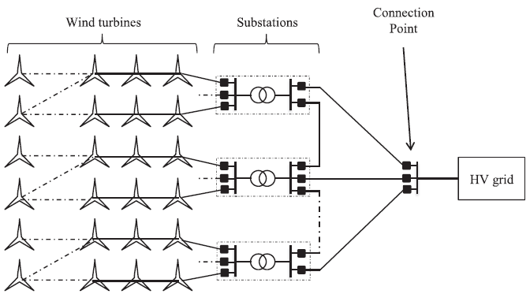
Figure 1: Network Wind farm (Smail et al., 2018).

LITERATURE REVIEW
WIND TURBINE DESIGN: In contrast to conventional fans, wind turbines generate electricity independently of the grid by using wind energy to spin blades that convert kinetic energy into rotary motion. Wind turbine blades, as seen in, capture wind energy and transform it into rotational motion to power an electrical generator and generate power.Fig. 2. (Alternative Energy Tutorials, n.d.).
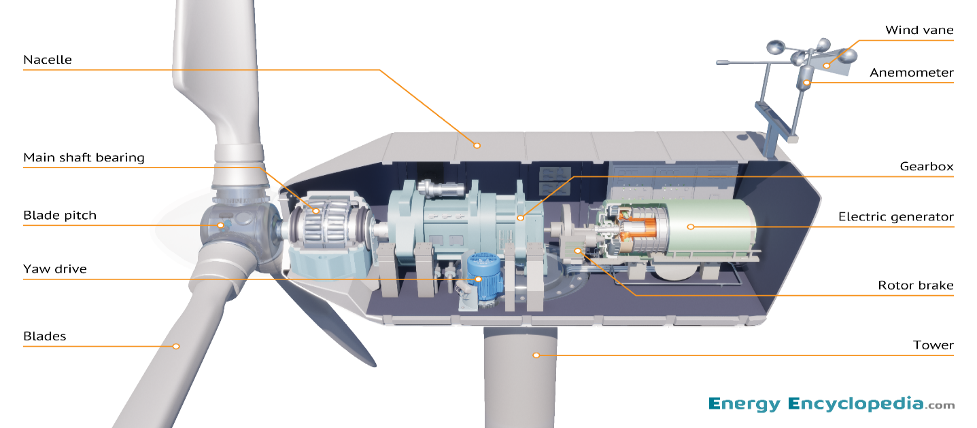
Figure 2: Wind Turbine (Energy Encyclopedia, 2024).

PROJECT LAYOUT
This wind farm design plan will take some things into account to achieve the goal of the survey.

SITE LOCATION
The plentiful wind resources of Northern Scotland is 10.59 m/s (as seen in Fig. 3 and Fig. 4), supply Orkney Island with electricity enabling it to generate revenue in 2013 and 2014. (OREF, 2024).
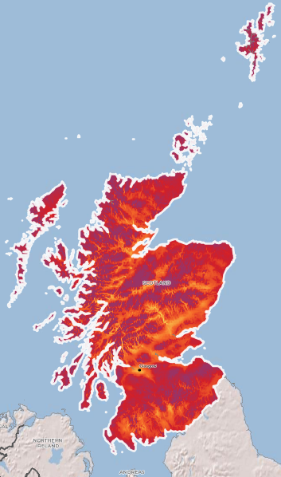
Figure 3: Norm Scotland Wind Speed at 100m (Wind Global Atlas, n.d.).

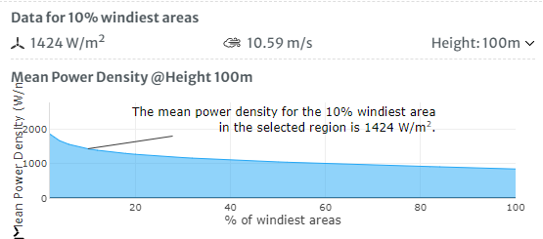
Figure 4: Scotland norm Density Power (Wind Global Atlas, n.d.)

SURVEY METEOROLOGICAL
Fig. 5 High winds, averaging 10.59 metres per second, are common at the Orkney Island wind farm. Because of this, Quanterness is a good site for our proposed wind farm, which would produce 90 MWh a year having a 0.03 roughness length Fig. 6. (Kaewpet and Bullen, n.d.).
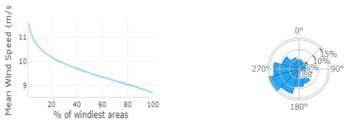
Figure 5: Wind Speed & Frequency Rose of Scotland (Wind Global Atlas, n.d.).

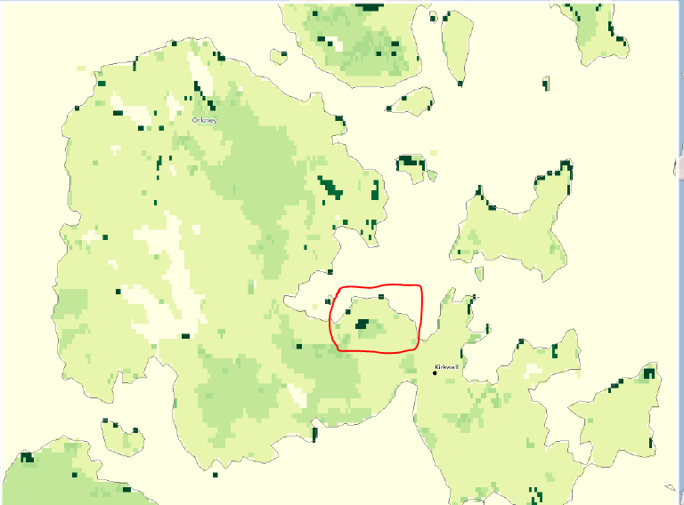
Figure 6: Roughness of Orkney Island (Wind Global Atlas, n.d.).

WIND ANALYSIS DATA
Table 1 High winds, averaging 10.59 metres per second, are common at the Orkney Island wind farm. Because of this, Quanterness is an ideal site for our proposed wind farm, which would produce 90 MWh a year with a roughness length of 0.03 see (WindPro, 2024).
Table 1: Data Analysis wind (Weibull Data) (WindPro, 2024).
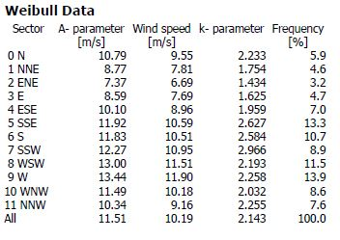
This region can produce 152,646 MWh of energy annually due to its great wind potential, as seen in Fig. 7. Fig. 8 displays other wind characteristics, including a noticeable frequency of wind in the west and steady speeds over the 3 m/s cut-in threshold of the turbine.(WindPro, 2024).
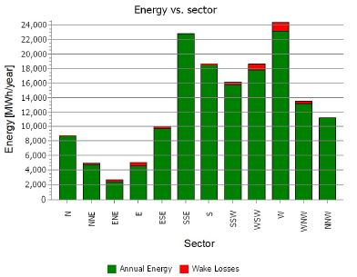
Figure 7: Production Energy Analysis (WindPro, 2024).

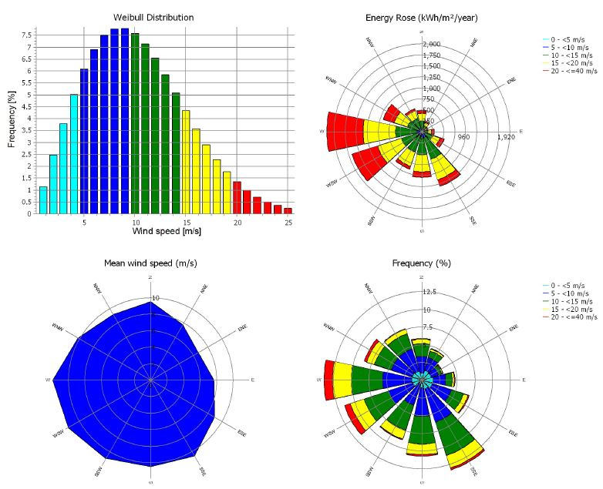
Figure 8: Analyzing Wind Data (weibull distribution, energy rose, mean wind speed, & frequency) (WindPro, 2024).

TURBINE SELECTION
The information for the wind turbines can be found in Table 2 and seen in Fig. 9.
Table 2: VESTAS V150-6.0 6000 150.0 hub: 149m (TOT: 224.9m) (wind-turbine-models.com, 2011).
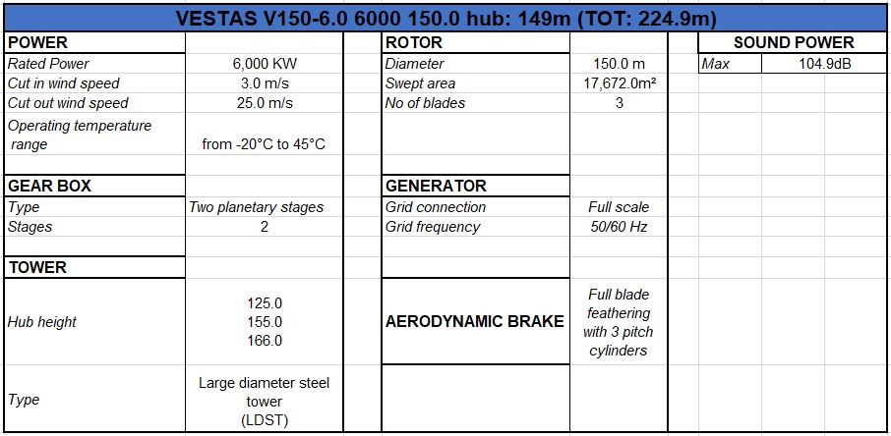
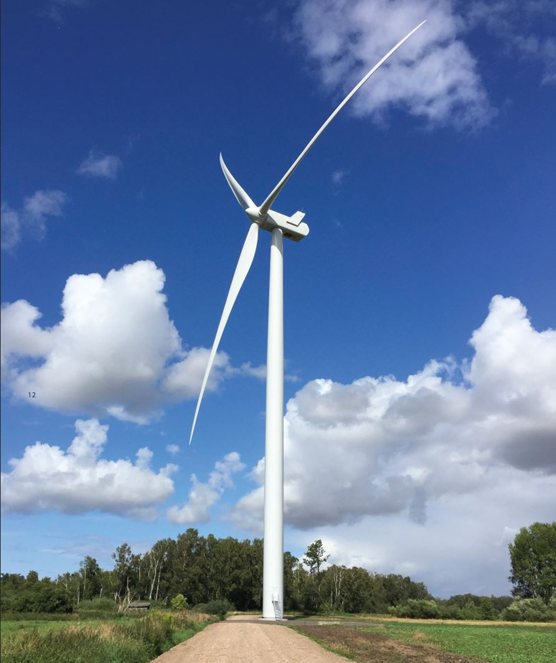
Figure 9: VESTAS V150-6.0 (wind-turbine-models.com, 2011).
Table 3 demonstrates the power curve analysis of the turbines. As seen in, the turbine will operate at its most efficient point when the lines join. Fig. 10.
Table 3: Power Curve Analysis Comparison (WindPro, 2024).
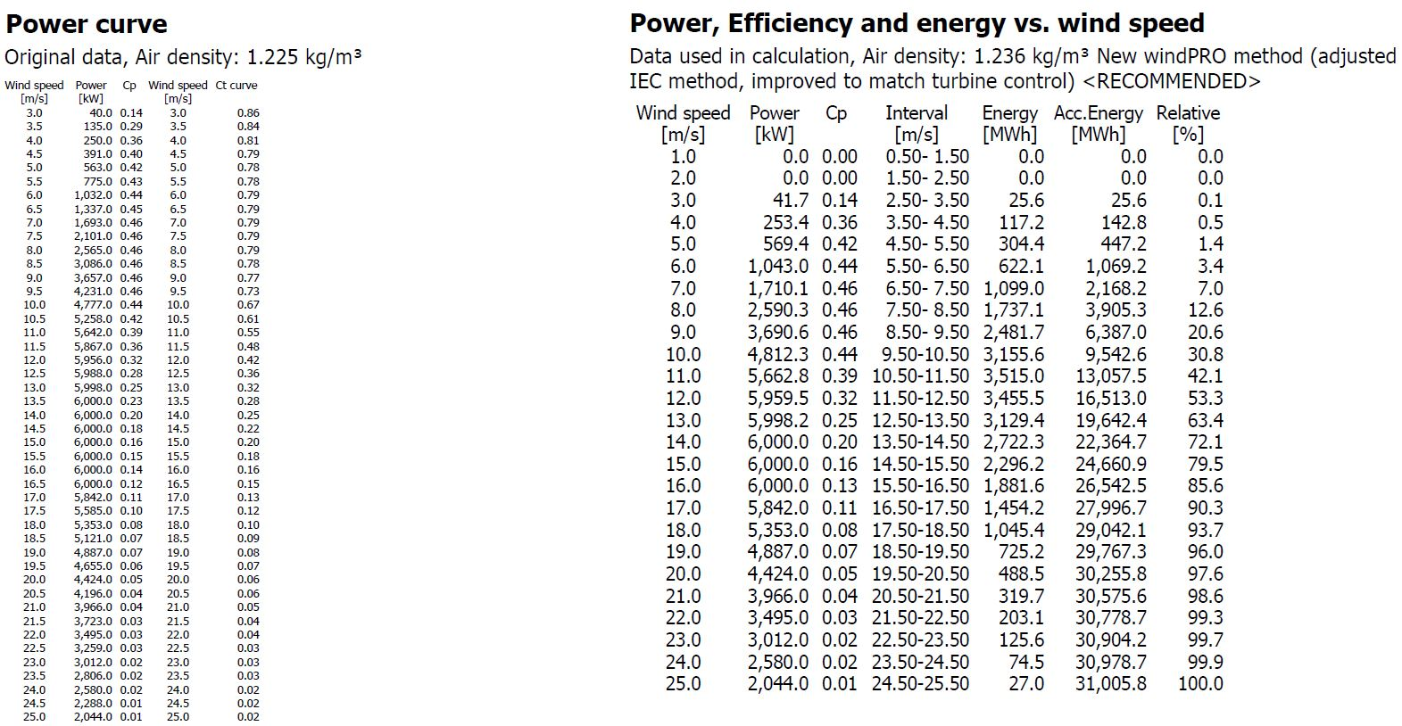
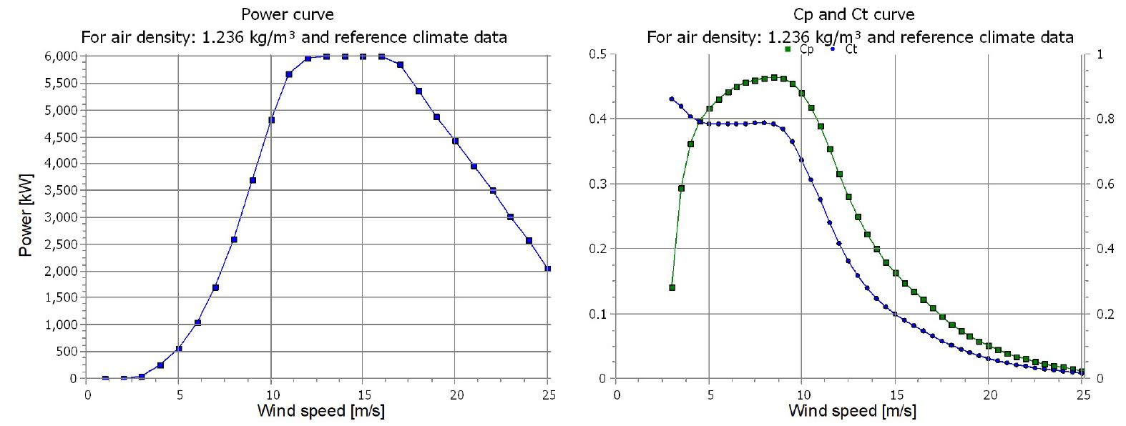
Figure 10: Power Curve Analysis & Cp and Ct Curve (WindPro, 2024).

ASSESSMENT SITE

PRESENT POWER GENERATION
Located in Orkney, two significant wind farms with a combined power output of up to 10MW are Hammars Hill (established in 2010) and Burgar Hill (established in 2007). (OREF, 2024).

TEMPERATURE EVALUATION
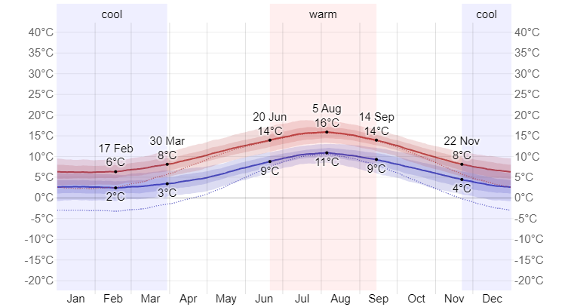
Figure 11: Norm Orkney Island: High and Low Temperatures(Weather Spark, n.d.)

Temperature influences turbine choices and wind speeds. Fig. 11; The temperature ranges in which turbines function see Fig. 12 and Fig. 13. These figures show the average temperature, wind direction, and speed in Orkney.
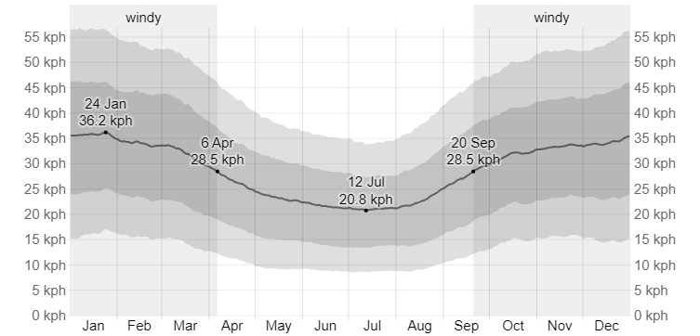
Figure 12: Speed of Orkney Island wind (Weather Spark, n.d.)
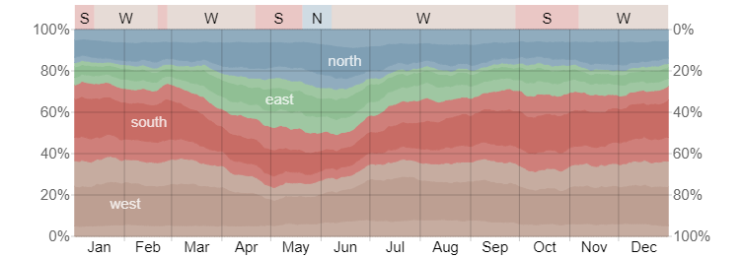
Figure 13: Wind Direction in Orkney Island (Weather Spark, n.d.)

LAND ACQUISTION
Housing and wildlife classifications impose restrictions on Orkney Wind Farm. 30 MW of capacity is envisaged for five turbines. Roads, substations, maintenance zones, and compounds are examples of components. Little fieldwork and less prone to environmental fluctuations. For its buildings, Orkney Island Council may use it. DPEA authorization for land acquisition was acquired, as evidenced by Fig. 14 (Orkney Islands Council, 1854).
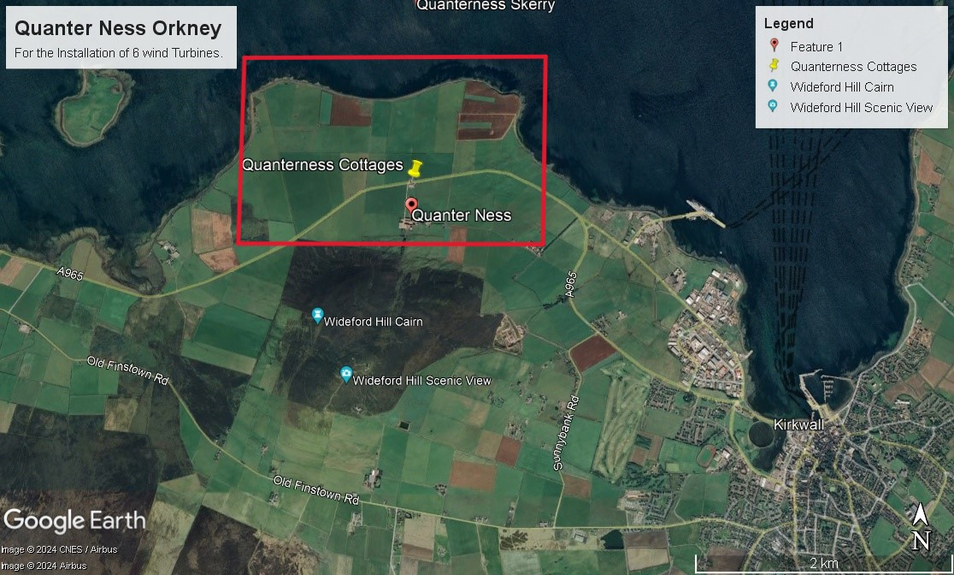
Figure 14: United Kingdom's Quanter Ness Orkney Island, Scotland(Brian McClendon, 2001).

SOCIAL IMPLICATION
With this concept, OIC hopes to establish Orkney Community Wind Farms to boost the local economy and generate money for needs and projects. All profits are retained locally, allowing communities to benefit from an annual Community Benefit Fund of £432,000 for innovative projects. (Orkney Islands Council, 1854).

ENVIRONMENT ASSESSMENT
Reducing carbon emissions is OIC's top priority, and it uses renewable energy to become carbon neutral. Every turbine could save 4,000 tonnes of CO2 a year, according to their wind farm idea (see Fig. 15), possibly compensating 84,000 tonnes per year. This is in line with Scotland's 20GW onshore wind target by 2030 and Orkney's climate ambitions. Table 4 outlines the actions planned to address the problems found in the Environmental Impact Assessment and surveys. (EIA) (Orkney Community Wind Farms, 2019).
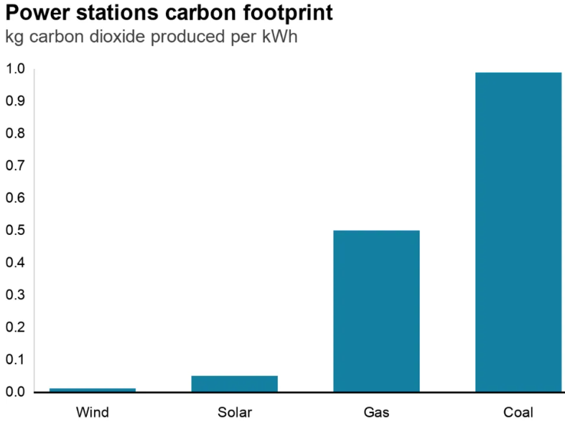
Figure 15: Power Station Emission (National Renewable Energy Laboratory (NREL), 2024).

Table 4: Environmental Impact Assessment (Challenges & Mitigation) (Orkney Community Wind Farms, 2019).
CONSIDERATION | Landscape & Visual | Ecology & Ornithology | Transport & Traffic | Noise | Site Specific | Cultural & Heritage
CHALLENGE | Evaluate turbine visibility within a 7km radius.  Shadow Flicker.  Residential properties are south and west of the development. | Wildlife and birds face disturbance and collision risks during construction and operation. | Traffic is up due to construction.  Road disruptions due to abnormal load delivery. | Construction causes more noise.  Turbine operational noise disturbance. | Telecom links on site.  Farmland has drainage. | Two archaeological sites are located east of the development.  Settings can impact nearby cairns and brochs.
MITIGATION | Site selection and turbine placement were carefully chosen for visual impact considerations in the development.  Shadow flicker protocol to be enforced prior to wind turbine operation. Turbines may be selectively shut down to mitigate flickering.  No landscape designations in the area or site boundary. | Ecology and ornithology surveys were conducted.  Creating a plan for species protection and habitat management. | Logistical requirements were analyzed thoroughly.  We'll develop a traffic plan with Roads Services for construction. | Turbines are positioned to keep noise levels within acceptable limits, with the nearest property 132m away.  Wind turbines will switch to 'noise optimized mode' if they exceed noise limits, reducing their noise output.  Create a plan to minimize noise and establish daytime-only working hours for construction. | Telecom providers consulted to ensure the layout didn't disrupt links.  The hydrologist and Landowner collaborated on drainage ditch assessments for design. | Two sites will be protected with a 100m buffer during construction.  Geophysical surveys precede construction to safeguard unrecorded archaeological sites.

WINDPRO SIMULATION EVALUATION
Based on factors including wake loss, wind direction, and turbine spacing, the wind farm simulation with turbines producing 30,529.2 MWh annually, Windpro projects a 152,646 MWh annual energy output. The farm generates 137,381.4 MWh yearly, which is a good performance for its size, even with a 2.5 per cent wake loss and slightly lower wind speeds of 10.2 m/s, as can be shown in Table 5.
Table 5: Computed Annual Energy for Wind Farm and WTGs (WindPro, 2024).
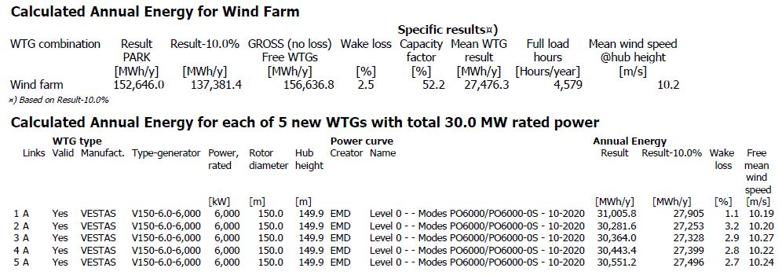
PDF File 1 represent PARK Main Result.
PDF File 1: WindPro PARK Energy Analysis (WindPro, 2024).

NOISE ANALYSIS
As seen in the Decibel module simplifies the process of assessing wind farm noise, which facilitates the repositioning of turbines and the creation of documentation that conforms with regional regulations. Fig. 16 (EMD Internationals, 2021). Noise from wind turbines is caused by aerodynamics (see Fig. 17) and mechanical sources, which include internal parts like gearboxes and generators as well as blade motion.(ETSU., 1996).
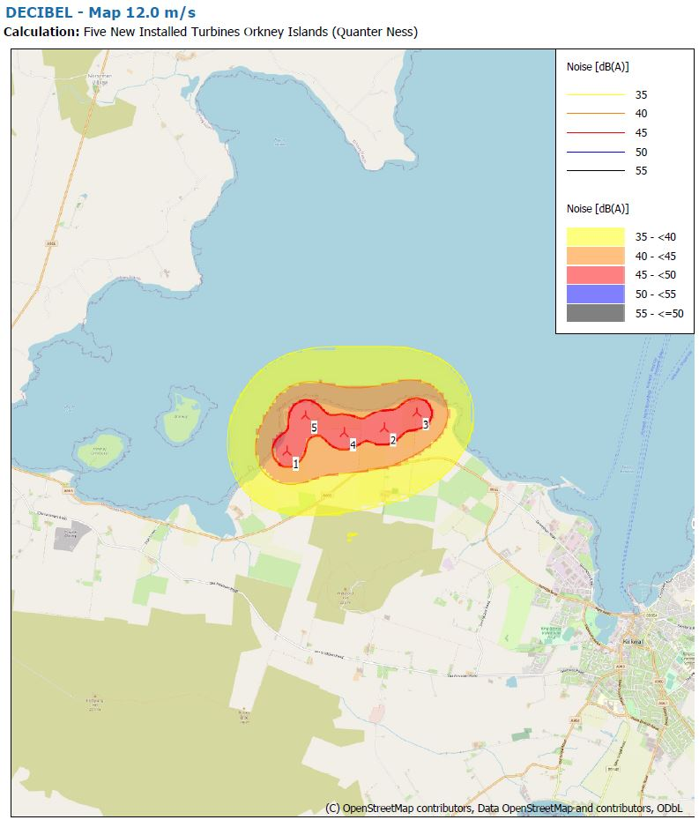
Figure 16: Decibel Orkney Island Scotland (Quanterness) Map 12.0 m/s (WindPro, 2024).
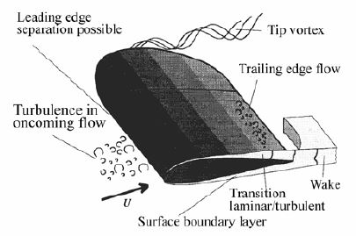
Figure 17: Aerodynamic Noise Effect (Clausen et al., 2013).

PDF File 2 represent the Noise Decibel.
PDF File 2: Noise Decibel (WindPro, 2024).

SHADOW FLICKER ANALYSIS
The Shadow model determines the number of hours per year that shadow flickers in Fig. 18 generated by wind turbines, affecting specific areas or regions (EMD Internationals, 2021). Shadow flicker occurs on surfaces like windows when rotating blades cast alternating shadows; it does not occur when clouds cover the light or when the turbine is not turning. (Bolton, 2007).
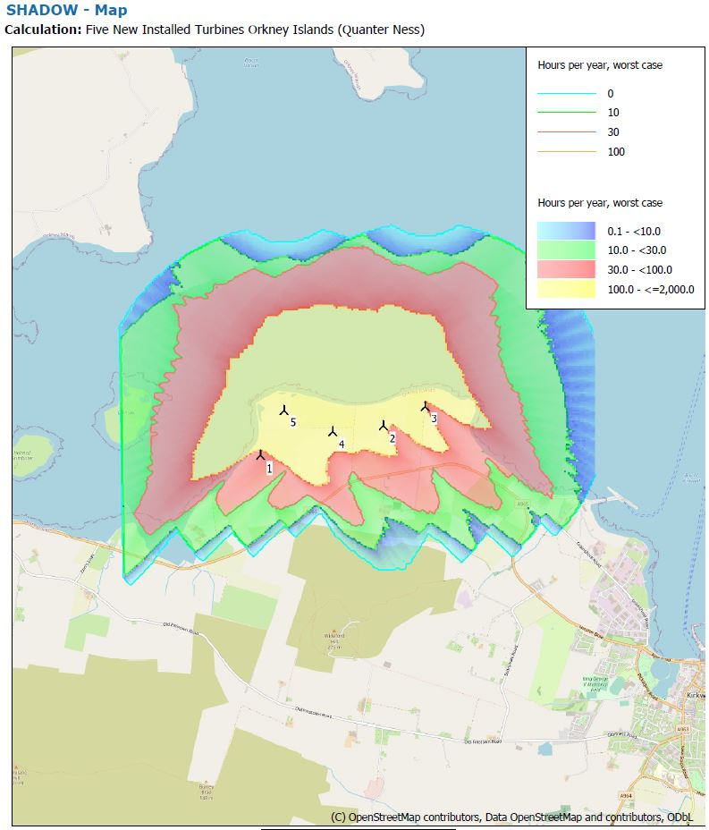
Figure 18: Shadow Flicker Orkney Island Scotland (Quanterness) (WindPro, 2024).

PDF File 3 show the SHADOW Map.
PDF File 3: Shadow Flicker (WindPro, 2024).

ZONES OF VISUAL INFLUENCE ANALYSIS
Assessing the visual impact of wind turbine groups across long distances, the ZVI module makes use of digital elevation models and the turbine placements shown. Fig.19. It produces color-coded maps that illustrate the visibility of turbines from different angles by demarcating visible and hidden zones. (EIA Registration, 2017).
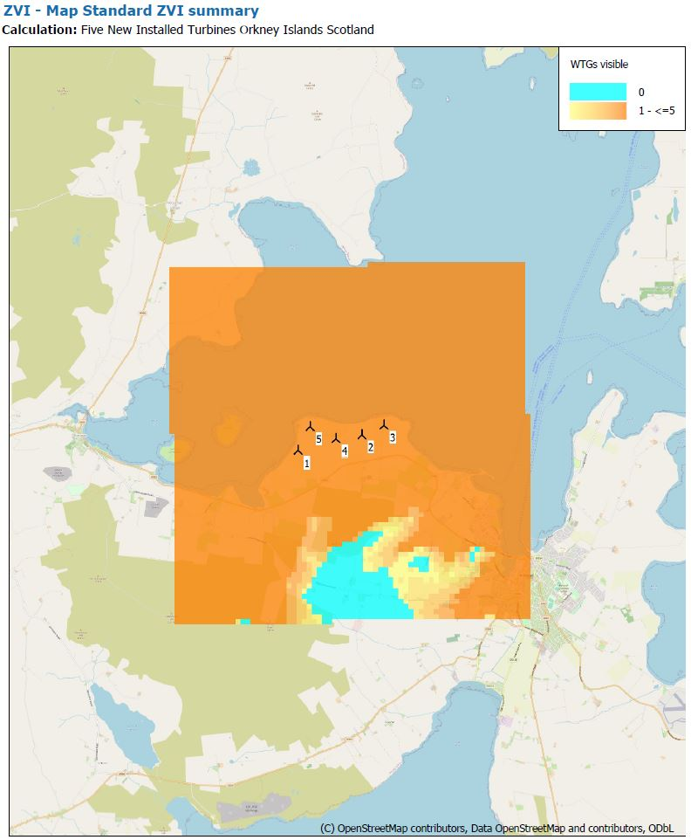
Figure 19: Zones of Visual Influence Orkney Island Scotland Quanterness (WindPro, 2024).
PDF File 4 represent the ZVI map.
PDF File 4: Zones of Visual Influence (WindPro, 2024).

PHOTOMONTAGE ANALYSIS
The Photomontage Fig. 21 permits the development of visually accurate depictions of wind turbine farms inside landscape images while Fig. 20 shows off Google Street View images. These visualisations show potential implications by superimposing proposed advancements over existing environments.(Bord na Mona and Winter, 2022).
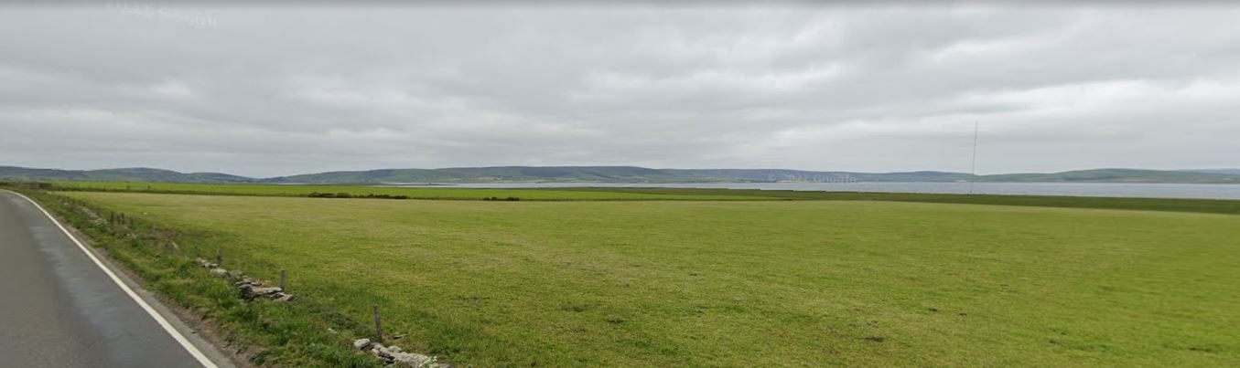
Figure 20: Quanterness Site without Wind Turbines (Google Earth, 2024).
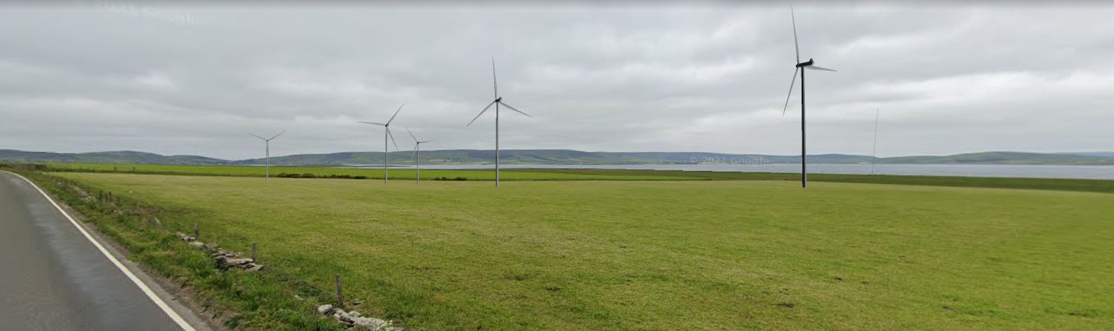
Figure 21: Quanterness Land Site with Wind Turbines (WindPro, 2024).
PDF File 5 give the Photomontage Result.
PDF File 5: Photomontage (WindPro, 2024).

GEOGRAPHIC INFORMATION SYSTEM ANALYSIS (GIS Data)
As demonstrated in Fig. 22, which displays the forests in green, protected areas in blue, and the Quanterness Orkney Island core path in red. GIS is a mapping system that combines various descriptive data with location-based information (Esri, 2022).
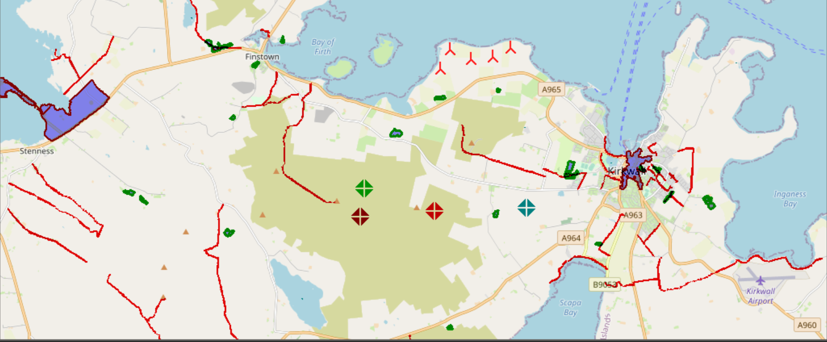
Figure 22: GIS Data for Site (WindPro, 2024).

PROJECT PLAN FOR ORKNEY WIND FARM (QUANTERNESS)

PRECONSTRUCTION PLAN
AACE International has suggested a thorough programme, and the Quanterness Wind Farm Project, approved by the Scottish DPEA, requires rigorous preparation. Fitzgerald, Scott M. (2023). Fig. 23 Prioritizing tasks like foundation work and turbine production to ensure the ground is adequate before building begins, the three-year preconstruction period is demonstrated to involve a lot of data collection, particularly for the met mast.
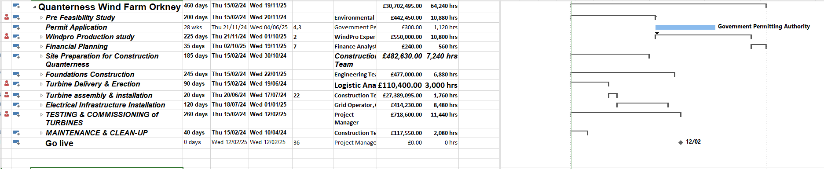
Figure 23: Preconstruction Plan (Microsoft Project) (Microsoft Project, 2024).

CONSTRUCTION PLAN FOR WIND FARM
On the Quanterness wind farm construction site, contractors begin work, focusing on the installation of turbines, electrical structure, and civil works as shown in Fig. 24 (Irish Wind Energy Association, 2019). This is a capital-intensive phase that includes building roads, installing substations, and laying foundations. Fig. 25 project's critical path, while Fig. 24 displaying on the Gantt chart the project's expected duration and timetable.

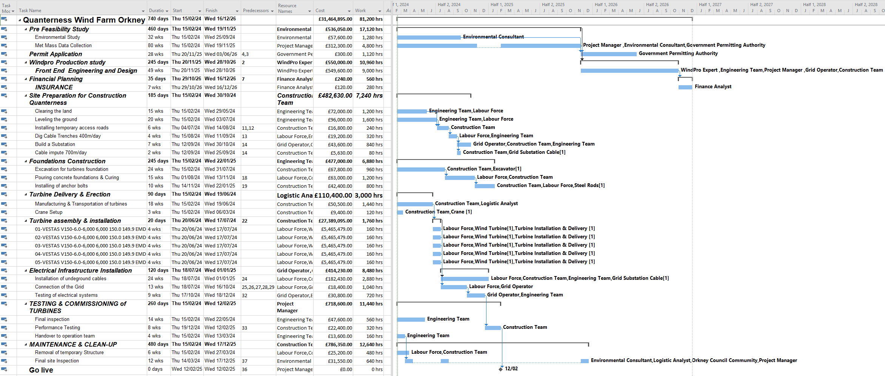
Figure 24: Scotland's Quanterness Orkney Island Construction Plan, Level All (Microsoft Project, 2024).
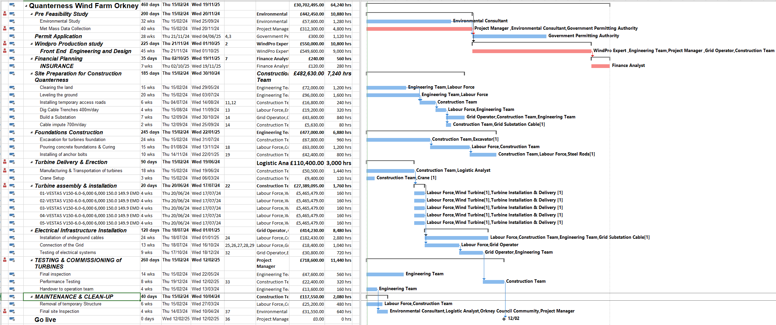
Figure 25: Critical Path Construction Plan Quanterness Orkney Islands Scotland (Microsoft Project, 2024).

COMPONENTS OF WIND FARM CONSTRUCTION

Contractor Preference
Esteemed Orkney Contractor Heddle Construction Ltd. offers comprehensive turnkey solutions and a plethora of wind turbine project experience. Their expertise in foundation building, site inspections, road construction, and crane services ensures that projects are completed safely, effectively, and affordably. (Heddle Civil Engineering, 2019).

Turbine Foundation
Tower and turbine loads, including overturning moments, are supported by wind turbine foundations Fig. 27. Common varieties include ribbed beam basements, shallow mat extensions, and piled foundations with diameters ranging from 15 to 22 metres Fig. 26. As demonstrated, the ribbed beam type features a basement, beams, and a central pillar that counteract moments Fig. 28. Because of Orkney's flat landscape, a narrow basement works well, but it takes more work and intricacy. (CNBM International, 2018).
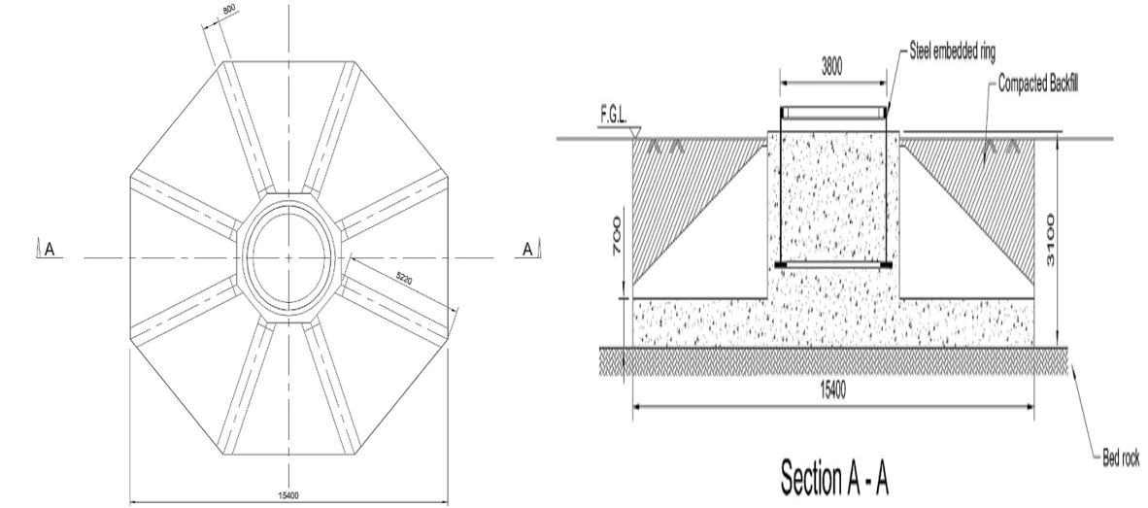
Figure 26: Turbine Foundation Layout (Currie et al., 2015).
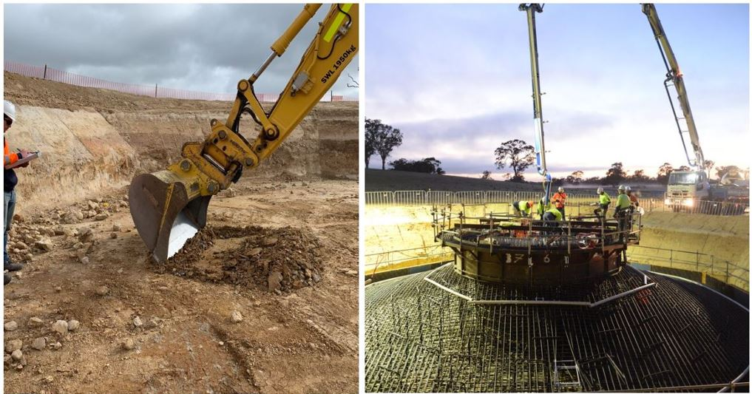
Figure 27: Digging of Turbine Foundation (Collector wind farm, 2021).
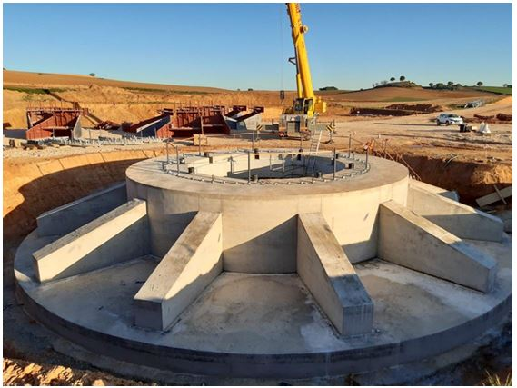
Figure 28: Ribbed Beam Basement Turbine Foundation (La Richardais, 2022).

Conveyancing of Turbines to Site Location
Quanterness Windfarm promises that nearby neighbours will experience the least level of disturbance from the turbine movement. Collett & Sons specialty automobiles Fig. 29 The components have a specific load classification, so handle them carefully under the guidance of trained Police Scotland personnel. Northwards Ltd. in Kirkwall, Denmark receives both the tower sections (149.9m) and the blades (73.7m). Fig. 31 and transported 2.7km to the site near St Ola see Fig. 30. The Orkney Islands Council has approved the new intersection on the A965 that provides access, and it complies with safety regulations. Fig. 32 (Pines Burn Deliveries, 2024).
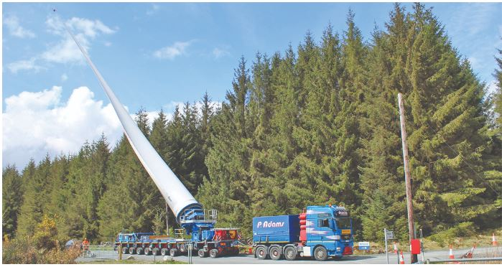
Figure 29: For the VESTAS 150-6.0 MW WTG Blade, Collett & Sons Haulier Specialist Vehicles for Abnormal Load(Collett & Sons, 2024).
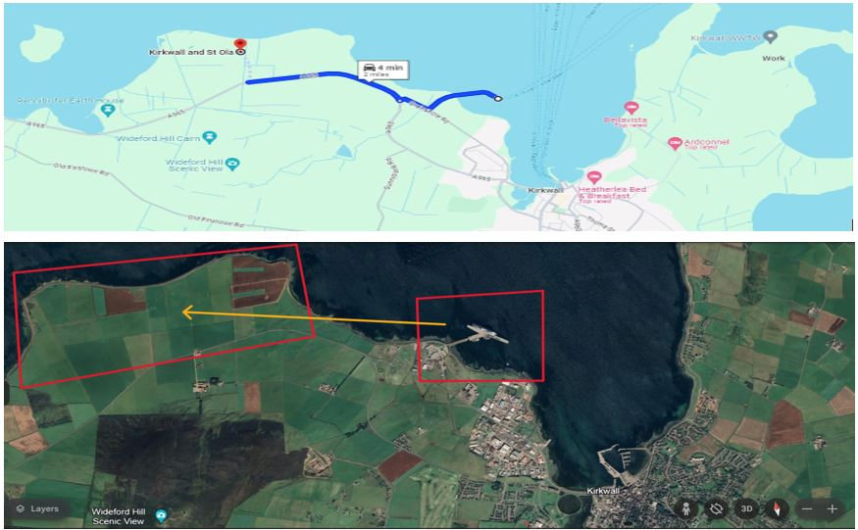
Figure 30: Kirkwall Depot to Wind Farm Site Directions and Access Route Map(Google Earth, 2024; Google Map, 2024).

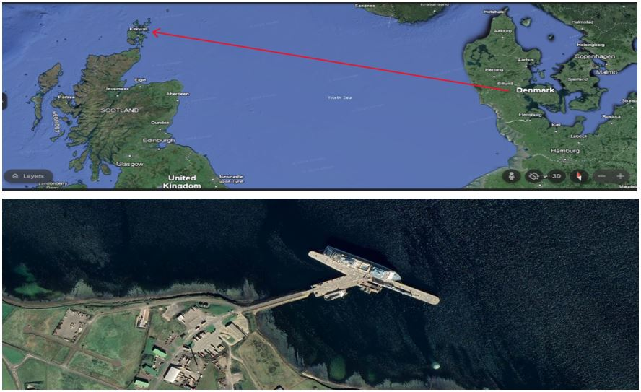
Figure 31: Map of Shipping from Denmark to Northwards Ltd. at Kirkwall Depot (Google Earth, 2024).
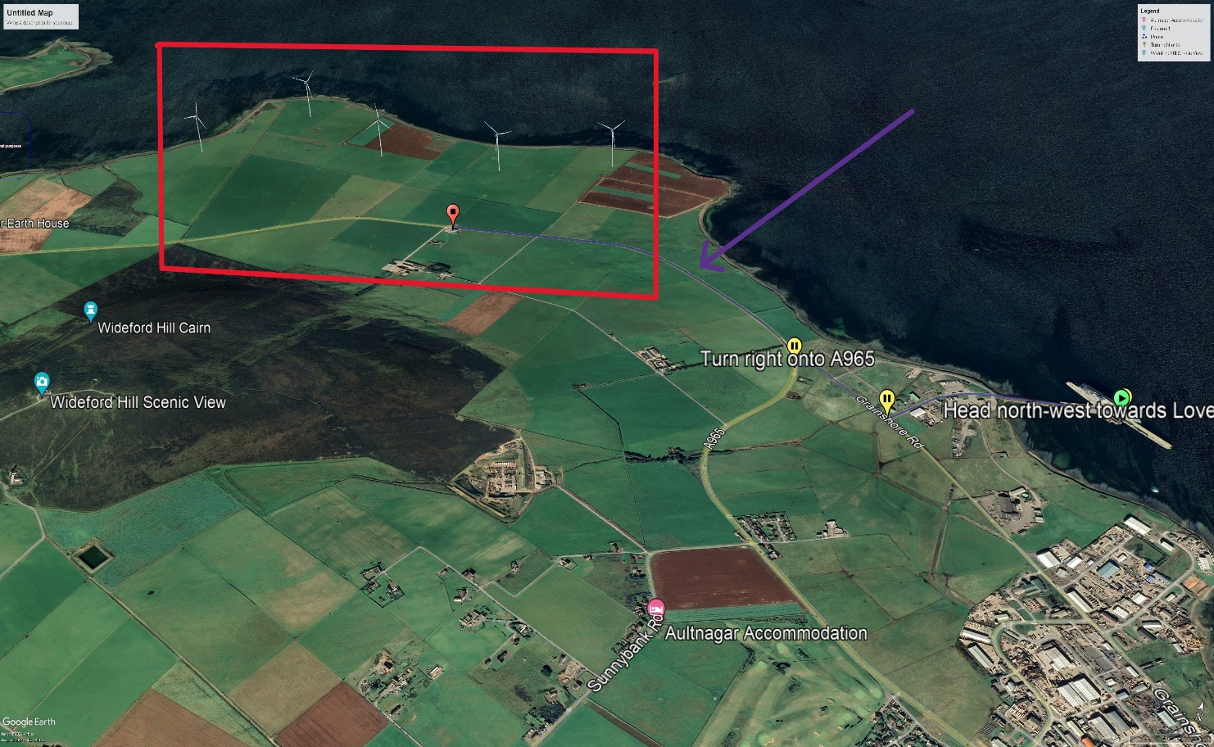
Figure 32: How to Get from Depot to Wind Farm (purple arrow indicating route to site & red mark indicating wind farm site with the photomontage of WTG) (Google Earth, 2024).

Roads to Wind Farm
Table 6 includes the price of constructing the roads to each turbine position, analysing the data, and installing the VESTAS 150-6.0MW wind turbines. It also includes the cost of constructing the cranes and establishing the grid connection. The data was generated using windPRO simulation, as demonstrated in Fig. 33.
Table 6: Access Road Data & Cost (WindPro, 2024).
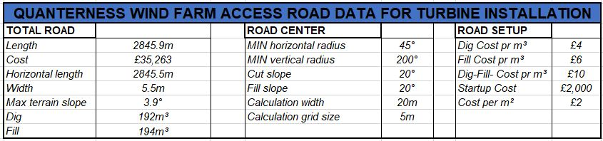

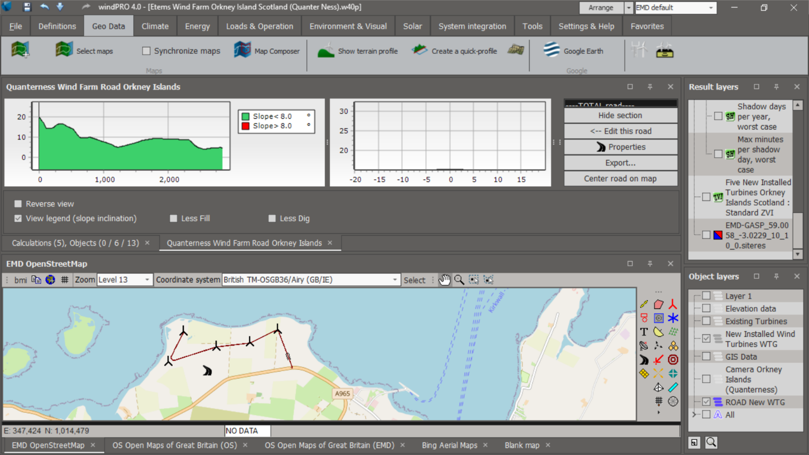
Figure 33: WindPro Road Map for Scotland's Orkney Island's Quanterness Wind Farm (WindPro, 2024).

Installations of Cable Trenches
The Council of the Orkney Islands, 1854 A 220 MW transmission link was certified by OFGEM; 135 MW must be justified for Orkney's wind farm; observe to Fig. 34. One wind farm, Quanterness, accounts for thirty megawatts of the ninety megawatts that the Orkney Islands wind farms contribute each year. In Scotland, installing cables to link to the grid Fig. 35.
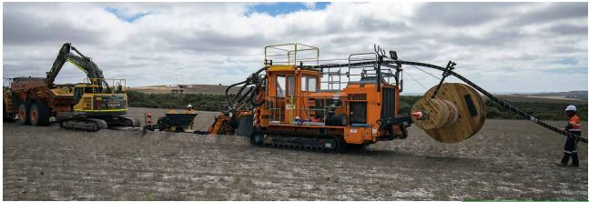
Figure 34: Cables Installation (Nexan Energy, 2018).

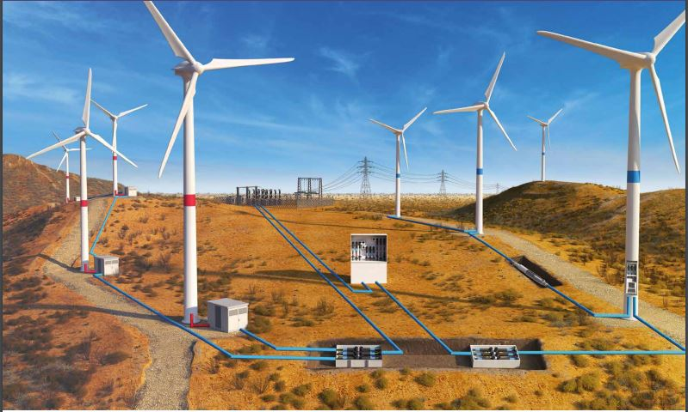
Figure 35: Onshore Installation (Nexan Energy, 2018).

Grid Connection
Clean electricity produced by the wind turbines is connected to the grid and exported at a voltage of 690 volts (Manzano-Agugliaro et al., 2020). By controlling varying wind speeds, power electronics maximise energy dispatch to accommodate variances. Fig. 36.
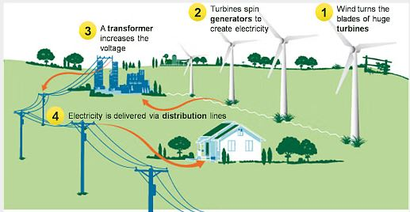
Figure 36: Grid Connection Operation (Amruta Patil, 2024).

WIND FARM PRESERVATION AND OPERATION
Throughout the lifecycle of a wind turbine, we offer comprehensive operation and maintenance services to ensure ongoing customer support. Utilizing a continuous data link for real-time monitoring, our skilled professionals carry out major repairs and regular maintenance to optimise efficiency. (Ingeteam, 2024).

DECOMMISSION
As wind farms near the end of their 20–25 year lifespan, decommissioning takes place, and it involves taking the equipment and turbines apart. With the appropriate licences and leases, precious parts can be recycled and repowering is feasible.. (Irish Wind Energy Association, 2019).

FINANCIAL EVALUATION
High installation costs are a barrier to wind turbine installation. Research examines several factors, including NPV, LCOE, and life cycle costs, to develop accurate models for planning and feasibility assessment. (Díaz and Soares, 2023).

CONTRACT FOR DIFFERENCE
With a 20-year fixed energy price, the Quanterness Wind farm has granted the Orkney Islands Council a Contract for Difference, reducing financial risk and meeting Ofgem's requirements. Fuel poverty is addressed, and local services are benefited by the £46.39/MWh CfD subsidy, which has been adjusted since 2012. (Orkney Islands Council, 1854).

EVALUATING FINANCIAL RISK
Decisions on investments are made more challenging during the building phase of wind farm projects because of the inherent hazards Fig. 25. Understanding these risks and how they affect cost, time, safety, and quality is necessary for making smart decisions (Mohamed et al., 2024). Project success and effective risk management depend on an understanding of risk factors Table 7. Cost overruns for the project are shown in the Gannt Chart from the Critical Path. Fig. 37.
Table 7: Risk Factors to be Considered (Mohamed et al., 2020)
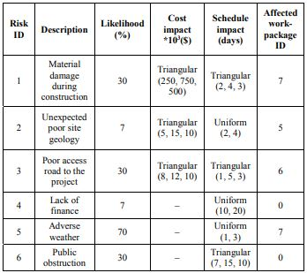
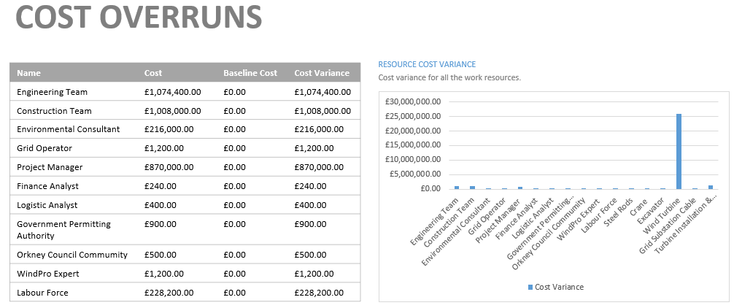
Figure 37: Wind Farm Cost Overrun (Microsoft Project, 2024).

REVENUE
The annual power sale, which brings in money for the wind farm project over 20 years by using the PPA rate, may be found at Table 8.

Table 8: Annual Cost of Quanterness Wind Farm (Microsoft Excel, 2022).
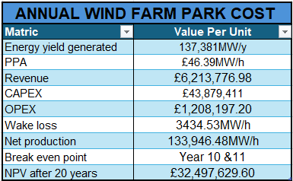

LEVELIZED COST OF ENERGY
A crucial statistic for assessing the costs associated with producing energy is the Life Cycle Cost of Energy (LCOE), which shows the lowest selling price per unit needed for the project to break even over the length of its 20-year lifespan, see Fig. 38, Using wind pro simulation software estimating the planned wind farm's LCOE at £29.77MW/h. (Tyler Stehly and Patrick Duffy, 2022).
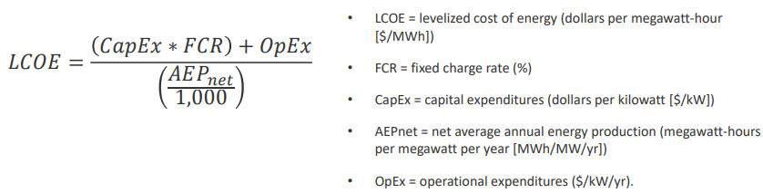
Figure 38: Energy Lifetime LCOE Calculation (Tyler Stehly and Patrick Duffy, 2022).

CAPITAL EXPENDITURE
Infrastructure like as turbines and installation is covered by CAPEX in onshore wind farms, as demonstrated in Table 9 and Fig. 39.

Table 9: Capital Outlay for the Wind Farm Project in Quanterness(Microsoft Excel, 2022).
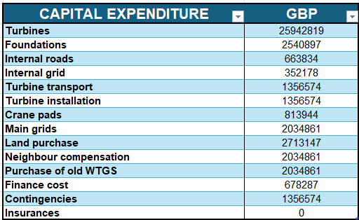
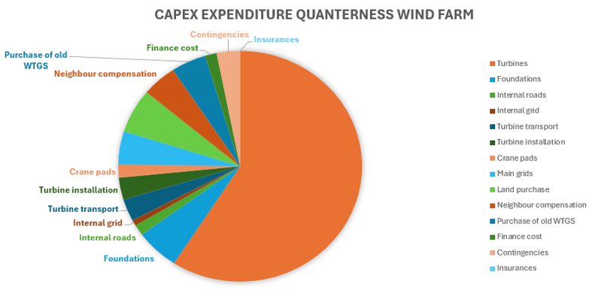
Figure 39: CAPEX Pie Chart (Microsoft Excel, 2022).

OPERATING EXPENDITURE
For instance, the Quanterness wind farm's operating, maintenance, and repair expenses (OPEX) are included. Table 10 and Fig. 40.

Table 10: Project Quanterness Wind Farm Operating Expenses (Microsoft Excel, 2022)
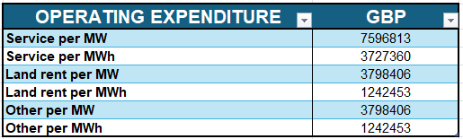
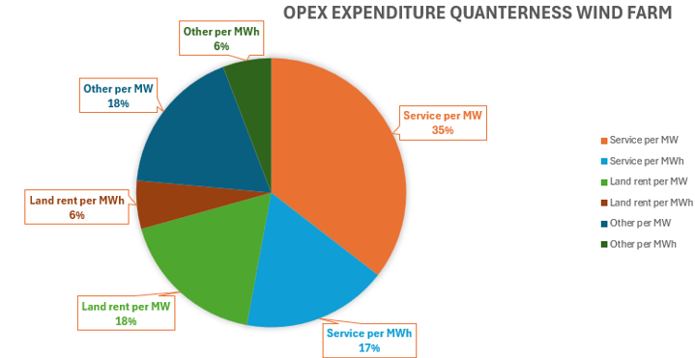
Figure 40: OPEX Pie Chart (Microsoft Excel, 2022)

NET PRESENT VALUE
The NPV method finds the economics of onshore wind farms by lowering projected cash flows. The CAPEX is £43,879,411 with an annual cash flow of £1,208,197.20 over 20 years. At the halfway point, profitability is reached. Fig. 41 with a NPV of £32,497,629.60 see Table 11.
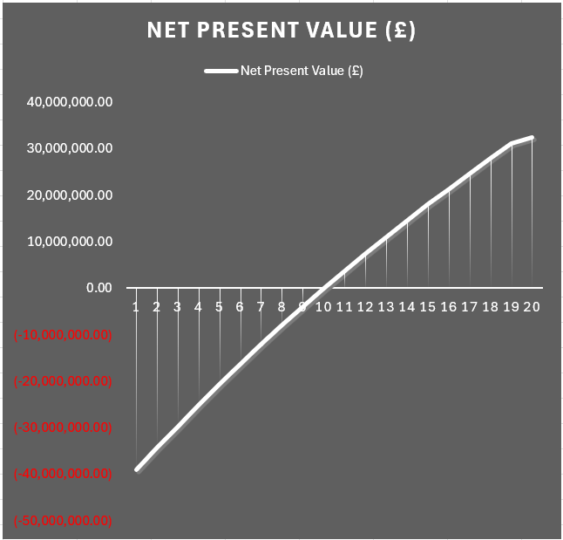
Figure 41: NPV of the Wind Farm Project (Microsoft Excel, 2022).

Table 11: Calculating Net Present Value Over a 20-Year Period(Microsoft Excel, 2022).
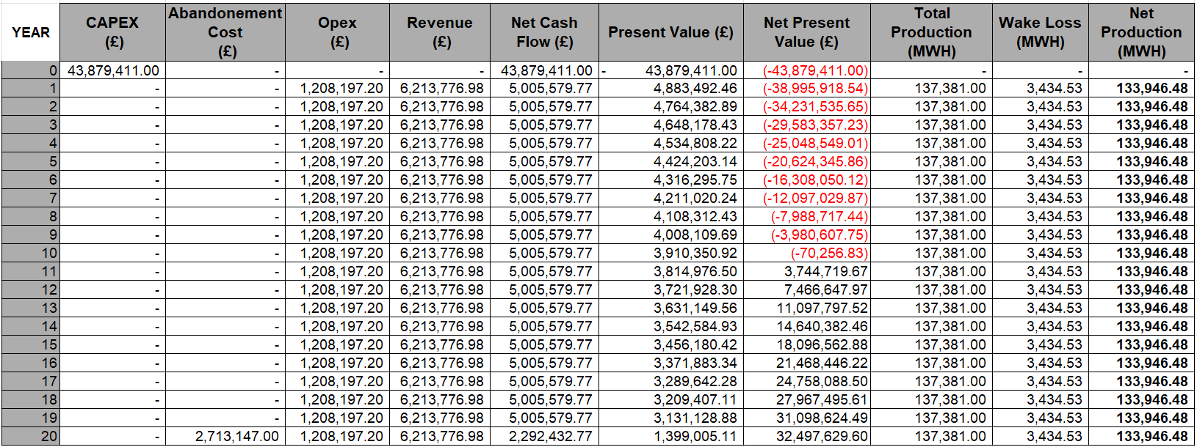

DISCUSSION
The whole plan for the Wind Farm includes a detailed analysis of site selection, design considerations, environmental impact, and financial viability. This decision is justified by the wealth of wind resources in Northern Scotland, particularly on Orkney Island. Fig. 3, as demonstrated by weather surveys and wind data analysis Fig. 8. Though these issues are handled with careful planning and mitigating methods, caution is still necessary when it comes to possible problems like noise disruption and aesthetic damage Table 4.
The simulation evaluations carried out by Windpro offer insightful information about the anticipated performance of the wind farm PDF File 1, including energy output Table 5, decibel size Fig. 16, shadow flicker amount Fig. 18, and visual impact volume Fig. 19. Using these simulations in conjunction with real-world data and evaluations ensures a thorough understanding of the technical aspects of the project as well as any potential consequences on the surrounding environment and populations.
With an emphasis on the benefits to the local economy and community involvement through initiatives like the Community Benefit Fund, the significance of socioeconomic considerations is emphasised. The project's commitment to sustainability and carbon reduction is demonstrated by its environmental assessments, which are consistent with regional and national climate goals.
The project's viability is determined via financial analysis. Table 8, Benefiting from a favourable Levelized Cost of Energy and a Power Purchase Agreement (LCOE). Value of Net Present (NPV) Fig. 41 analysis demonstrates long-term profitability Table 11, significant startup operating and capital expenses.
A balanced approach to wind farm development overall is demonstrated by the customised idea for the Quanterness Wind Farm, which takes into account technical, environmental, social, and financial problems. Careful planning, stakeholder involvement, and mitigation strategies ensure a sustainable and feasible project that benefits the neighbourhood as well as the switch to renewable energy sources—even though there may be challenges and concerns.

CONCLUSION
The Quanterness Wind Farm concept employs a thorough methodology that includes financial evaluations, environmental studies, and careful site selection. The research ensures both viability and long-term profitability by utilising the wind resources of Northern Scotland, specifically in Orkney Island, and using state-of-the-art tools like Windpro to generate accurate forecasts. Socioeconomic components like community involvement and the Community Benefit Fund are included into the project, which increases its relevance. This in-depth research facilitates the switch to renewable energy sources and acts as a roadmap for the growth of wind energy sustainably. In addition to addressing financial, socioeconomic, environmental, and technological concerns, it sets a benchmark for upcoming wind farm developments.

REFERENCE
Alternative Energy Tutorials. (n.d.). “Wind Turbine Design ”, Alternative Energy Tutorials, available at: https://www.alternative-energy-tutorials.com/wind-energy/wind-turbine-design.html (accessed 10 February 2024).
Amruta Patil. (2024), “Wind Farm - Environment Notes”, Wind Farm - Environment Notes.
Bolton, R. (2007), “Evaluation of Environmental Shadow Flicker Analysis for Dutch Hill Wind Power Project”, Environ. Compliance Alliance, New York.
Bord na Mona and Winter. (2022), “Photomontage Booklet for Proposed Garryhinch Wind Farm”, Proposed Garryhinch Wind Farm.
Brian McClendon. (2001), “Google Earth”, Keyhole , 10 June, available at: https://earth.google.com/web/search/quanterness/@58.99851988,-3.03132043,19.33634376a,6748.35645385d,35y,0h,0t,0r/data=CigiJgokCc-Gck5zfk1AEXS0mOQxfE1AGWRBaSvW5gfAISw30rnbdgjAOgMKATA (accessed 13 February 2024).
Clausen, N.-E., Cronin, T. and Jowittt, W. (2013), “Planning and development of wind farms: Environmental impact and grid connection”, DTU Wind Energy. DTU Wind Energy I,(46)[in English].
CNBM International. (2018), “Onshore Wind Turbines Foundation Types”, CNBM International Wind Power, 11 May, available at: http://www.steelwindtower.com/wind-turbine-foundation-5-foundation-types-explained-for-onshore-wind-turbine/ (accessed 20 February 2024).
Collector wind farm. (2021), “Gallery”, Ratch - Australia Project, available at: https://www.collectorwindfarm.com.au/gallery (accessed 20 February 2024).
Collett & Sons. (2024), “Collett & Sons to transport components for Scotland wind farm”, Giving Wind Direction Wind System , 21 February, available at: https://www.windsystemsmag.com/collett-sons-to-transport-components-for-scotland-wind-farm/#:~:text=Heavy%20haulage%20specialists%20Collett%20are,in%20Dumfries%20%26%20Galloway%2C%20Scotland. (accessed 21 February 2024).
Currie, M., Saafi, M., Tachtatzis, C. and Quail, F. (2015), “Structural integrity monitoring of onshore wind turbine concrete foundations”, Renewable Energy, Elsevier, Vol. 83, pp. 1131–1138.
Díaz, H. and Soares, C.G. (2023), “Cost and financial evaluation model for the design of floating offshore wind farms”, Ocean Engineering, Elsevier, Vol. 287, p. 115841.
EIA Registration. (2017), “VISUAL IMPACT ASSESSMENT-Kent Hill 3 Wind Project”, Transalta.
EMD Internationals. (2021), “WindPro”, Niels Jernes, available at: chrome-extension://efaidnbmnnnibpcajpcglclefindmkaj/https://www.emd-international.com/files/windpro/windPRO-module-description.pdf (accessed 19 February 2024).
Energy Encyclopedia. (2024), “Wind Turbine, Schematic Diagram ”.
Esri. (2022), “What is GIS”, National Geographic Explorers, available at: https://www.esri.com/en-us/what-is-gis/overview (accessed 19 February 2024).
ETSU., W. group on N. from W.T. (1996), The Assessment and Rating of Noise from Wind Farms, ETSU.
González, J.S., Rodriguez, A.G.G., Mora, J.C., Santos, J.R. and Payan, M.B. (2010), “Optimization of wind farm turbines layout using an evolutive algorithm”, Renewable Energy, Elsevier, Vol. 35 No. 8, pp. 1671–1681.
Google Earth. (2024), “Earth Version”, Google , available at: https://earth.google.com/web/@59.00212048,-3.01745229,18.55958948a,70.24640739d,35y,-77.79833118h,67.57001451t,0r/data=OgMKATA (accessed 19 February 2024).
Google Map. (2024), “Northward Ltd Depot to Wind Farm Site St Ola Kirkwall Quanterness Orkney Island Scotland”, Google , 20 February, available at: https://www.google.com/maps/dir/58.9991562,-2.9718449/59.0065629,-3.02387/@58.9980428,-2.9896125,13.25z/data=!4m2!4m1!3e0?hl=en&entry=ttu (accessed 21 February 2024).
Heddle Civil Engineering. (2019), “WIND ENERGY”, Heddle Construction Limited, available at: https://www.heddle.co.uk/renewables/wind-energy#:~:text=Wind%20energy%20is%20a%20well,Plant%20projects%20in%20the%20islands. (accessed 20 February 2024).
Ingeteam. (2024), “O&M Onshore Wind Power”, Ingeteam Power Technology S.A., 7 February, available at: https://www.ingeteam.com/cz/cs-cz/industry/provoz-a-udrzbace/p16_64_338/operation-and-maintenance-onshore-wind-power.aspx (accessed 21 February 2024).
Irish Wind Energy Association. (2019), “Life Cycle of an Onshore Wind Farm ”, Ionic Consulting , March, available at: chrome-extension://efaidnbmnnnibpcajpcglclefindmkaj/https://windenergyireland.com/images/files/iwea-onshore-wind-farm-report.pdf (accessed 20 February 2024).
Kaewpet, P. and Bullen, C. (n.d.). “FEASIBILITY STUDY OF ORKNEY’S WINDFARM DEVELOPMENT FOR SELF-SUFFICIENT FOR ENERGY IN ELECTRICITY DEMAND AND ROAD TRANSPORT SECTORS”.
Kusiak, A. and Song, Z. (2010), “Design of wind farm layout for maximum wind energy capture”, Renewable Energy, Elsevier, Vol. 35 No. 3, pp. 685–694.
Microsoft Excel. (2022), “EXCEL ”, 20 February.
Microsoft Project. (2024), “Construction Schedule”, Microsoft, Kingston, London , 16 February.
Mohamed, E., Seresht, N.G., Hague, S. and AbouRizk, S.M. (2020), “Simulation-based approach for risk assessment in onshore wind farm construction projects”, 2020 Asia-Pacific International Symposium on Advanced Reliability and Maintenance Modeling (APARM), IEEE, pp. 1–7.
National Renewable Energy Laboratory (NREL). (2024), “Carbon Footprint”, BBC News, available at: https://www.bbc.co.uk/news/explainers-60945298 (accessed 15 February 2024).
Nexan Energy. (2018), “ONSHORE WINDFARM SOLUTIONS”, WindLink.
OREF. (2024), “ORKNEY RENEWABLE ENERGY FORUM”, Registered in Scotland with Registration Number SC287437, available at: https://www.oref.co.uk/orkneys-energy-1/wind/ (accessed 12 February 2024).
Orkney Community Wind Farms. (2019), “Carbon Neutral”, Orkney Island Council, available at: https://orkneywindfarms.co.uk/carbon-neutral (accessed 13 February 2024).
Orkney Islands Council. (1854), “Orkney Community Wind Farms”, Orkney Wind Farm, available at: https://www.orkney.gov.uk/Council/C/orkneys-community-wind-farm-project.htm (accessed 12 February 2024).
Pines Burn Deliveries. (2024), “Transport arrangements”, Energie Kontor, available at: https://energiekontor.co.uk/pines-burn-deliveries/#:~:text=The%20transport%20of%20the%20turbine,low%20speeds%20on%20certain%20routes. (accessed 21 February 2024).
La Richardais. (2022), “Engineering of Wind Turbine Foundations”, CTE Wind International .
Smail, H., Alkama, R. and Medjdoub, A. (2018), “Optimal design of the electric connection of a wind farm”, Energy, Elsevier, Vol. 165, pp. 972–983.
Tyler Stehly and Patrick Duffy. (2022), “Cost of Wind Energy Review”, 2021 Cost of Wind Energy Review.
Weather Spark. (n.d.). “Climate and Average Weather Year Round in Orkney, Scotland, United Kingdom”, Cedar Lake Ventures, Inc, available at: https://weatherspark.com/y/40130/Average-Weather-in-Orkney-United-Kingdom-Year-Round#Sections-Temperature (accessed 13 February 2024).
Wind Global Atlas. (n.d.). “Wind Global Atlas”, 2024, available at: https://globalwindatlas.info/en/ (accessed 12 February 2024).
WindPro. (2024), “EMD Internationals”, Windpro, 17 February.
wind-turbine-models.com. (2011), “Vestas V150-6.0 ”, Lucas Bauer & Silvio Matysik, available at: https://en.wind-turbine-models.com/turbines/2293-vestas-v150-6.0-enventus (accessed 18 February 2024).

